Anticipatory Set: Ask Students: What type of factors may influence Earth Systems?: time of year, human population and activities, energy flow, land and sea temperature, precipitation, etc…. Ask Students: How do we study earth to determine if it is changing at all?: NASA satellites, aircraft, field research stations, and computer simulations based on real data…. Tell students: Today we are going to look at NASA real-time data and technologies to understand a little bit more about earth systems using a HoloGLOBE – an augmented reality program and device called a Merge Cube.

Standards Alignment:

NGSS Middle School | MS-PS3-3. Apply scientific principles to design, construct, and test a device that either minimizes or maximizes thermal energy transfer. [Clarification Statement: Examples of devices could include an insulated box, a solar cooker, and a Styrofoam cup.] [Assessment Boundary: Assessment does not include calculating the total amount of thermal energy transferred.]
NGSS High School | HS-ESS3-4. Evaluate or refine a technological solution that reduces impacts of human activities on natural systems. [Clarification Statement: Examples of data on the impacts of human activities could include the quantities and types of pollutants released, changes to biomass and species diversity, or areal changes in land surface use (such as for urban development).
Career Technical Education Anchor Standard | Apply technology to enhance productivity. Career-ready individuals find and maximize the productive value of existing and new technology to accomplish workplace tasks and solve workplace problems. They are flexible and adaptive in acquiring and using new technology. They understand the inherent risks—personal and organizational—of technology applications, and they take actions to prevent or mitigate these risks.

Student Outcomes: Students will be able to:
- Use technology (HoloGLOBE) to evaluate the change of Earth Systems over time
- Identify the factors that NASA satellites monitor on Earth
- Develop or evaluate technology that can minimize the influence of human impacts on Earth Systems

Materials: + Smartphone/ipad or other camera enabled device with touchpad
+ Merge cube
+ HoloGLOBE app downloaded on device
+ Laptop computer to access MyNASAData LAS

Essential Questions: How can we evaluate Earth Systems over time? What factors influence how Earth Systems change over time? How can technology be used to minimize the effects of human impacts on Earth Systems?

Day 1 Introduction:
- Turn on your mobile device and open up the HoloGLOBE app. Position the Merge Cube on the cube case stand and your mobile device on the device stand. (You can also hold both if you prefer.) Point the device camera at the merge cube and you should see a globe appear.

- Click on the green “+” on the left side of your screen.
- Click the GLOBE icon 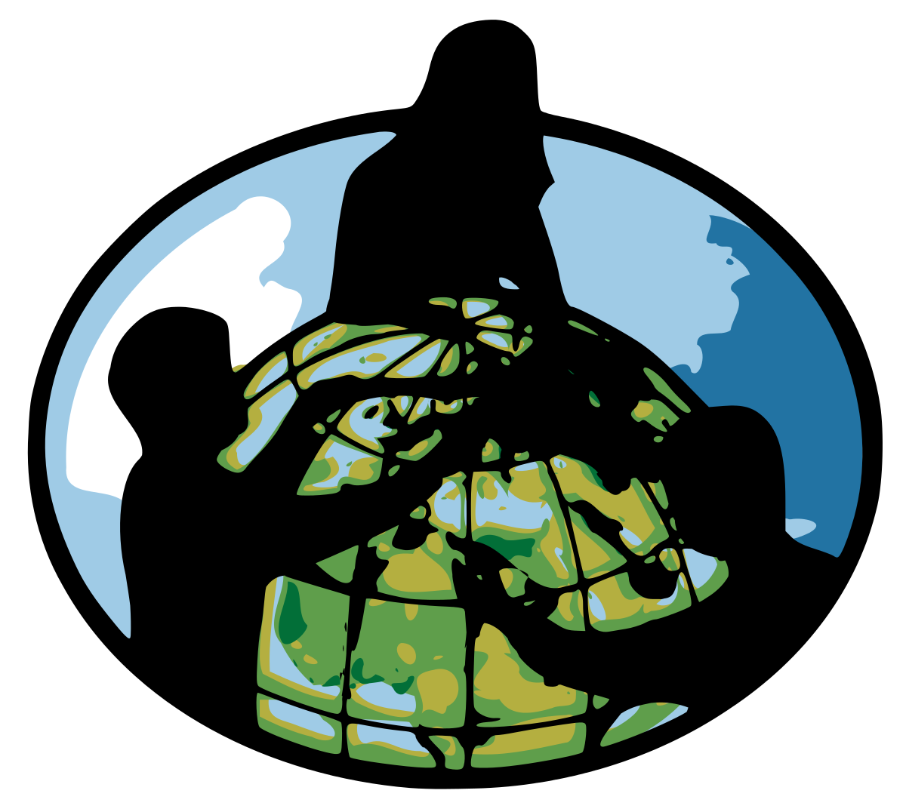 on the right of the screen and watch the short video. Answer these 5 questions when the video is done. (Read the questions before you begin the video.)

- Arrange the color pattern (yellow, blue, red) from coldest to hottest in the Earth’s visual land and sea surface temperature measurements: ________________, __________________, ___________________.

- What part of our land & sea surface temperature on Earth changes the most in a given year? ___________________________________
- What part of our land & sea surface temperature on Earth changes the least in a given year? ___________________________________

- What part of our Earth has the least precipitation in a given year? __________________________________

- What part of our Earth has the most precipitation in a given year? __________________________________

Day 2 Activity 1: Aerosols – define aerosols and give examples of natural and manmade aerosols

GLOBE Protocol: Aerosols – Collect an aerosol measurement using a sun photometer/calitoo. Note: you will also need to collect a cloud measurement at the same time and collect an air temperature as well.
HoloGLOBE
- Click on the NASA icon on the right side of the screen. A message appears about the data. It says: “This models provides data….” READ THIS MESSAGE. As you observe the data, look for patterns within each map and factors that could influence these patterns.
- Now click on the light blue “” on the right. A message appears about the data you are seeing. It says: “AOT, also called…..” READ THIS MESSAGE, and answer the question on your worksheet. Notice that behind the message each month of the year appears every second and a pink and white image of the Earth are associated with each month.
- To get rid of the message and see the pink and white data, click the green “-“ on the left
- Now click on the green “+” on the left and you should see the rotating pink and white data images with the month at the top of the globe.
- Reposition your Merge Cube so you are looking at North America and answer the questions for this activity.

Day 2 Activity 1 AOT Questions:

- What does AOT mean? __________________________________________________________________________________

- What does aerosol optical depth (thickness) measure?

________________________________________________________________________________________________________

- Give two examples of aerosols that affect the depth (thickness) measurement from space:

____________________________________ and _______________________________

- In what month(s) of the year do you see the most pink colors (most AOT) over North America? Based on what you know happens during this (these) month(s), identify some factors that may influence these AOT values.

Month(s) most AOT: _____________________________________________________________________

I think the AOT is higher in this (these) month(s) because during this (these) month(s)
_____________________________________________________________________________________________________________
_____________________________________________________________________________________________________________

Day 2 Activity 2: Cloud Coverage – you can do the GLOBE estimate cloud coverage activity as a warm up

GOBE Protocol: Clouds – take students outside and complete the cloud protocol, if you haven’t done so already in Activity 1

HoloGLOBE
- Click on the NASA icon on the right side of the screen. A message appears about the data. It says: “This models provides data….” READ THIS MESSAGE. As you observe the data, look for patterns within each map and factors that could influence these patterns.
- Now click on the light blue “” TWICE on the right. A message appears about the data you are seeing. It says: “Cloud coverage is the percent…..” READ THIS MESSAGE, and answer the question on your worksheet. Notice that behind the message each month of the year appears every second and a blue and white image of the Earth are associated with each month.
- To get rid of the message and see the blue and white data, click the green “-“ on the left
- Now click on the green “+” on the left and you should see the rotating blue and white data images with the month at the top of the globe.
- Reposition your Merge Cube so you are looking at North America and answer the questions for this activity.

Day 2 Activity 2 Cloud Coverage Questions:

- What does cloud coverage mean?
_____________________________________________________________________________________________________________

- What is the color range in the images?

_______________________________________________________________________________________________________________

- In what month(s) of the year do you see the highest percentage of cloud cover over North America? Based on what you know happens during this (these) month(s), identify some factors that may influence these percentages.

Month(s) most cloud coverage: _____________________________________________________________________

I think the cloud coverage is higher in this (these) month(s) because during this (these) month(s)
_____________________________________________________________________________________________________________
_____________________________________________________________________________________________________________

and/or

Day 2 Activity 3 Insolation (solar radiation)

Day 2 Activity 4 Precipitation (total rainfall)

Day 2 Activity 5 Surface Skin Temperature (land and sea surface temperatures)

Day 2 Activity 6 Green Up/Green Down (Chlorophyll concentrations and vegetation)

Day 3 Activity 1: NASA Satellites

My NASA Data LAS: Take students to the MyNASAData website and link to the LAS. Show students the tutorial video on how to manipulate the information in the Live Access Server (LAS). Now have students click on Data Set in the upper left and click on the Geosphere then Land Cover Classification then Grasslands. Under Date and Time, identify September 2015, 2016 or 2017. Have students choose one geographic location that is a continent. Have the students export the image of the continent they see using the “print” feature of the LAS. May choose to have students look at other LAS features related to:

- Drought Risk | - Snow and Ice | - Earthquake
- Clouds | - Land Surface Temperature | - Precipitation
- Sea Surface Temperature

GLOBE Protocol: Fire Fuel – Take students out to learn about the different types of living and dead organic materials that can become fuels for wildland fires.

HoloGLOBE
- Click on the satellite icon at the top of your screen.
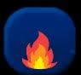
- Click on fire icon on the right – Identify the date of this image on your worksheet.
- Click the “i” icon at the top of your screen. A message appears about fire images. READ THIS MESSAGE.

- Rotate your Merge Cube and look for fire “dots”. Look at the same continent whose image you printed with grasslands using NASA’s LAS. (Note: if you don’t have the continents identified on your image, click on the “globe” image at the top until it says “Continent”.) As you compare the LAS grassland data to the number of fires data, look for patterns and identify factors that could influence these patterns. Remember, your LAS data is a few years behind your HoloGLOBE data.

Day 3 Activity 1 NASA Satellite (fire) Questions:

- What LAS continent and year did you select? Continent: ________________________ Year: _____________

- Using the HoloGLOBE, when do naturally occurring fires usually happen?
_____________________________________________________________________________________________________________

- What typically causes naturally occurring fires?

_______________________________________________________________________________________________________________

- What is the fire scale that you see on your HoloGLOBE image? ____________________________________

- How do the data compare/contrast?
_____________________________________________________________________________________________________________
_____________________________________________________________________________________________________________

