On-Line Data Analysis Activity

Purpose: Students will look at different forms of data representation using the MyNASAData Earth Systems Data Explorer. Students will determine the best vehicle to use to visually represent sea surface temperatures off the coast of California.

Anticipator Set: Discuss with students the type of data they have collected for their research project. Through this discussion, include the number and types of data sets collected. Ask students how they might represent data (in general) to an audience about their research.

Background: Data analysis is defined as a process of cleaning, transforming, and modeling data to discover useful information for decision-making. The purpose of Data Analysis is to extract useful scientific information from data and make a conclusion based upon the data analysis. Compare – to identify what is similar between two or things; contrast – what is different between two or more things.

Materials:
- Satellite images from April 2019, July 2019, October 2019 and January 2019 of surface sea level temperatures off the California coast
- Data Graphs based on satellite images from April 2019, July 2019, October 2019 and January 2019 of surface sea level temperatures off the California coast
- Data table of surface sea level temperatures of sea surface temperatures outside of San Francisco April 2019, July 2019, October 2019 and January 2019
- Data graph of surface sea level temperatures off the California coast April 2019, July 2019, October 2019 and January 2019

Instruction Part I:
- Show students satellite images. Have them write down or discuss what they see in the image. Have them list at least 3 pieces of information that the image is providing (color for temperature, latitude, x and y axis, date of data etc…)
- Show students graph images from satellites. Have them write down or discuss what they see in the image. Have them list at least 3 pieces of information that the image is providing. What is different about the satellite images from the graph images? (no color, line graphs, no coast line images, etc….)
- Show students surface sea temperature data table and associated graph for an area right outside of San Francisco. Compare and contrast all 3 forms of data visualization. Create a table that compares and contrasts all forms of data visualization.

Instruction Part II:
- Putting it all together. Students will re-analysis the data they have collected for their research question. What information is the MOST important to convey about their research?
- Students will determine the best form of visualization for their data, including the type of chart that best represents the information they want to convey.
- Students will create their data visualization.

Conclusion:
- Student teams will share their visualization with other student teams.
  - What is the research question?
  - What data was collected?
  - What question does the data answer?
  - What visual is the best to convey the data conclusion?

Next Steps:
- Prepare data results/data analysis/conclusion for research project.

Sea Surface Temperature Satellite Images April 2019 – January 2020

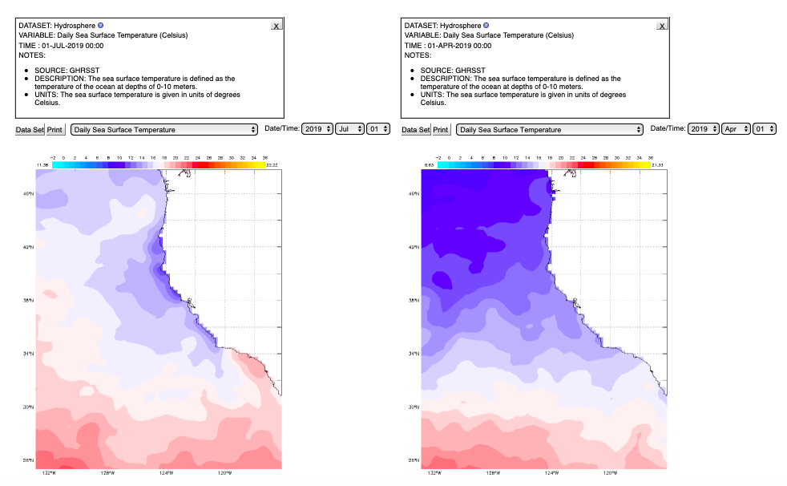

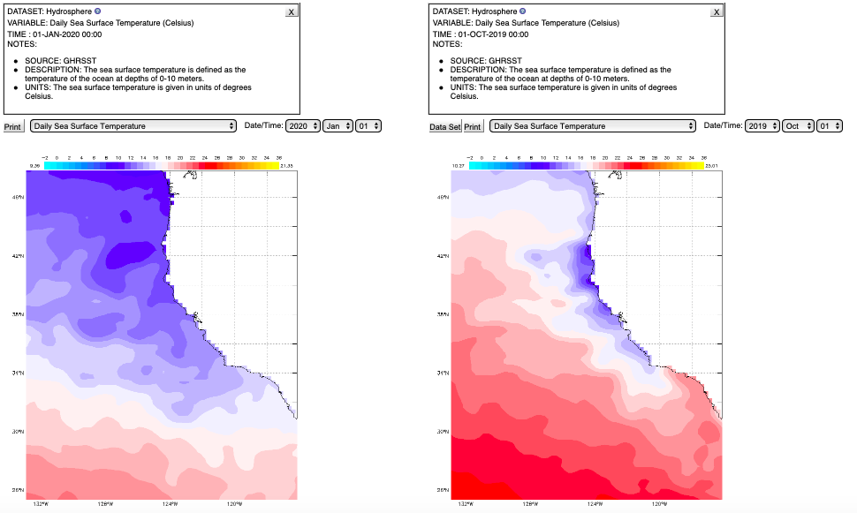

Sea Surface Temperature Data Graphs April 2019 to January 2020

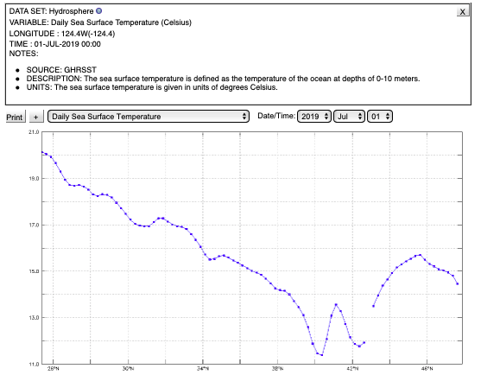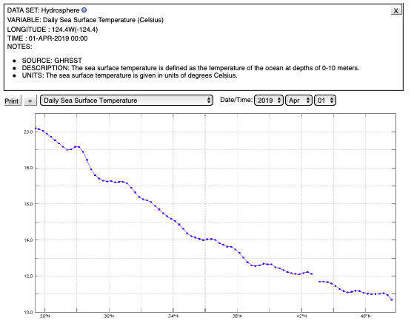
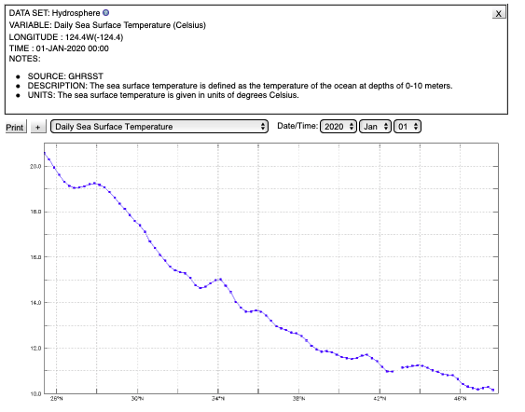
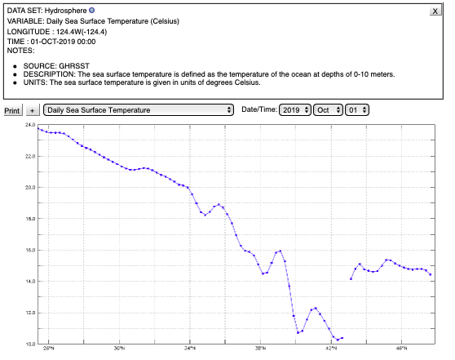

Sea Surface Temperature Data Table

DATE | Temperature Degrees C
01-Apr-2019 | 10.94
02-Apr-2019 | 9.54
03-Apr-2019 | 10.49
04-Apr-2019 | 10.95
05-Apr-2019 | 10.83
06-Apr-2019 | 11.49
07-Apr-2019 | 11.22
08-Apr-2019 | 10.69
09-Apr-2019 | 10.55
10-Apr-2019 | 10.51
11-Apr-2019 | 10.54
12-Apr-2019 | 10.55
13-Apr-2019 | 10.56
14-Apr-2019 | 10.68
15-Apr-2019 | 10.8
16-Apr-2019 | 10.81
17-Apr-2019 | 10.35
18-Apr-2019 | 11.26
19-Apr-2019 | 10.89
20-Apr-2019 | 11.08
21-Apr-2019 | 11.11
22-Apr-2019 | 10.44
23-Apr-2019 | 10.41
24-Apr-2019 | 10.73
25-Apr-2019 | 10.7
26-Apr-2019 | 10.91
27-Apr-2019 | 10.92
28-Apr-2019 | 10.94
29-Apr-2019 | 11.19
30-Apr-2019 | 11.13
01-Jul-2019 | 15.91
02-Jul-2019 | 16.38
03-Jul-2019 | 16.4
04-Jul-2019 | 16.38
05-Jul-2019 | 16.04
06-Jul-2019 | 15.84
07-Jul-2019 | 15.81
08-Jul-2019 | 15.78
09-Jul-2019 | 15.61
10-Jul-2019 | 15.38
11-Jul-2019 | 16.54
12-Jul-2019 | 16.79
13-Jul-2019 | 16.94
14-Jul-2019 | 17.28
15-Jul-2019 | 17.05
16-Jul-2019 | 16.95
17-Jul-2019 | 17.24
18-Jul-2019 | 17.51
19-Jul-2019 | 17.39
20-Jul-2019 | 17.18
21-Jul-2019 | 17.36
22-Jul-2019 | 17.72
23-Jul-2019 | 18.14
24-Jul-2019 | 18.39
25-Jul-2019 | 18.46
26-Jul-2019 | 18.64
27-Jul-2019 | 18.89
28-Jul-2019 | 18.93
29-Jul-2019 | 18.35
30-Jul-2019 | 18.13
31-Jul-2019 | 18.14
01-Oct-2019 | 17.42
02-Oct-2019 | 16.99
03-Oct-2019 | 16.69
04-Oct-2019 | 16.76
05-Oct-2019 | 16.9
06-Oct-2019 | 16.9
07-Oct-2019 | 16.87
08-Oct-2019 | 16.78
09-Oct-2019 | 16.78
10-Oct-2019 | 16.46
11-Oct-2019 | 16.74
12-Oct-2019 | 16.51
13-Oct-2019 | 16.52
14-Oct-2019 | 16.52
15-Oct-2019 | 16.42
16-Oct-2019 | 15.98
17-Oct-2019 | 16.3
18-Oct-2019 | 16.96
19-Oct-2019 | 16.45
20-Oct-2019 | 16.11
21-Oct-2019 | 16.37
22-Oct-2019 | 16.69
23-Oct-2019 | 16.85
24-Oct-2019 | 16.55
25-Oct-2019 | 15.53
26-Oct-2019 | 15.77
27-Oct-2019 | 15.73
28-Oct-2019 | 15.57
29-Oct-2019 | 15.45
30-Oct-2019 | 15.28
31-Oct-2019 | 15.17
01-Jan-2020 | 11.85
02-Jan-2020 | 12.02
03-Jan-2020 | 11.92
04-Jan-2020 | 11.57
05-Jan-2020 | 11.59
06-Jan-2020 | 11.55
07-Jan-2020 | 11.64
08-Jan-2020 | 11.81
09-Jan-2020 | 11.82
10-Jan-2020 | 11.76
11-Jan-2020 | 11.5
12-Jan-2020 | 11.24
13-Jan-2020 | 11.21
14-Jan-2020 | 11.46
15-Jan-2020 | 11.22
16-Jan-2020 | 10.85
17-Jan-2020 | 10.93
18-Jan-2020 | 11
19-Jan-2020 | 10.39
20-Jan-2020 | 10.66
21-Jan-2020 | 10.77
22-Jan-2020 | 10.78
23-Jan-2020 | 10.85
24-Jan-2020 | 10.89
25-Jan-2020 | 10.76
26-Jan-2020 | 10.88
27-Jan-2020 | 9.97
28-Jan-2020 | 10.69
29-Jan-2020 | 10.68
30-Jan-2020 | 10.65
31-Jan-2020 | 10.71

