Earth Science Systems Walk In the Forest
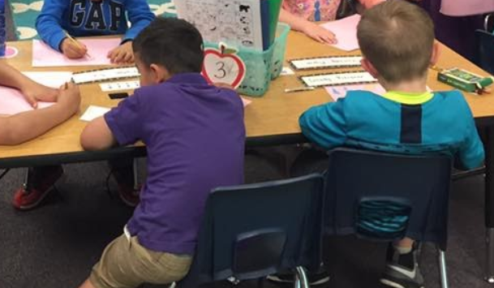
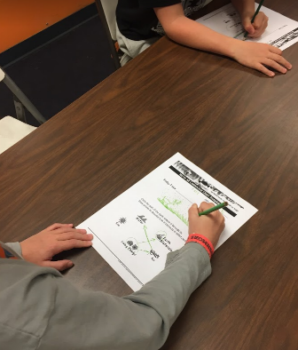
I presented the Elementary GLOBE Earth Science Systems program “We Are All Connected” to the classrooms that I visited during the school year. (I visit approximately 750-1000 youth a month during the school year)

In this activity, youth continue to explore the idea of interaction among Earth components as they identify processes in the Earth system and indicate how they illustrate an interaction between two of the Earth system components.
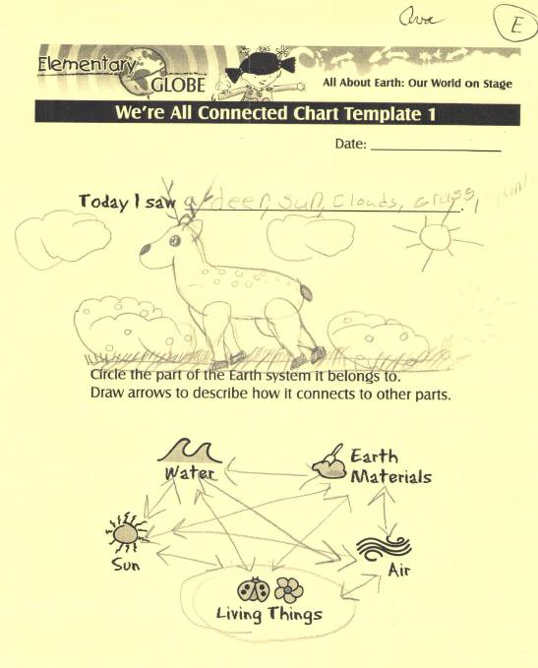
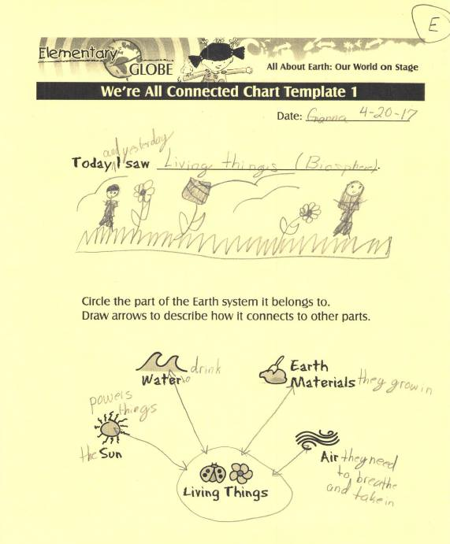
Below are a few pages of the activity that the youth completed.

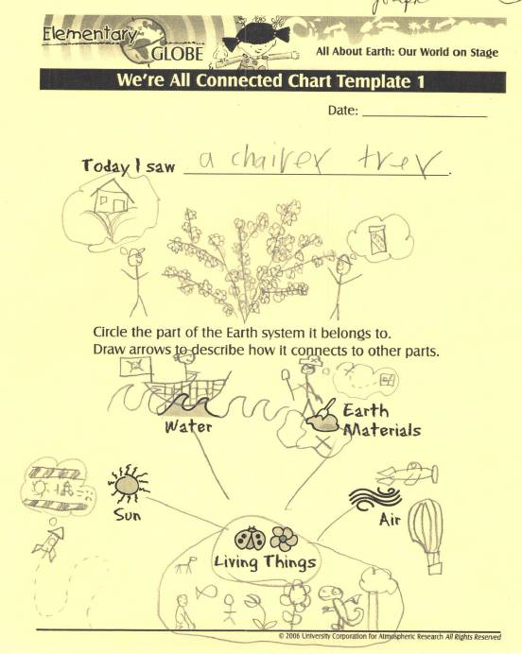

These two Walk In the Forest field trips were held in the fall of 2016 and spring of 2017 at Sawyer Park near Deadwood and Skyline Wilderness Area in Rapid City, SD as a follow-up to the classroom activity.
The youth were bussed into these areas, brought their lunch and water, and spent the day learning about the Biosphere, Geosphere, Hydrosphere and Atmosphere.
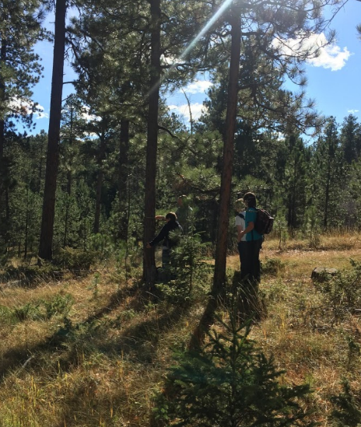
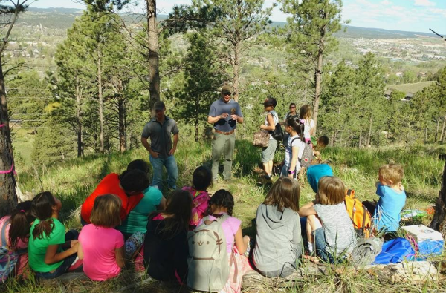

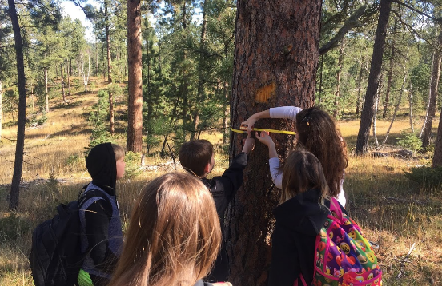

These field trips were provided in cooperation with SDSU Extension Pennington County 4-H, South Dakota Project Learning Tree, South Dakota Family Foresters, and the Black Hill National Forest.
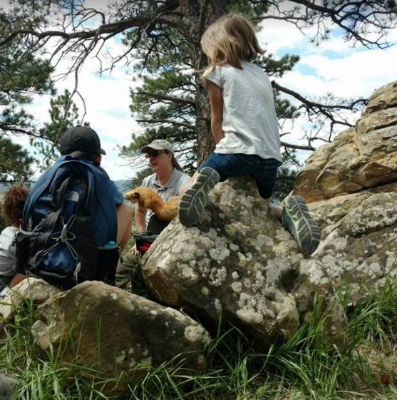
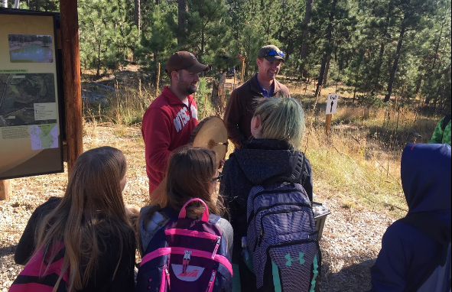

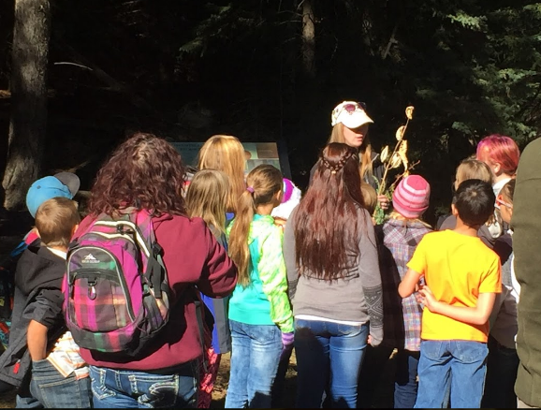

In the fall of 2016 approximately 110 youth participated in the event with their teachers and adult helpers. In the spring of 2017 approximately 120 youth attended the event with their teachers and parent helpers.
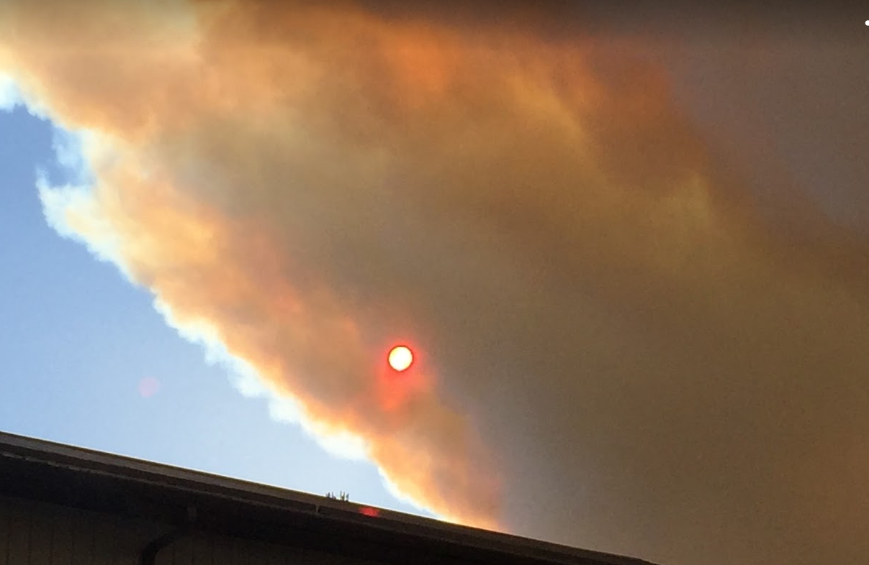
Aerosols

In this activity the youth worked in groups to make an aerosol sampler, a simple adhesive tool that allows students to collect data and estimate the extent of aerosols present at their club. The purpose of the activity is to introduce youth to aerosols and help them understand that there are small particulates in the atmosphere; to engage them in collecting, analyzing, interpreting data, and making predictions; and to introduce them to the concept of random sampling.
It just happened that there was a prescribed burn going on just west of the town the day we took samples. (see picture above) It gave us a great chance to see aerosols in the atmosphere.

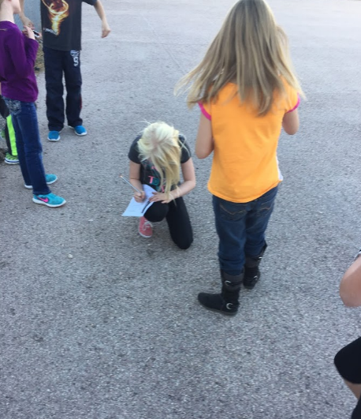
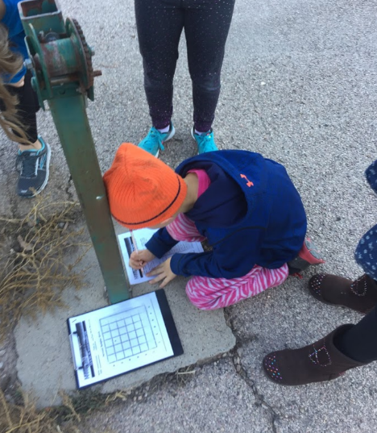

Water Wonders
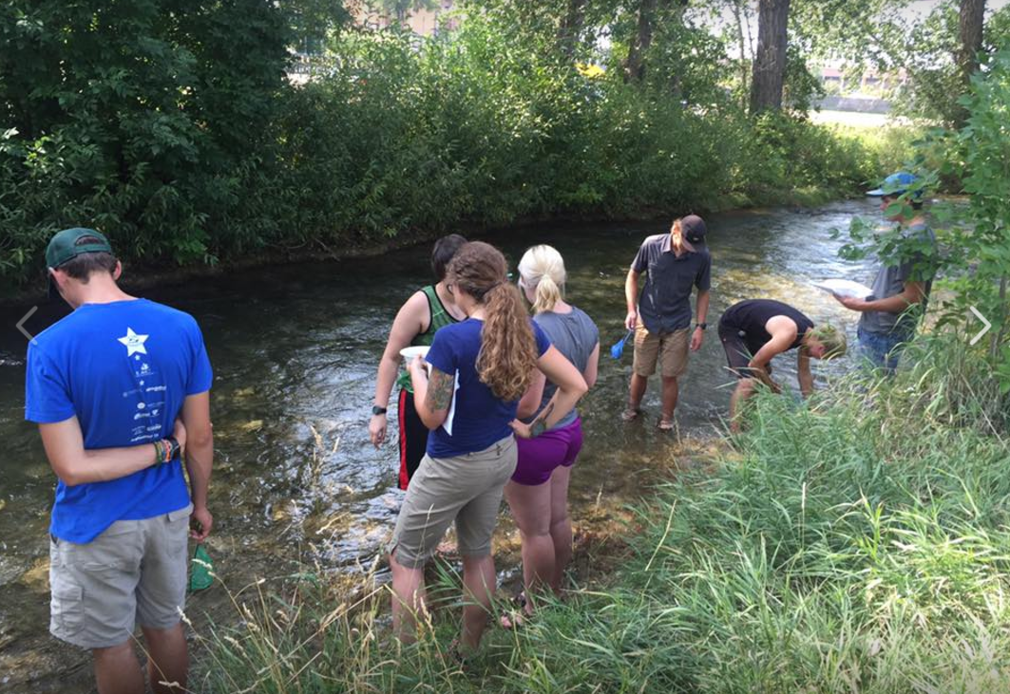

Youth were introduced to different species of macroinvertebrates. They hypothesized why each insect looks the way it does. Then they made observations of macroinvertebrates at Rapid Creek and conducted field observations. They used the dichotomous key to identify the macroinvertebrates they found.
For the younger youth, I used 3 totes of water that I set up with different items to represent different macroinvertebrates and they ‘collected’ their items and determined the quality of the water by counting the types of items they collected from the different totes. They were shown a simplified ID pamphlet showing some of the more common macroinvertebrates found in Rapid Creek. I also showed them my collection of macroinvertebrates that I have.
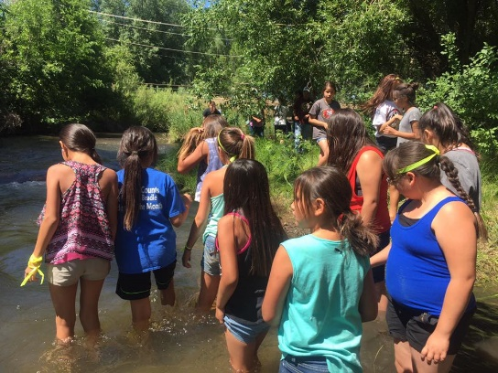
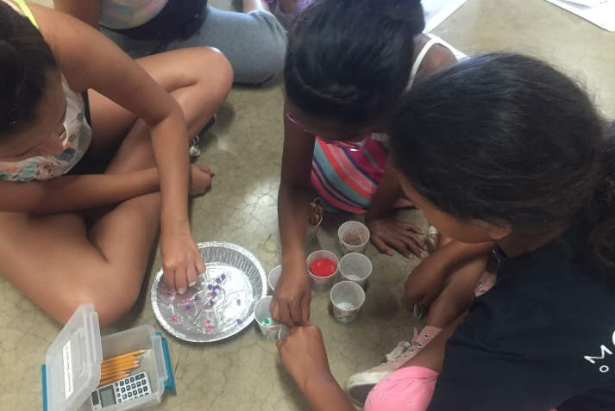

Soils

Getting to Know Soil
During one of my classes, each student made predictions about the properties of various soil samples. I had sand, silt and clay soil samples for them to investigate, (what they see, smell and feel) and recorded their observations on their data sheet. Next, they examined horizons by doing the soil shake activity with them and recorded what they saw at 2 minutes and 10 minutes. We did not record at 24 hours as this is just a once a month class. They then created a soil profile flip chart. I gathered some soil from the garden and had the youth examine the soil for organic matter and ‘critters’ that they may find and record what they saw. There were pill bugs, earthworms, centipedes, earwigs, millipedes, grubs, and other ‘critters’ that I could not identify.
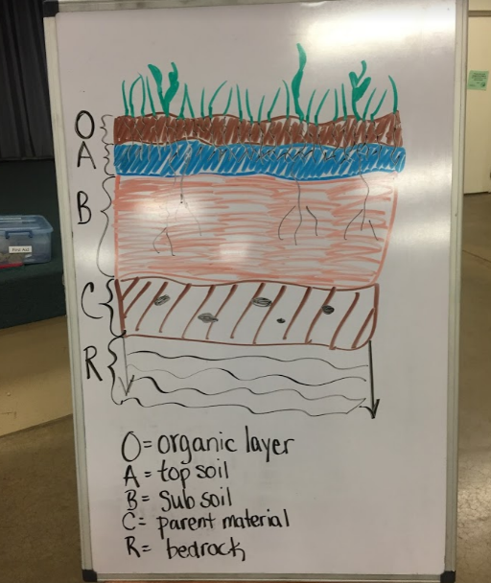
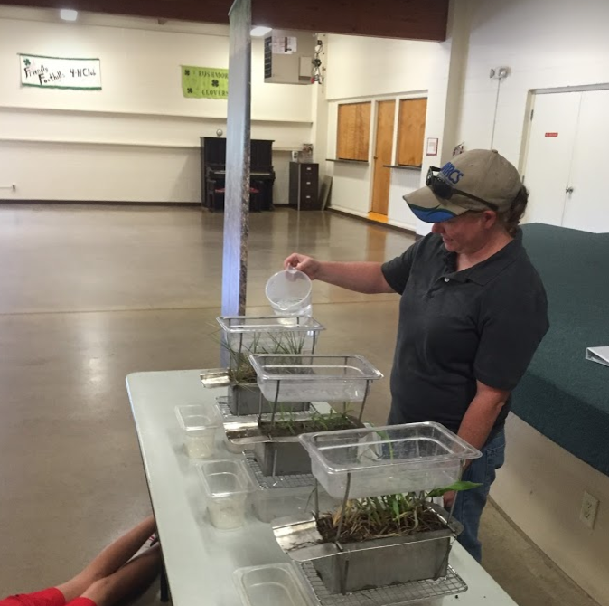

During another class I took a group of Jr Leaders out for the soil temperature protocol data collection during one of their meetings. There are 5 locations behind my building that are official GLOBE sites that I set up, and we sampled 3 of them. I recorded the data that was collected onto the GLOBE website. (I did not get any pictures though.)
The National Resources Conservation Service presented a soil cover demonstration during one of my classes that showed how different soil cover affects soil runoff and water quality of the runoff (picture above).
I’ve enjoyed using the GLOBE curriculum in my classes and will continue to do so in the future!

Jane Amiotte

