The Mosquito Protocol Bundle

I. Summary

According to the World Health Organization, more than 50% of the world’s population is at risk of contracting a mosquito-borne disease. Mosquitoes infect hundreds of millions of people with diseases such as yellow fever, malaria and dengue, and kill more than a million people each year.
By making observations and recording data using the GLOBE Observer Mosquito Habitat Mapper App, you can report information about the mosquitoes that you find locally and contribute to reducing the risk of disease outbreaks in your community.

In temperate regions, climate change and warming temperatures have accelerated invasive mosquito migration to higher elevations and latitudes. Mosquitoes need warm temperatures, (a minimum of 6-16° C and a source of standing water to grow and develop. Because of these requirements, mosquito populations are acutely sensitive to changes in environmental conditions. To understand how mosquito populations respond to short and long-term changes in habitat, there are many first-order scientific questions that need to be explored, such as:

- What are the preferred habitats of specific mosquito species?
- What lag time is exhibited after an extreme weather event before mosquito populations increase or decrease?
- How hot does it have to be before mosquito populations decline?
- Does humidity play a role in mosquito population dynamics?
- What relationship is exhibited between land cover, land use, and mosquito breeding sites?
- What impacts do floods, droughts, and high or low-temperature anomalies have on mosquito populations?

The GLOBE Mosquito Bundle identifies useful GLOBE Protocols and datasets that can be explored in conjunction with Mosquito Habitat Mapper data to answer science questions that have relevance to public health as well as expanding our understanding of mosquito biology and ecology.

II. List of the GLOBE Protocols and GLOBE Observer data included in this bundle
Atmosphere Protocols
- Air temperature
- Precipitation
- Precipitation pH
- Relative humidity

Biosphere Protocols
- Green Up, Green Down
- Land Cover Classification
- Biometry- Canopy cover and Ground cover

Hydrology Protocols
- Water temperature
- Water pH
- Turbidity
- Salinity
- Dissolved oxygen

Pedosphere Protocols
- Soil moisture

GLOBE Observer
- Mosquito Habitat Mapper
- Land Cover
- Trees
III. Science Background
Mosquito vectors are considered to be among the deadliest animals in the world. It is estimated that millions of people succumb to disease transmitted to humans by mosquitoes (WHO 2020).
Changes in both human activity and climate play significant roles in the increase of vector-borne disease worldwide. Human migration, travel, and commerce have enabled mosquito vector species previously isolated geographically to expand globally. Both rapid urbanization and changes in land use practices have played a role in increased vector borne disease risk, bringing mosquito vector species into close contact with human populations. For example, unreliable piped water and inadequate sewage management create opportunistic breeding habitats in urbanized areas, and destruction of native forest habitats through land clearance for agriculture, forestry, and mining bring mosquito vectors into new landscapes and in direct contact with human populations.
Changing climates have enabled invasive mosquito species previously confined to the tropics and subtropics to advance poleward and establish mosquito populations that have the potential to transmit pathogens that can cause disease. Changes in precipitation regimes- both increased frequency of heavy rainfall, and counterintuitively, drought events, can promote the creation of opportunistic still water habitats for breeding mosquitoes. Increased temperatures have enabled species to expand their ranges into areas where seasonal freezing and cold temperatures previously limited their viability. Rising temperatures are also implicated in improved mosquito survival, susceptibility to pathogens, increased biting behavior in females, decreased maturation time, and more generations per season. Accelerated rates of pathogen development and transmission culminate in an increased risk of mosquito-borne disease.

There are still many fundamental questions about mosquito biology and ecology that need to be answered. Examining the relationship between environmental data and mosquito data will fill critical gaps in scientific understanding of disease transmission dynamics. For example, because mosquitoes are cold-blooded organisms that spend part of their life cycle as an aquatic organism, it is expected that some relationship will emerge when examining mosquito data in conjunction with temperature and precipitation data. Scientists have investigated a wide variety of environmental variables, and some have shown to be important factors in determining when and where mosquito habitats are found.

Variations in humidity can impact vector populations. In an experimental analysis, a decrease in humidity (from 80 to 60%) reduced egg numbers and changed oviposition patterns (Costa et al. 2010). Surface wetness, modeled from soil moisture, topographic and vegetation data has been used to predict the abundance of flood and swamp water mosquitoes (Shaman et al. 2002). In a study targeting mosquito species responsible for transmitting malaria pathogens in Kenya, models that include soil moisture as a parameter improved prediction of biting rates compared to rainfall alone and was broadly more predictive than raw precipitation data. Moisture lags of two weeks explained up to 45% of Anopheles gambiae biting variability, compared to 8% for raw precipitation (Patz 2002).

In sub-Saharan West Africa, scientists have been investigating how malaria vectors survive during the intensely hot and dry months. While some species are able to persist in a semi-dormant state (aestivation) during the dry season, research by North and Godfray (2018) modeled the persistence of mosquito vectors of malaria in Burkina Faso, and determined that neither aestivation nor local dispersion from nearby (ca. 30 km) regions with year-round moisture could explain the dramatic surge in mosquito populations observed in sub-Saharan West Africa during the rainy season. Their model suggests that long distance migration (over hundreds of kilometers) best explains the observed population dynamics. Insect trapping experiments from the Sahel in Mali have demonstrated that mosquitoes can travel as high as 290 meters above the ground for as far as 300 km in a single nighttime 9-hour flight (Huestis et al. 2019). The authors propose that seasonal high-altitude southerly winds could carry mosquito vectors to the Sahel from wetter, year-round habitats in the south, and return them when the winds blow in the opposite direction in the dry season. The model by Huestis et al. (2019) suggests that massive migrations of more than 50 million mosquitoes take place every year in this region, and may resolve the region’s “dry-season paradox.” (Dao et al. 2014).

Sallam et al. (2017) conducted a systematic meta-analysis of research studies that examined the land cover, meteorological, and socioeconomic factors that potentially explain when and where Aedes mosquitos were found. The authors compiled the outcomes from 21 published research studies that employed a variety of different methodologies, models, and variables.
In their review, they identified the most common parameters examined by different scientist teams exploring factors determining the spatio-temporal distribution of Aedes mosquito habitats, as well as the most common modeling software employed:

Species Distribution Models  (SDMs) | Meteorological Variables | Land Cover/Land Use Variables | Socioeconomic  Determinants
Random Forest | annual precipitation | land cover | human population density
Max Ent | mean annual daytime temperature | canopy cover | housing density
Artificial Neural Network | nighttime temperature | vegetation type | housing age
Genetic Algorithm for Rule set Production | drought index | residential settings | median family income
Boosted Regression Tree | relative humidity | urban heat island | poverty index
Support Vector Machines | evapotranspiration | impervious surface | human case data
 | soil moisture | topography
Table 1. Species Distribution Models, meteorological variables, land cover and land use variables, and socioeconomic determinants identified in the systematic literature review by Sallam et al. (2017).

The review noted that there was no single factor that could explain variation in the spatiotemporal distribution of Aedes. The authors concluded by emphasizing the need for more studies, “to improve our knowledge about Aedes presence/abundance within their flight range in response to the interaction between environmental, socioeconomic and meteorological systems,” (Sallam et al. 2017).
Examination of both GLOBE Protocol data and environmental satellite data in conjunction with Mosquito Habitat Mapper data will contribute to better understanding of the importance and roles played by different environmental variables. In future research, examining these parameters in conjunction with demographic and epidemiological data in a multi-system modeling approach will generate risk models that can be utilized to predict disease outbreaks and inform mosquito control practices.
IV. Experimental Questions that can be addressed using the Mosquito Habitat Mapper App.
In addition to examining the relationship between environmental conditions and mosquito populations, there are also opportunities for students to conduct field experiments to illuminate egg-laying behaviors of different mosquito vectors. Note the Mosquito Habitat Mapper has a comments box on the last frame of the mobile tool (labeled eliminate breeding habitat).This comments box is there for your use: you can fill out this box to keep track of specific habitat variables that you are examining, or to identify features of containers that are not listed in the choices in the app, such as dark vs. light colored containers, or inside vs. outside, shade/no shade, etc. These data will be uploaded to the GLOBE database and you can access all observations that you input into the comments box.
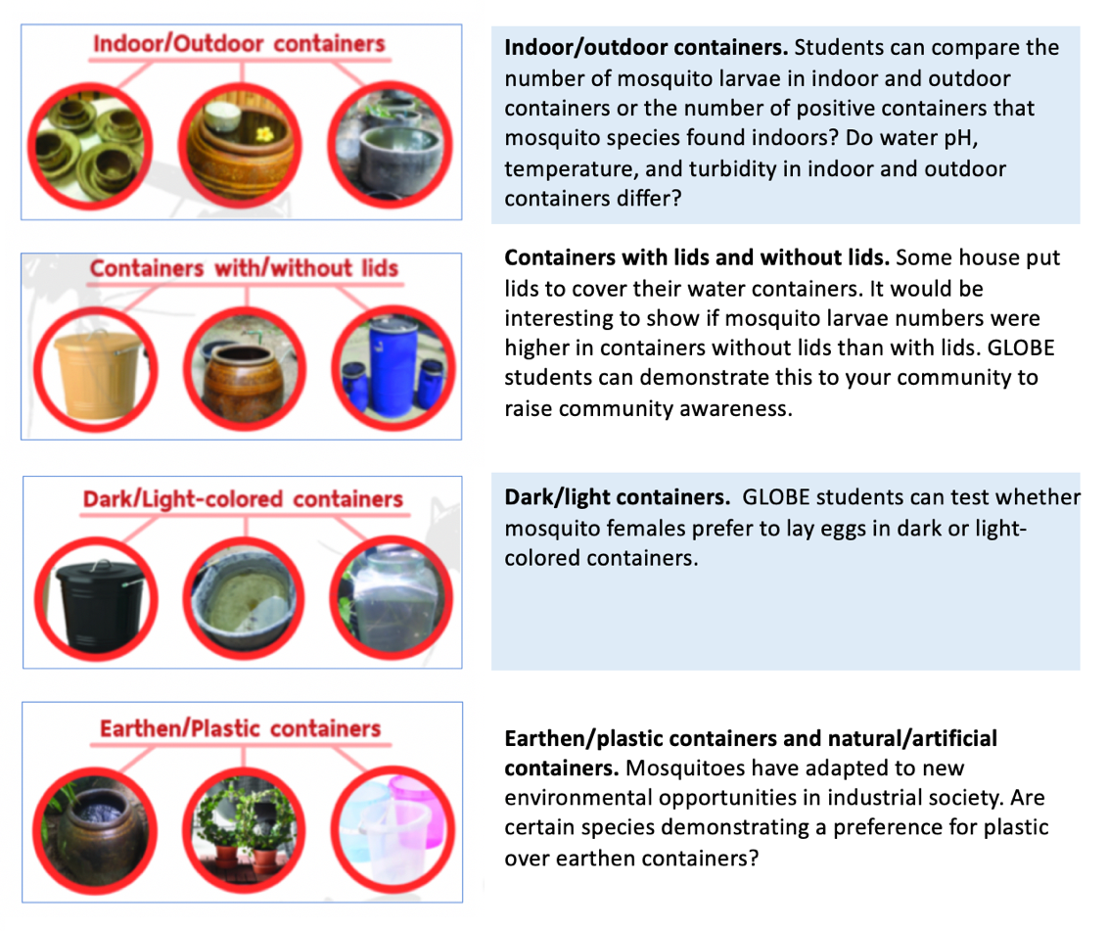

V. Example Case Study

Case study I: The effect of ENSO on dengue cases in Muang Nakhon Si Thammarat by Princess Chulabhorn Science High School Thammarat, Thailand.

Research Questions: How do the El Niño and La Niña events influence dengue cases in Muang district, Nakhon Si Thammarat, southern Thailand?

Introduction
Dengue cases in Muang Nakhon Si Thammarat in the wet season were higher than in the dry season (Figure 1) (Noradin et al., GLOBE IVSS 2016).
Figure 1. Monthly dengue cases in wet and dry seasons at Muang Nakhon Si Thammarat, Thailand for January 2011-January 2016 (Noradin et al., 2016).

Data Collection
Dengue cases in January 2011-December 2017 were obtained from the Vector-Borne Disease Control Centre laboratory 11. Nakhon Si Thammarat atmospheric data were collected from Meteorological Department of Thailand during January 1987-December 2017. Nakhon Si Thammarat atmospheric data were collected from the automatic weather station located at Princess Chulabhorn College Nakhon Si Thammarat during January 2017-December 2017.

El Niño-La Niña data were obtained from the National Weather Service Climate Prediction Center during 1987-2017. We collected daily rainfall, rainy days, relative humidity, mean/min/max temperature and El Niño -La Niña data. We separated dengue cases from January 2011- December 2017 into year of El Nino-La Nina and normal year. Sea Surface Temperature (SST) data during January 1987 to December 2017 were obtained from http://www.cpc.ncep.noaa.gov/data/indices/sstoi .indices. We collected SST data using data from Nino 3.4 index. This information indicates the state and severity of SST at each time period and indicate the starting point of El Niño and La Niña events (Xue et al., 2003).

Data analysis
House index was calculated as the number of positive households divided by the total number of households inspected. Household locations with the number of mosquito larvae were visualised as the point overlaid on Google Earth. Descriptive statistics were calculated. Independent sampled t-tests were used to test the mean differences of dengue cases and climatic factors are influenced by El Niño-La Niña events. Pearson correlations were used to test the association between dengue cases and climatic factors. The significant tests were one-tailed with significant level at P<0.05.

Results

Number of Dengue cases and local Temperature Index
The ENSO indices used in this study were the Nino 3.4 during 1987–2017. ENSO events were defined as periods at or above the +0.5°C SST anomaly for warm (El Niño) events and at or below the -0.5°C anomaly for cold (La Niña) events. Our results showed that La Niña events were observed in 2011–2012, normal events were observed in 2013–2014, and El Niño events were observed in 2015–2016 (Figure 2).
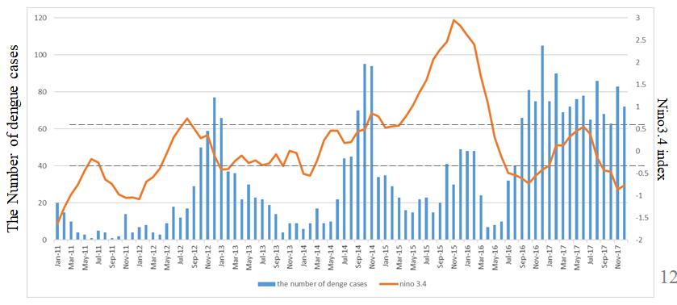
Figure 2. Dengue cases in Muang Nakhon Si Thammarat (blue bars represent monthly dengue cases) and ENSO indices (orange line represents Nino 3.4 Index).

The number of dengue cases seems to be increasing after El Niño events (Figure 3).

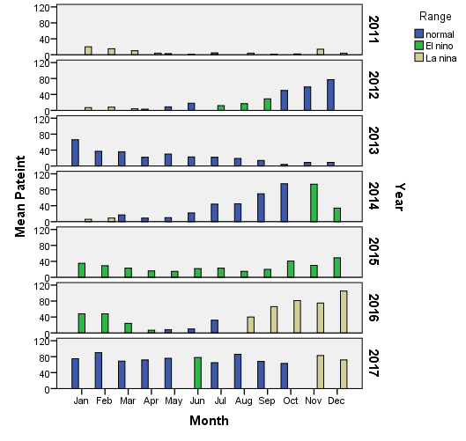
Figure 3. Dengue incidences in El Niño (green bars), Normal (blue bars) and La Niña (yellow bars) events.
The ENSO index and Relative Humidity in El Niño times.
Relative humidity (%) was positively correlated with Nino3.4 in the Muang district, Nakhon Si Thammarat province during El Niño events. Climate factors were not significantly correlated with Nino 3.4 in La Niña events (Table 1).

Table 1 Spearman Correlation coefficient of Nino 3.4 and El Niño’s climatic factors (N=32)

 | Rainfall (mm) | Rainy days (days) | Mean Temperature (°C) | Relative Humidity (%)
El Niño event
Spearman Correlation | 0.146 | 0.329 | -0.221 | 0.550
Sig (1-tailed) | 0.258 | 0.067 | 0.161 | 0.004
La Niña event
Spearman Correlation | 0.190 | -0.289 | 0.365 | -0.303
Sig (1-tailed) | 0.211 | 0.108 | 0.057 | 0.097

Climatic factors and dengue cases during El Niño events
Rainfall, rainy days, mean temperature and relative humidity were positively correlated with dengue cases in Muang district, Nakhon Si Thammarat in El Niño and La Niña events. The number of rainy days was the only factor that positively correlated with dengue cases. Other climatic factors were not significantly correlated with dengue cases (Table 2).

Table 2 Spearman Correlation coefficient of dengue cases and El Niño’s climatic factors (N=32)

 | Rainfall (mm) | Rainy days (days) | Mean Temperature (°C) | Relative Humidity (%)
El Niño event
Spearman Correlation | 0.454 | 0.458 | -0.647 | 0.581
Sig (1-tailed) | 0.017 | 0.016 | 0.002 | 0.002
La Niña event
Spearman Correlation | 0.294 | -0.409 | -0.037 | -0.067
Sig (1-tailed) | 0.104 | 0.037 | 0.439 | 0.389

Table 3: Number of households, positive households, house index and dengue cases during El Niño - El Niño events.
 | Aedes Larvae
 | Mar-2016 (El Niño event) | Jan-2018 (La Niña event)
No. of households | 32 | 32
No. of positive households | 25 | 23
House Index (HI) (%) | 78.13 | 72.88

House index at Muang Nakhon Si Thammarat and El Niño - La Niña events.
From the GLOBE mosquito larvae collection in March 2016 (El Niño event) and February 2018 (La Niña event), house indices (HI) for Ae. aegypti and Ae. albopictus were extremely high (Table 3). Nakhon Si Thammarat province had the HI >5% during El Niño events in March 2016 (HI 78.13%) and La Niña events in January 2018 (HI 72.88%) indicates that Nakhon Si Thammarat is a dengue high risk area.

VI. Conclusion

Climate change poses a great threat to human health in the 21st century. Vector-borne diseases, mediated by cold-blooded organisms, are expected to be the “most climate-sensitive subset of all infectious diseases,” because of their sensitivity to a wide variety of climate parameters (Caminade et al. 2019). Documenting changes in the Earth system, in conjunction with the distribution and prevalence of mosquito vectors, is critical to decreasing disease risk and improving human health worldwide. Using the GLOBE Observer Mosquito Habitat Mapper app will help us to gain a better understanding on the location and numbers of mosquitoes present at a variety of spatial scales, from community-scale to worldwide.
References Cited
Caminade, C., McIntyre, K. M., & Jones, A. E. (2019). Impact of recent and future climate change on vector-borne diseases. Annals of the New York Academy of Sciences, 1436(1), 157–173. https://doi.org/10.1111/nyas.13950.
Costa, E., Santos, E., Correia, J. and de Albuquerque, C. (2010). Impact of small variations in temperature and humidity on the reproductive activity and survival of Aedes aegypti (Diptera, Culicidae). Revista Brasileira de Entomologia, 54(3), 488-493.
Dao, A., Yaro, A. S., Diallo, M., Timbiné, S., Huestis, D. L., Kassogué, Y., Traoré, A. I., Sanogo, Z. L., Samaké, D., & Lehmann, T. (2014). Signatures of aestivation and migration in Sahelian malaria mosquito populations. Nature, 516 (7531), 387–390. https://doi.org/10.1038/nature13987.

Huestis, D.L., Dao, A., Diallo, M. et al. (2019). Windborne long-distance migration of malaria mosquitoes in the Sahel. Nature 574, 404–408. https://doi.org/10.1038/s41586-019-1622-4.
Hunter, P. R. (2003). Climate change and waterborne and vector-borne disease. Journal of Applied Microbiology, 94, 37S-46S. Retrieved from https://sfamjournals.onlinelibrary.wiley.com/doi/pdf/10.1046/j.1365-2672.94.s1.5.x.
Patz, J., Strzepek, K., Lele, S. Hedden, M., Greene, S. Noden, B., Hay, S. Kalkstein, L. and Beier, J. (2002). Predicting key malaria transmission factors, biting and entomological inoculation rates, using modelled soil moisture in Kenya. Tropical Medicine and International Health, 3(10), 818-827. https://doi.org/10.1046/j.1365-3156.1998.00309.x.
Sallam, M., Fizer, C., Pilant, A. and Whung, P. (2017). Systematic review: Land cover, meteorological and socioeconomic determinants of Aedes mosquito habitat for risk mapping. International Journal of Environmental Research and Public Health, 14:1230. https://doi.org/10.3390/ijerph141230.
Shaman, J., Stieglitz, M., Stark, C. Blancq, S., and Cane, M. (2002). Using a dynamic hydrology model to predict mosquito abundances in flood and swamp water. Emerging Infectious Diseases, 8(1), 8-13. Retrieved from https://www.ncbi.nlm.nih.gov/pmc/articles/PMC2730265/.
WHO (2020) Mosquito-borne Diseases. Retrieved from https://www.who.int/neglected_diseases/vector_ecology/mosquito-borne-diseases/en/.
Acknowledgements
Authors, Dr. Mullica Jaroensutasinee and Dr. K. Jaroensutasinee, GLOBE Science Working Group and students of Princess Chulabhorn Science High School Thammarat, Thailand who submitted the IVSS project used in the case study.

Updates 4_09_20: Scientific background section, Dr. Russanne Low, GLOBE Observer Mosquito Habitat Mapper Science Lead

