Rivers and Lakes bundlE protocol
I. Introduction
Freshwater is essential for our planet. It is vital for people and other living things around us. Freshwater environments include rivers, lakes, wetlands, streams and underground aquifers. They store and clean the water that's crucial for people and wildlife. Rivers and lakes in particular due to their greater water supply potential and easy access to human exploitation are facing greatest threat.
Rivers and lakes supply water for drinking, irrigation, manufacturing, energy and transport. They also help to prevent erosion, provide natural protection from flooding, moderate the local climate, and act as sink for the waste we dispose in rivers and lakes.
Water is recognized by the United Nations as a precondition for human existence and for sustainability of the planet, which guide us to undertake the responsibility to effectively manage this resource so as to avoid pollution and scarcity. In the last century, we have lost many of the world’s wetlands and their wildlife. The gravity of the problem is documented in the Living Planet Report of 2016. The report shows a decline of 80 percent in the Freshwater Living Planet Index which is two times the respective decline in oceans and forests.
II. List of the GLOBE Protocols included in the bundle.
Hydrosphere Protocol
Temperature
Transparency
pH
Alkalinity
Electrical Conductivity
Salinity
Dissolved oxygen
Nitrates

Atmosphere Protocol
Air temperature
Relative humidity
Precipitation
Precipitation pH

Biosphere Protocol
Land cover
III. Science background and description of GLOBE protocols
Two thirds of the world's precious wetlands were lost in the last century. The drying of rivers, lakes and wetlands, along with increased pollution, have damaged livelihoods and affected human health. If our freshwater resources are managed wisely, it is highly possible to meet the fresh water needs of people and wildlife. It is our obligation to protect and manage this vital resource around the world and in the local environment in which we live.
Why is an integrated approach needed to study and manage our rivers and lakes?
If we want to manage our freshwater resources, we need to measure the current environmental status of rivers and lakes both in terms of quantity and quality. This will help us identify the factors that influence our fresh water resource management. Therefore, these measurements are critical to support our efforts in managing our freshwater resources.
The role of citizen science is very important to complement this effort. Study of rivers and lakes are predominantly covered under the discipline of hydrology. But rivers and lakes are formed and regulated by complex processes happening in the atmosphere and land activities surrounding them. Hence, a protocol bundle is necessary for the holistic understating of our rivers and lakes. To this end, the purpose of the Rivers and Lakes Protocol Bundle is to group GLOBE protocols that may provide students with the knowledge and ideas of various interactions happening in their local rivers and lakes.
Protocols
A schematic depiction of the River and Lake Bundle protocol is provided in Figure 1. The thematic areas in the four blue circles, the respective GLOBE protocols & their scientific importance are explained in Table 1.

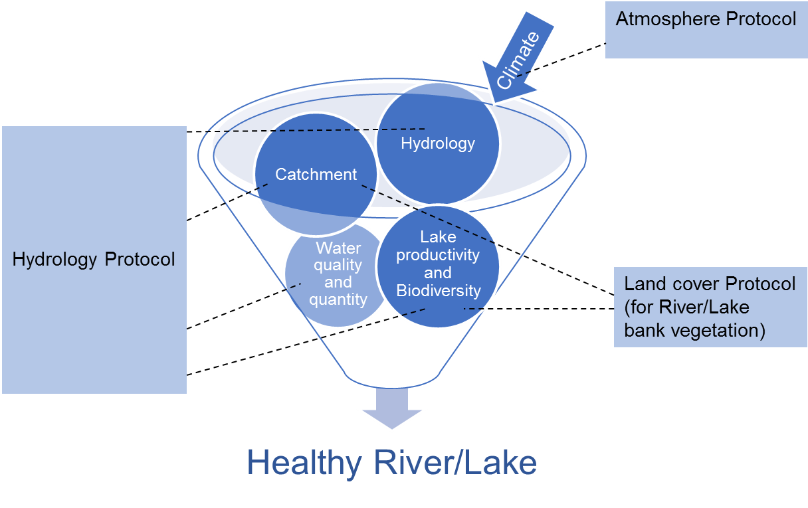

Figure 1.Schematic representation for the Rivers and Lakes Bundle protocol

Table 1. Overview of thematic areas, respective GLOBE protocols, parameters and their scientific significance for studying rivers and lakes.
Areas | GLOBE protocol | Parameters | Significance of parameters/  Scientific importance  (Source: GLOBE Protocols e-training)
a. Water quality and quantity  b. Hydrology  c. Productivity | Hydrosphere  https://www.globe.gov/get-trained/protocol-etraining/etraining-modules/16867649/12273 | Temperature | Temperature influences the amount and diversity of aquatic life. The nutrient-rich bottom deep waters mix with the upper water because of temperature variation. Many fish and other aquatic animals spawn at the time of year when the temperatures rise and food is abundant. However, high water temperatures induced by industrial effluent discharge in to rivers and lakes negatively affect aquatic life.
 |  | Transparency | It reflects the depth to which light can penetrate. Sunlight is necessary for aquatic plants because it provides the energy for photosynthesis. How deeply light penetrates into a water body determines the depth to which aquatic plants can grow.  Transparency is one of the pollution indicators in rivers and lakes, which are highly influenced by human activities.
 |  | pH | pH affects most chemical and biological processes that take place in water. It affects the solubility and biological availability of nutrients. It also determines the solubility of potential toxic substances such as heavy metals.  pH has a strong influence on what can live in water. Aquatic organisms have certain pH ranges they prefer or require. Salamanders, frogs and other amphibian life, as well as many macro invertebrates, are particularly sensitive to extreme pH levels. Most insects, amphibians and fish are absent in water bodies with pH below 4.0 or above 10.0.  Since most organisms are sensitive to changes in water pH, scientists monitor unusual decreases or increases in the pH of water bodies.
 |  | Alkalinity | Alkalinity and pH are properties of water that are related, but different. Alkalinity is the measure of the pH buffering capacity of the water. pH, on the other hand, is the acidity of water.  Alkalinity is expressed as the amount of calcium carbonate (CaCO3) in your water, although other substances can contribute to alkalinity as well.  Alkalinity comes from dissolved rocks, particularly limestone (CaCO3), and soils. It is added to the water naturally as water comes in contact with rocks and soil. Water dissolves the CaCO3, carrying it into streams and lakes. Those water bodies that have high alkalinity are well buffered and resist changes in pH even when acidic substances are added to the water.
 |  | Electrical Conductivity (EC) | Electrical conductivity measures the capacity of water to transmit an electrical current and this capacity is directly related to the concentration of salts in the water.  EC provides a general measurement of water quality. Significant changes in conductivity can be an indication of pollution in a water body. For instance, an oil spill might lower electrical conductivity, and discharged sewage and soil run-off may increase electrical conductivity.
 |  | Salinity | The salinity of a water body increases when evaporation exceeds water input; thus salinity can tell us about hydrology as well as changes in climate. Salinity also plays a role in the ecology of rivers and lakes.  Salinity will also increase due to the discharge of wastewater into water bodies.
 |  | Dissolved Oxygen (DO) | In water, dissolved oxygen is vital for living organisms. Although plants and algae add valuable oxygen to the water, overgrowth can potentially lead to reduced oxygen in the water body. As plants and algae die and decay, bacteria use the dissolved oxygen in the water to decompose the dead materials. The amount of available dissolved oxygen in the water may become very low, harm fish and other aquatic animals, and result in dead zones in a water body.
 |  | Nitrates | Nitrogen is considered as a “limiting nutrient”. When nitrogen is in low amounts, plants use up all the available nitrogen in the water and this limits growth and reproduction. Many plants that use nitrogen are microscopic algae, or phytoplankton.  On the other hand, additional amounts of nitrogen added to the water may allow the plants to grow and reproduce more. Excessive amount of fertilizers, which contain nitrogen used in agriculture, may reach lakes and rivers through run off.  When an excess amount of a limiting nutrient such as nitrogen is added to a lake, stream, or estuary, water becomes highly productive. This may cause tremendous growth of algae and other plants. This process of enriching the water is called eutrophication. The resulting excess plant growth can cause taste and odor problems in lakes used for drinking water or can cause nuisance problems for users of the water body. Water with high concentrations of nitrates is unfit for human consumption.
a. Catchment  b. Productivity | Biosphere  https://www.globe.gov/get-trained/protocol-etraining/etraining-modules/16867717/3099387 | Land cover | Land cover is a general term used to describe what is on the ground covering the land.  Land cover surrounding rivers and lakes has great influence on the water body as well as of the productivity and quality of the system. For example, open land with no vegetation will erode more and thereby increase the sedimentation in a water body. In the long run it will affect the water use for various purposes by people.
a. Climate | Atmosphere  https://www.globe.gov/get-trained/protocol-etraining/etraining-modules/16867642/12267 | Air temperature | Air temperature affects the temperature and evaporation of water bodies. Climate change is rapidly warming lakes around the world, threatening freshwater supplies and ecosystems.
 |  | Relative Humidity (RH) | The amount of water in the atmosphere is one of the determining factors of the weather and climate in an area.  Taking RH measurements helps us understand how quickly water evaporates from Earth’s surface. RH measurements are important in classifying an area as arid (dry), or humid (moist). The amount of RH in the atmosphere influences the formation of clouds and the occurrence of precipitation.
 |  | Precipitation | Knowing how much precipitation falls and where it falls helps us understand weather and climate. It also allows us to estimate the amount of water coming in to rivers and lakes.  The seasonal variation in precipitation will help us understand the amount of water available in rivers and lakes; to this end, knowing precipitation amounts and seasonal patterns is necessary to manage water use judiciously.  The amount of rainfall – fresh water – also greatly influences the physio-chemical properties of the water body and thereby the productivity of rivers and lakes.
 |  | Precipitation pH | Particles and gases in the air dissolve in raindrops and ice crystals and particles get stuck on droplets and crystals. When they fall to the surface as precipitation these chemicals and particles get in water bodies and may change their chemistry. While this process cleans the air, it can pollute surface water.
Note: More parameters relevant to rivers and lakes from any GLOBE protocols, can also be included depending on the scope of the study.

Student Research Questions
If you want to use your measurements in your local rivers and lakes to do research as a GLOBE student, it is helpful to work out research questions before you start measuring and collecting a large amount of data. Examples of research questions are:
1. How does the source of water for your river/lake affect it?
2. Is your river/lake, clean?
3. What kind of plants and animals live in your lake and/ or river?
4. What is the temperature, the pH and dissolved oxygen level of your river and/or lake? Can you recognize indications of pollution?
5. What are the sources of pollution to tour rivers and lakes?
6. How can you contribute to conserve your river or lake, and what could be done about it?
7. Are there any efforts taken by the local community to protect or restore the rivers and lakes in your area? How do these efforts help improve the quality and/or increase the quantity of water?

IV. Summary
The following case study on river Drava in Croatia by primary school GLOBE students is a good example submitted to the GLOBE International Virtual Science Symposium (IVSS). Students used hydrosphere and atmosphere protocols to study changes in river parameters during the winter and summer seasons (they did not study land cover). However, they used the river water level data provided by the National Meteorological and Hydrological Service. The river water level as you know depends on the nature of land cover through which the river flows. Hence this study also studied, in an indirect manner, land cover. In conclusion, the students were able to recognize the relationship between parameters reflecting the domains of hydrosphere, atmosphere and pedosphere (influenced by land cover change) that determine river water quantity and quality. It is worth mentioning that this study is a result of a yearlong collaboration between two GLOBE schools located at two different ends of the river in the same country.
As a GLOBE student, you need to know that your measurements are supportive for monitoring, protecting and restoring rivers and lakes in your locality and they also support global efforts to sustainably manage our freshwater resources.

V. A case study submitted by GLOBE students to IVSS 2017
The Drava River through Miles and Seasons
Students: Nina Gavranović, Sandra Slunjski, Borna Nikolić, Leonora Majstorović, Kristina Puškadija and Lucija Mađarić
Mentors: Lidija Tivanovac and Marina Balažinec
GLOBE Schools: Primary School I. Kukuljevića, Belišće and Primary School II. Varaždin

1. Introduction, research questions and hypotheses
Drava is the longest European river. It enters Croatia at Ormoz, and flows into the Danube near Aljmas. The entire length of the flow is 720 km. Annual average flow rate of Drava is 1- 1.5 m/s, it has a relatively fast flow and high mechanical strength, which erodes the coast. It is fed by glacial water regime which means maximum water draft from May to July, lowest draft of water from December to February. Drava is of great importance for two very distant cities - Varazdin and Belisce. This distance attracted us to do joint project. Drava dictates development, location and climate of the cities, which is why we were very interested in this research.
Research questions:
1. What is the annual mean temperature of the river Drava in Varazdin and Belisce?
2. What are the properties that affect Drava River in the two stations during the year?
3. How river water level affects water temperature and water clarity at these stations?
Hypotheses:
1. Annual mean temperature of the water will be balanced without major deviations on both the station with minimum temperatures in winter and peaking during the summer months.
2. Small differences are expected in water temperature, the greater the difference on the two stations is expected in the transparency of the water.
3. Water level affects the properties of the Drava river. A higher water level of the river causes less transparency and a lower temperature at both stations.
2. Research methods
Water and air temperature and transparency of Drava were measured at specific stations along Drava.
Measurements were conducted according to GLOBE Hydrology protocols. The temperature of water and air (an atmosphere protocol) were measured with alcohol thermometers. The transparency of water was measured with the use of the Secchi disk. Furthermore, the National Meteorological and Hydrological Service provided data for water level.
In order to compare the data, measurements were taken the same days of the week at the same time at both stations.
3. Results and Discussion
The research had a 1-year duration (from 4th October 2014 to 4th October 2015). Measurements were conducted on Saturdays from 13 to 14 hours at stations Varazdin and Belisce.
Chart 1 shows that the transparency of water was much higher at station Varazdin. The measured values ​​were in the range of 10 cm up to 250 cm. The highest values ​​of transparency were measured at the end of December and in January. Transparency was the lowest in October and November.

Chart 1. Temporal variation of the transparency of the Drava river at stations Varazdin and Belisce.
In Chart 2, it is seen that water temperature at both stations match. The temperature maxima were recorded in July and August (Belisce - 27˚C, and Varazdin - 25 ° C). Minimum temperature was recorded in December and February.

Chart 2. Temporal variation of water temperature of the Drava river at stations Varazdin and Belisce.
Chart 3 shows that the annual mean water level at the station Varazdin is uniform while at the station Belisce there are leaps in the winter and summer months. The highest measured values were 412 cm and 250 cm at Belise and Varazdin respectively. The lowest values ​​were 95 cm in Belisce and 76 cm in Varazdin.

Chart 3. Temporal variation of water level of the river Drava at stations Varazdin and Belisce.

Charts 4 and 5 present the temporal variations of water level and transparency in both river measuring stations. It is clearly seen how water level affects the transparency of the water as the higher the water level, the less transparency of water and vice versa.

Chart 4. Graphic view of impact of water levels (Blue line) on transparency (Red line) at the station Varazdin.
Chart 5. Graphic view of impact of water levels (Blue line) on transparency (Red line) at the station Belisce.

Charts 6 and 7 present the temporal variation of water level and water temperature for both measuring stations. An inverse proportionality of the water temperature and water level was observed throughout the year. Practically, when water level increases, water temperature decreases and vice versa.

Chart 6. The dynamics of the water level (red line) and water temperature (blue line) at the station Varazdin

Chart 7. The dynamics of the water level (red line) and water temperature (blue line) at station Belisce.
4. Conclusions
(a). The increase in water temperature is associated with an increase in solar radiation and thus the temperature of air. In summer and autumn months, water temperature was slightly higher at the station Belisce while in spring and winter temperatures were the same in both stations. The reasoning about the slightly higher temperatures at the station Belisce in the summer and autumn months may be the altitude difference (Varazdin-169-173n / m; Belisce- 91-93n / m).
(b). Water transparency data show higher values at the station Varazdin. This may be because of the sandy and muddy ground on the station Belisce and greater erosion of the surrounding soil while the river is passing through the township. The highest values ​​of transparency were recorded in December and January when the water level and productivity decreased.
(c). From the results of the research, it was found that the water level affects the temperature and water transparency at both stations. At the station Varazdin stable water level can be linked to hydro powers in the area that regulate the amount of water, but also reduce amount of sediment (Bonacci, 2006).
Higher water levels were recorded at Belisce with two maximums in the late spring and summer (snow melting) and late fall due to heavy rainfall. Minima are in winter and in September when there is no melting of ice in the Alps. At station Belisce, there is less transparency due to high water levels and muddy and sandy substrates.
5. Literature
1. GLOBE Hydrology protocol and atmosphere protocol
2. Bonacci O, Oskoruš D. 2006. The influence of three croatian hydroelectric power plants operation on the river drava hydrological and sediment regime, Faculty of Civil Engineering and Architecture, Split University
3. http://www.obz.hr/hr/pdf/zastitaokolisa/Osnova%20obiljezja.pdf
4. http://www.dzzp.hr/dokumenti_upload/20100423/dzzp201004231344260.pdf

