The Weather Bundle Protocol

I. Introduction
Weather, is the state of the atmosphere at a particular place during a short period of time. It reflects such atmospheric parameters as air temperature, air pressure, air humidity, precipitation (type and amount), clouds (type and cover) and winds (direction and speed). It is directly related to the energy budget of the place concerned and to this end is also a function of land cover which influences the amount of solar radiation absorbed or reflected by the ground and along with surface temperature the amount of thermal radiation that is emitted.
Weather is different in different parts of the world and changes over minutes, hours, days, and weeks. The majority of weather events take place in the troposphere, i.e. the part of Earth’s atmosphere that extends from the ground to roughly 8-15 km. altitude.
It is important to (a) monitor the atmospheric parameters so as to predict or to explain changes in prevailing weather conditions; (b) understand the interdependencies of the various atmospheric parameters; (c) link the atmospheric parameters to the energy and water budget of the locale; and (d) understand the dynamics of the atmosphere in terms of cold/warm fronts, high/low pressure systems, cloud formation, etc. It is also important to understand the difference between weather and climate, even though both depend on many of the same atmospheric parameters.
The purpose of the Weather Bundle is to suggest a group of GLOBE protocols that can provide students and teachers with integrated knowledge of the parameters and processes which control weather and are responsible through their changes, for weather events.

Figure 1 provides a graph of the Weather Bundle; the main parameters to be studied are provided in the middle of the graph and are linked to the respective GLOBE protocols.

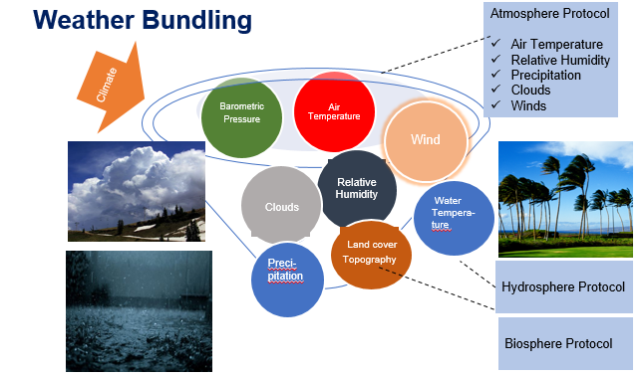

Figure 1. A schematic representation of the Weather Protocol Bundle.

II. List of the GLOBE Protocols included in the bundle

Atmosphere Protocols
Air temperature
Pressure
Relative humidity
Precipitation
Clouds

Biosphere Protocol
Land cover classification

Hydrosphere Protocol
Water temperature (surface)

III. Science background and description of GLOBE Protocols

Air temperature is both a climate and weather parameter. Along with air pressure, relative humidity, clouds, and precipitation, it is possible to obtain a view of the weather patterns of the area concerned.
Air temperature depends on the energy budget of the area concerned; it affects air pressure, relative humidity, the rate of evaporation, wind speed and direction and finally precipitation patterns and type. Many interesting short-term temperature fluctuations occur in connection with local weather disturbances. A cold front can reduce air temperature close to the ground by several degrees Celsius; similarly air temperature will increase with the passage of a warm front.
Air pressure is the force per unit of area exerted on TEarth’s surface by the weight of the air above the surface. The number of air molecules above a surface determines air pressure. As the number of molecules increases, they exert more pressure on a surface and atmospheric pressure increases. By contrast, if the number of molecules decreases, so too does the air pressure. In an area with an unstable and thus ascending air mass, a low pressure system is developed at the surface and a high pressure one at the top of the troposphere.
A close correlation of energy budget, air temperature, air pressure and winds exists. When the energy budget changes in a place, then a change of air temperature is caused, leading to a change of air pressure. The latter activates the pressure gradient force (the difference in pressure from place to place), which forces the movement of an air mass from an area of high pressure to a low pressure one. Winds are produced in this way. The intensity of winds depends on the degree of change of the energy budget, and thus of air temperature and pressure. The larger the gradient of pressure, the stronger the winds.
Atmospheric humidity is the amount of water vapor or moisture in the air; it is an important weather parameter, closely linked to precipitation. All types of precipitation, including drizzle, rain, and snow are produced as a result of the condensation of atmospheric moisture. Relative humidity in particular is the amount of moisture in the air compared to what the air can hold at a specific temperature.
Precipitation is one of the three main processes that constitute the hydrological cycle (the other two are evaporation and condensation). Water evaporates from ocean, land, and freshwater surfaces, condenses to form clouds and finally returns to Earth’s surface as precipitation.

Evaporation results in higher relative humidity and causes an air mass to become thermodynamically unstable and thus to rise in the atmosphere. Evaporation is higher over marine areas, especially in areas where the sea surface temperature exceeds 26 C. As a matter of fact extreme weather events such as hurricanes, originate, among other areas, in the warm waters of the Caribbean seas from August to September, thus at times when the sea surface temperature is above 26 C.

Clouds are formed when water vapor is condensed on aerosol particles that are suspended in the air. Condensation takes places when air masses are cooled by expansion while they lift in the air, at higher altitudes where pressures are lower. Clouds of vertical extent (called Cumulus and Cumulonimbus) reflect instability in the lower atmosphere and indicate convective motions. They are usually associated with low pressure systems (typically associated with bad weather).

Land cover is important as knowing the type of materials at the surface is useful in defining the energy budget of the area concerned as this depends on the albedo, the thermal emission coefficient and the heat capacity of surface materials. Evaporation is related to land cover as impervious urban materials such as asphalt and concrete, do not retain water for evaporation, whereas vegetation transpires water transforming soil moisture to atmospheric humidity.

V. Examples of case studies

Case Study 1. Define the relationship between air temperature and air pressure (at the ground).

Populate the Table below, for a selected day for an area of interest. Once the Table is completed, work out a graphical representation of the relationship between air temperature and air pressure for the area measured. Observe the correlation between these atmospheric parameters and explain their changes.

Time of day | Air temperature (deg Celsius) | Air pressure (mb)
09.00
12.00
15.00
18.00
21.00
24.00

Case Study 2. Link the presence of clouds to atmospheric pressure.

Populate the Table below, for selected days. Take note that air descends in high pressure systems, a fact which results in cloud evaporation. High pressure is almost always considered a sign of good or fair weather. On the contrary in low pressure systems, air ascends and develops clouds (and eventually storms). Thus low pressure is associated with bad weather.

Day | Air pressure (mb) | Presence of clouds (yes/no)

Case Study 3. Follow the formation of Cumulonimbus

Cumulonimbus (Cb) clouds grow vertically and their yops can reach altitudes of 10 km. And higher. At this height, the prevailing winds (of high intensity) will flatten the top of the cloud, shaping it as an anvil. They reflect strong instability in the troposphere and high amounts of water vapor, for instance due to excessive evaporation. Cumulonimbus clouds are associated with low pressure systems forcing air masses to rapidly ascend and form convective clouds due to condensation; they bring heavy rain, snow, hail, lightning, and sometimes tornadoes.

A Cumulonimbus cloud is recognized as follows: (a) the cloud has grown very high in the atmosphere and is distinct from other clouds in the same area; (b) the cloud is dark in its base, a clear sign of potential rain; (c) the cloud has a flat top; (d) sudden and intense rain takes place; and (e) lighting and thunder are observed.

Figure 2 shows a Cumulonimbus cloud as observed from an airplane flying at an altitude of 30,000 ft.

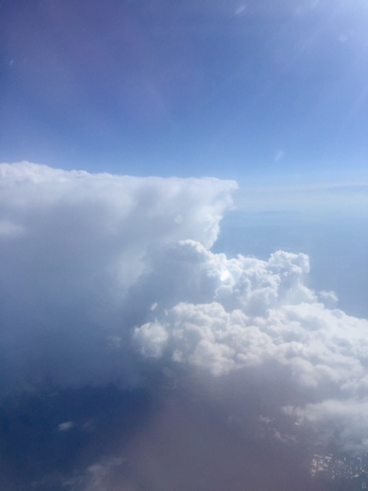
Figure 2. A Cumulonimbus cloud in full deployment. Note the anvil shape top, a characteristic sign of high winds (photo courtesy: C. Cartalis).

VI. Summary

Regardless if it is hot or cold, dry or humid, windy or calm, weather is a fascinating ensemble of several atmospheric parameters described and interrelated through the laws of physics and thermodynamics Their interdependence defines the prevailing weather patterns and also controls their evolution in space and time.
Weather is influenced by climate change, taken that the increase of air or sea surface temperature, may lead to extreme weather events of increased frequency and intensity. The weakening of the polar cell in the Arctic is associated with the thermal disturbance in the area, potentially associated to the melting of ice. Once the polar cell is weakened, very cold air masses move toward the equator, a phenomenon called a cold air intrusion.
Given that weather influences human security as well as a wide number of human activities and economic sectors, from transport to agriculture and from tourism to energy production, it is of great importance to establish and operate spatially wide monitoring networks and take advantage of meteorological satellites as to detect changes and predict the weather with the required accuracy; it is also important to maintain meteorological records which are supportive for weather modeling and analysis.

