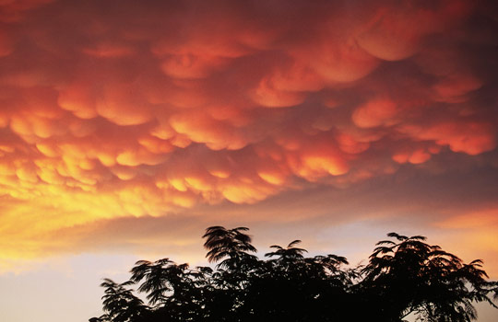
Mammatus clouds
You'll often see mammatus clouds during severe weather. These blankets of low-hanging pouches can persist for hours, though the life of an individual storm cell is measured in minutes. "Very typically you see mammatus associated with thunderstorms, when the air is filled with descending particles," says Peggy LeMone, a senior scientist emerita at the National Center for Atmospheric Research (NCAR) in Boulder, Colo. LeMone, who has kept her head in the clouds for decades, grew up poring over the International Cloud Atlas. "I'm like a meteorological bird-watcher,"

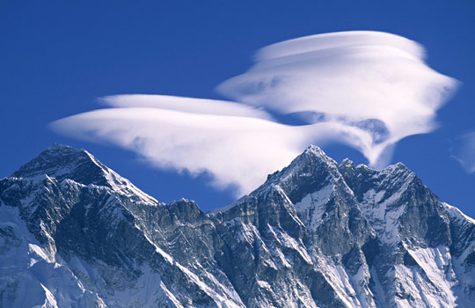

Lenticular clouds
See that saucer shape hovering over a nearby mountain summit? Unless you believe in UFOs, have no doubt that this lens-shaped manifestation is a lenticular cloud. These clouds, common in some parts of the high country, form when moist air passes over mountaintops and standing air waves that form downwind cool to the dew point. Powered aircraft pilots avoid lenticulars for their turbulence, but pilots of gliders seek out their powerful wave uplift. Get really lucky and you'll see a train of lenticulars, each floating over its own rocky peak.

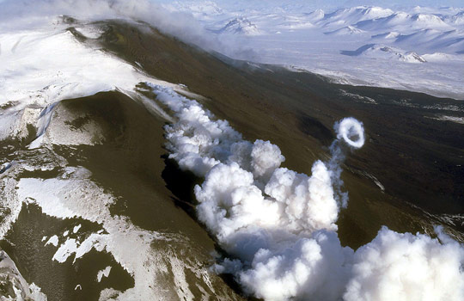

Steam rings
We're not just blowing smoke when we tell you that on rare occasions, volcanoes can puff out circular clouds of steam or smoke. When an active volcano expels hot gas from a circular vent at just the right speed, a vortex of steam can form and float skyward, doing a pretty good impression of a smoking Jack Nicholson or your favorite femme fatale. The Italian volcanoes Etna and Stromboli have been among the best producers of steam or smoke rings; for a period of months in 2000, Etna chain-smoked hundreds of ring clouds each day.
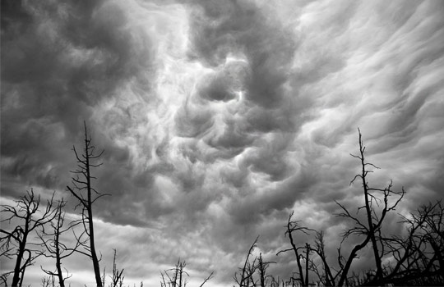

Undulatus asperatus
Whoever says there's nothing new under the sun hasn't seen undulatusasperatus, which typically form in the wake of severe weather. These wavy, gnarly, Gothed-out, low-flying clouds form an uneven deck that looks as if it might spawn a funnel cloud — but usually there's no harm done. In 2009, the undulatus, whose relationship to the other inhabitants of the cloud kingdom is still a matter of debate, was proposed as a new cloud type. In the continental United States, the Plains states are the best place to see undulatus.

Nacreous clouds
These mother-of-pearl clouds — a sort of cousin of noctilucent clouds — weave many iridescent colors together in beguiling wavy sheets. These polar stratospheric clouds are observed when the sun is just below the horizon, when ice crystals in the high atmosphere cool to minus 100 degrees Fahrenheit. Nacreous clouds form in the lee of mountain ranges such as the Transantarctic Mountains.

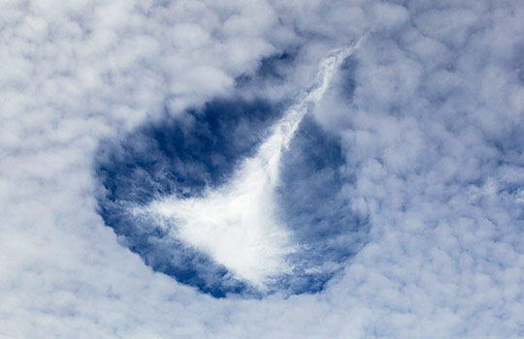
Hole-punch or fallstreak clouds
No, it's not a bird or a plane or the mother ship or a crop circle in the sky, it's a hole-punch cloud. These rare formations happen most often when an aircraft passes through high clouds containing water droplets that are still liquid even though their temperature is below freezing. Air currents created by the plane evaporate or freeze the droplets almost instantly, causing them to fall out of the cloud and leaving behind a distinct hole. Alternatively, "if a small shower has occurred, you can get a pocket of cool air that sinks" through a supercooled cloud layer below, punching a hole in it, explains LeMone of NCAR.

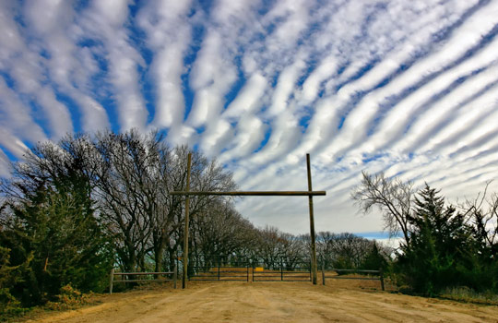
Cloud streets
Why do small cumulus clouds sometimes fall into parallel rows and roll across the sky like troops in formation? "It's complicated," meteorologists and physicists say, before invoking mechanisms ranging from convection currents to chaos theory. Cloud streets usually do move across the sky, but when a large man-made structure such as an airport tarmac is present, a street of clouds may remain stationary over it for hours, as LeMone of NCAR has observed. "Human activity will affect the distribution of clouds," she says.

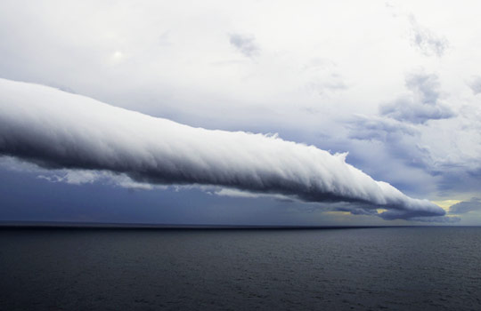

Roll clouds
A roll cloud looks like a rolling pin blanketed in cotton, hanging in the sky under higher clouds, appearing to rotate in place, often stretching from horizon to horizon. Yes, mind-blowing. This rare type of arcus cloud forms when a solitary wave pattern called a soliton sets up in the atmosphere and sustains itself in a roll form, usually near a seacoast or a severe thunderstorm. Also called morning glory clouds, coastal roll clouds sometimes form one after another; sightings of as many as 10 parallel rollers have been reported.

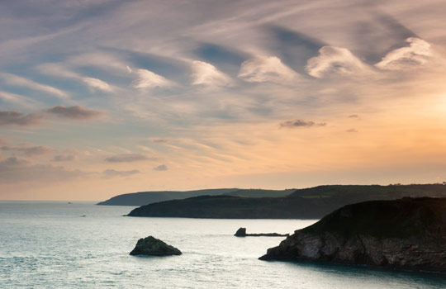

Kelvin-Helmholtz clouds
If there were a reality TV show about Kelvin-Helmholtz clouds, it might be called "When Paisleys Attack."These rows of rolling psychedelic swirls form when a cloud layer and the level of atmosphere above it are moving at different speeds, as when a stiff wind shears off the tops of ocean waves to create whitecaps. "I saw a pretty cool Kelvin-Helmholtz this morning," says LeMone of NCAR. "Here in Colorado, the mountains force up the air to the condensation level, creating the perfect platform for Kelvin-Helmholtz."

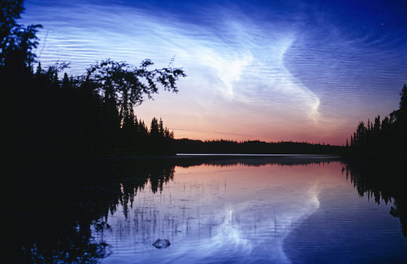

Noctilucent clouds
The odds are that if you spend some time at high latitudes — say, 50 to 70 degrees north or south — you'll look up one evening after the sun has set and the sky darkened and see noctilucent clouds, wispy apparitions in many colors streaking the heavens. These celestial clouds — at 250,000 to 300,000 above the Earth, they are at the edge of space — are formed of ice crystals and are illuminated by the sun even as it has fallen a few degrees below the horizon from a terrestrial perspective. Noctilucent, or "night-shining" clouds — not to be confused with northern lights — have appeared with increasing frequency over the past century, a trend attributable to climate change, some scientists posit.

