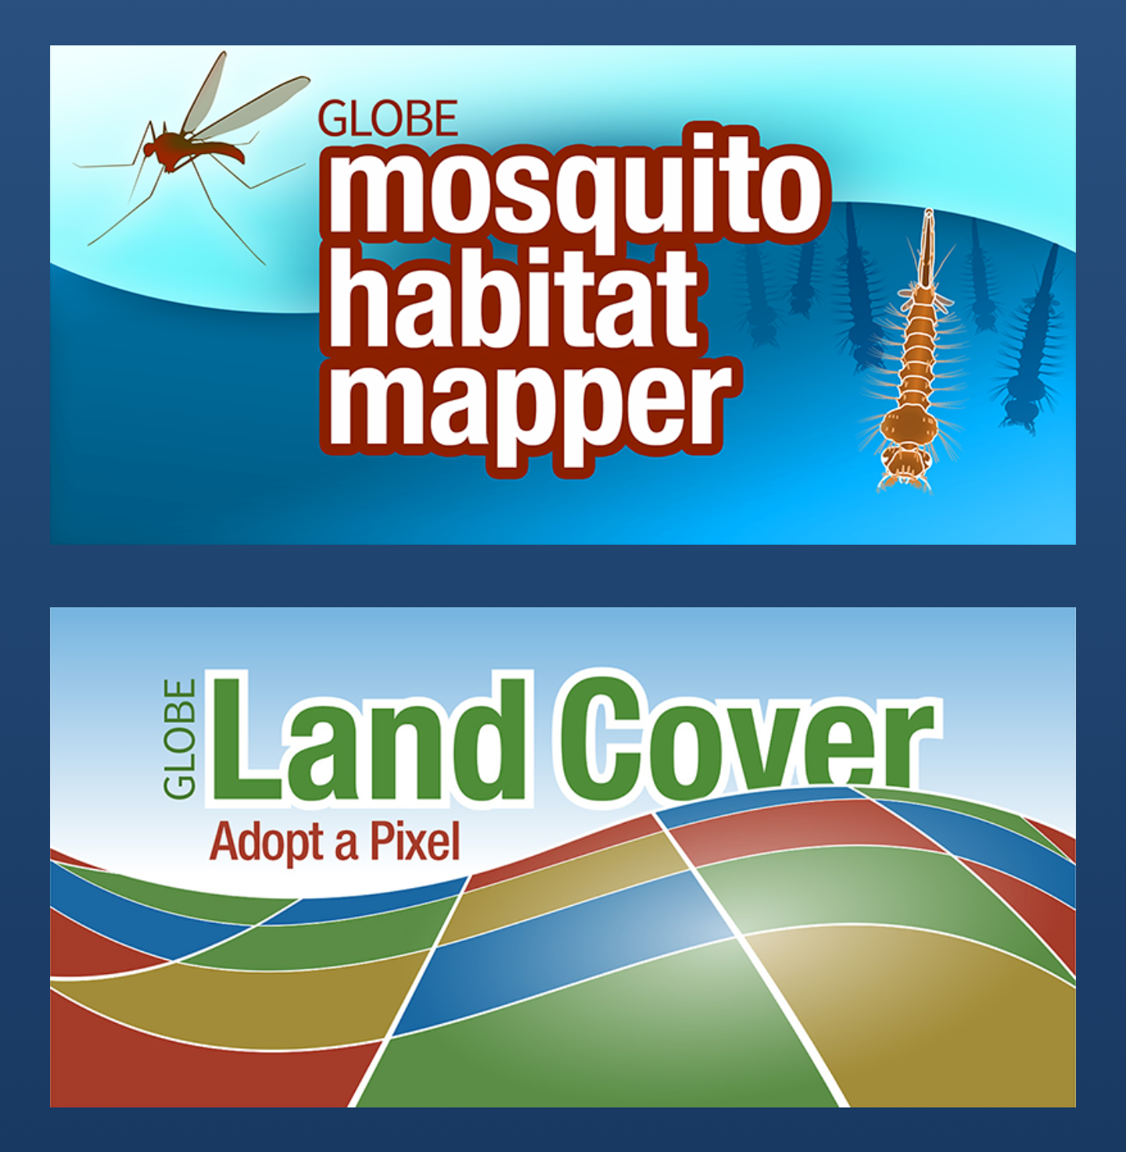  How to participate:  - Download the GLOBE Observer app and register.  - Take photos of mosquito larvae and mosquito habitats using the Mosquito Habitat Mapper tool.  - Take photos of the same location using the Land Cover tool. | Mosquito Habitat Photo Challenge  July 25 - August 25, 2021  https://observer.globe.gov/mosquito-challenge  Scientists need your photos of mosquito larvae and land cover to help prevent mosquito-borne diseases.  The Global Learning and Observations to Benefit the Environment (GLOBE) Program invites citizen scientists from around the world to participate in the Mosquito Habitat Photo Challenge. This challenge combines Mosquito Habitat Mapper and Land Cover (two GLOBE Observer app tools) to document mosquito breeding habitats with photos.  GLOBE would like you to take photos of mosquito habitats, in either natural or artificial containers. If mosquito larvae are present, you are encouraged to photograph them with a magnifier (optional). Then, we’d like you to take photos of the land around the habitat location using the Land Cover tool.  Photos submitted during this challenge will be used to create automated classification programs that can identify mosquito larvae and the environments they prefer. Such computer programs can help prevent outbreaks of mosquito-borne disease.

The Global Learning and Observations to Benefit the Environment (GLOBE) Program is an international science and education program that provides students and the public worldwide with the opportunity to participate in data collection and the scientific process and contribute meaningfully to our understanding of the Earth system and global environment. Announced by the U.S. Government on Earth Day in 1994, GLOBE launched its worldwide implementation in 1995.
The GLOBE Observer app is a GLOBE’s data entry tool that allows an international network of citizen scientists to work together to learn more about our shared environment and changing climate. To participate, just download the GLOBE Observer app and submit regular observations. GLOBE Observer currently accepts observations of Clouds, Mosquito Habitats, Land Cover and Trees. Lead your own program and incorporate various hands-on activities using resources in the GLOBE Observer Toolkit for Informal Educators: https://observer.globe.gov/toolkit.

The NASA Earth Science Education Collaborative (NESEC) is enabling broad participation in authentic NASA Earth STEM experiences for lifelong learners, including GLOBE citizen science and student investigations with NASA. NESEC is comprised of four GLOBE Partners, led by the Institute for Global Environmental Strategies (IGES) in partnership with the Earth sciences organizations at NASA’s Goddard Space Flight Center (GSFC), Jet Propulsion Laboratory (JPL), and Langley Research Center (LaRC). NESEC is funded under NASA award NNX16AE28A.


