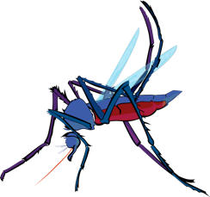
Data Bites
GLOBE Mission Mosquito Data Challenge
Overview
This challenge is designed to introduce the user to the GLOBE Visualization tool. Users will select a protocol layer, use a filter, and select a specific date or date range. Screen capture the map, save it and upload/add it to the map gallery at this url: https://padlet.com/cassie_soeffing/datachallenge1

Data may seem esoteric on the surface, meaning only a small number of trained people know how to access it, but that isn’t the case with GLOBE data and the GLOBE Visualization tool. Anyone can access millions of Earth observations, determine which data applies to a particular area or use, and then display and download it in a meaningful way.
 | Information | Proccess
Objectives | Viewers will be:  Introduced to GLOBE, GLOBE Observer, and the GLOBE Visualization system.  Skills introduced, with a “show me that” you can do it are:  - Navigating to GLOBE Visualization tool,  - How to add layers,  - Select date or range  - Save map  - Use Padlet as a gallery wall for data bite challenge | https://www.globe.gov/globe-data/visualize-and-retrieve-data  Create a map with mosquito observations at either a local, state, or country level.  Define a date or range for the data.  Screen capture the map and save it.  Upload the map picture to Padlet (https://padlet.com/cassie_soeffing/datachallenge1)
Summary | From your map, can you …  - See patterns in the observations?  - Determine the frequency of observations?  - Describe similarities or differences in the data?  - See changes over time (temporal) or spatial (expanded locations).  Explain how and what you did to create your map? | Create your own free Padlet account and share your GLOBE Visualizations with others.  Share your data map from the GLOBE Visualization tool.
Extension Ideas |  | - Change the base map in GLOBE.  - Add land cover classification  - Zoom in to see if the land cover and mosquito observations coincide.  - Article: Making Sense of Data https://my.nsta.org/resource/6943/making-sense-of-data

