GO at Home
Land Cover Activity

Remote sensing is the science of obtaining information about an object or place from a distance. Obtaining that information requires remote sensing instruments. The instruments detect the different wavelengths of electromagnetic energy that are released by different objects on the Earth’s surface. For example, land cover data is obtained using passive remote sensors on satellites in space. Land cover images are not photographs; they are images where wavelengths from different types of land cover are assigned a color on the image. You can find out more about remote sensing here: https://earthdata.nasa.gov/learn/remote-sensing.
LAND COVER MANUAL CLASSIFICATION ACTIVITY
To do this activity with a group, reproduce the image below for each participant.
Discuss what is shown in the image. What can the participants identify? What is easy to decipher? What is more difficult? Here are some guidelines that scientists use when they are visually interpreting a land cover image:
Color: Some satellite images display particular colors that can be used to distinguish features. However, it depends on the type of material. When looking at a ‘natural color’ image, in general, vegetation is green, water is blue or black, bare ground is brownish, building roofs are white or black, and roads are black, brown, or white.

Shape: Agricultural areas tend to have abrupt linear edges and geometric shapes like rectangles and squares. Streams are linear features that can have many bends and curves. Roads tend to have parallel sides and frequently have fewer curves than streams. In high-resolution images, geometric shapes (squares and rectangles) can be structures, like houses or apartment buildings.

Size: Major highways and rivers can be distinguished from smaller roads and tributaries by their width.

Topographic or geographic location: If you are in a location with mountains and valleys, forested areas will tend to be on the mountainous areas with steeper slopes, while grassland and agricultural areas will be within the valleys. Since Landsat images are acquired in the morning, hillsides opposite the Sun may be in shadow.

Association: A vegetated area within an urban setting may be a park or cemetery. Wetlands may be located next to rivers, lakes, or estuaries. Commercial centers will be located next to major roads, railroads, or waterways.
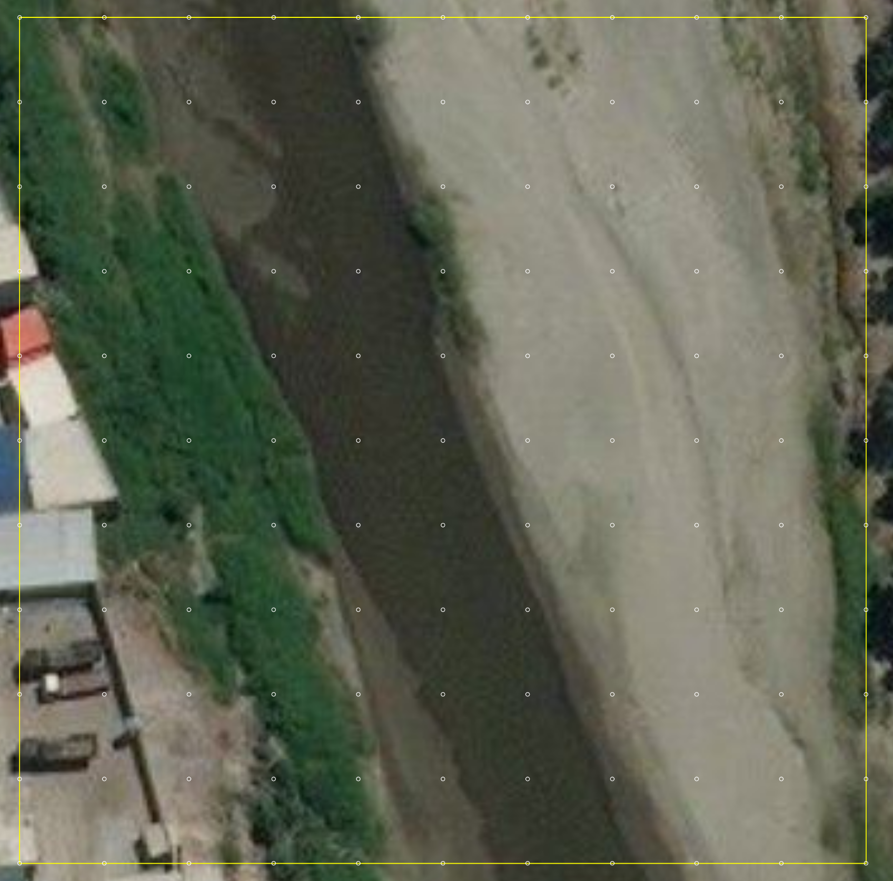

CLASSIFY THIS LAND COVER SCENE. WHAT DO YOU SEE?

USE COLORED PENCILS OR CRAYONS. COLOR AROUND EACH DOT ON THE IMAGE, USING THIS KEY:

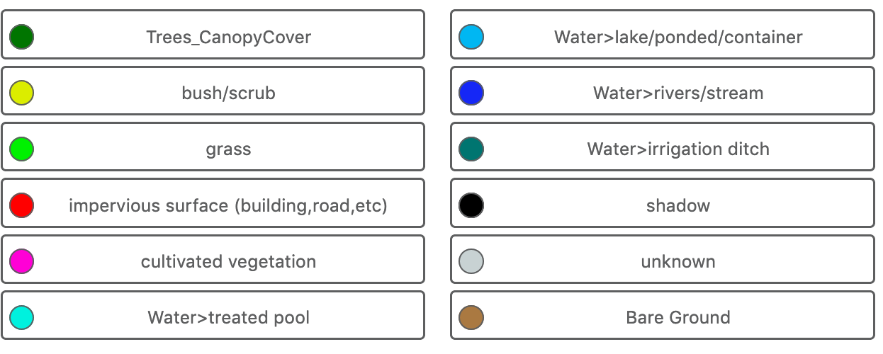

For Educators:
You can have each classifier in your group tally how many of each of the classifications they identified on their image on this table:

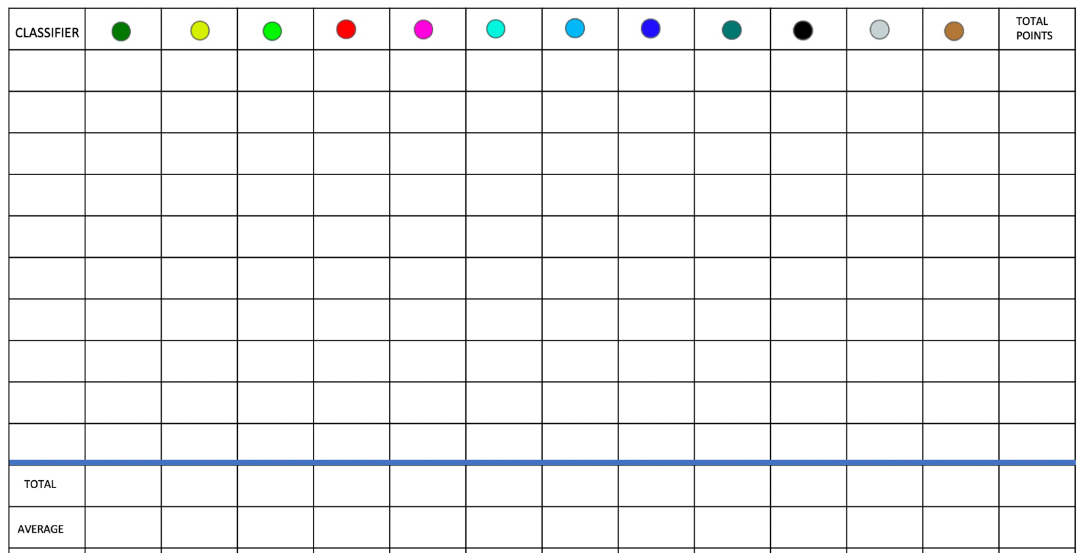

DISCUSS: What was the most common land cover type in the image? Which land cover type might be necessary for mosquitoes? What type of water source was the mosquito habitat described by the GLOBE Observer (find the middle of the image that corresponds to where the sample was obtained)?

FAQ: What if I make a mistake in classifying the features in the land cover image?

Remote sensing scientists do not have one acceptable overall accuracy percentage to guide them when making a map from satellite imagery. Required accuracy levels depend on the objective of the map. It is very interesting to study the error matrix and observe what land cover classes are being confused with each other. All errors are not equal. In most cases, it would be far worse to label an area as water when it is conifer forest than it would be to label a conifer woodland as a conifer forest. In addition, remote sensing scientists try to improve their maps using the information gained in the error matrix. These attempts may involve collecting more land cover data to assist in the mapping, studying the spectral response patterns of land cover types, and/or applying different classification techniques. Land cover mapping from satellite imagery is often an iterative process, and accuracy assessments can take place many times before a final map is achieved. Once scientists have an assessed map, they use it to answer their investigative (or research) questions. They may compare the amounts and locations of natural and developed areas, the percentages of land cover types that are important to the community such as agriculture, wetlands, transportation, recreation areas, etc. or specific locations of habitats they are studying.

ADDITIONAL RESOURCES:

Learn about the science of the electromagnetic spectrum and the physical properties of light that are used by sensors on satellites to remotely sense the planet. https://science.nasa.gov/ems/01_intro

Tour of the Electromagnetic Spectrum: https://science.nasa.gov/ems/01_intro

A website with Landsat image Collectors’ Cards:
https://landsat.gsfc.nasa.gov/landsat-9/fun-with-landsat-9/

ACTIVITY:
Exploring Remote Sensing
https://smd-prod.s3.amazonaws.com/science-pink/s3fs-public/atoms/files/ems-exploring-remote-sensing_1.pdf

Level: Grades 5-9.
This 5E activity can be done with students to simulate the process of remote sensing.

Materials needed for each team of students
- Light meter (find an app and use with a mobile device)
- Meter stick
- Science notebooks

Text primarily from GLOBE Manual Land Cover Mapping Learning Activity. https://www.globe.gov/documents/355050/19c0ce4a-ffcf-4e7a-a39a-2f4ff23fe68f
Text from GLOBE Manual Land Cover Mapping Learning Activity. https://www.globe.gov/documents/355050/19c0ce4a-ffcf-4e7a-a39a-2f4ff23fe68f

