Volume 1, Issue 2

MULTI Newsletter

A Community Approach to Engaging Students
and Teachers in Effective STEM Education

January 2020
Contact Us at
Janelle Johnson
jjohn428@msudenver.edu
Rich Wagner
wagnerri@msudenver.edu
Linda Sivertson
lsivert@msudenver.edu
Dawn Cummings
Dawn.Cummings@ccd.edu
In this Issue
1. Student Research EXPO
Teacher RSVP (by 1/25)
https://forms.gle/5zpMe3vKXn3q56Vq8
Lunch & Parking Pass RSVP
families, too!
https://forms.gle/LM6mmAJ9LDMTfcVT6
2. Teacher Stipends for Assisting Education Research
3. Classroom Visits from Scientists and Undergraduate
Science Students
4. Teacher Field Camp in New Mexico

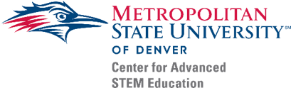
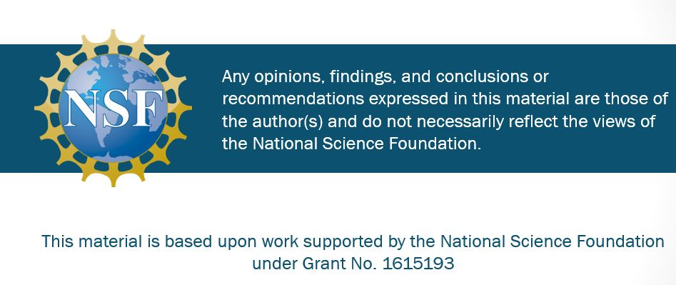
MULTI STEM Student Research Showcase Saturday, February 8, 2020; 9am – Noon
Auraria Campus, Science Building, 2nd Floor
We are excited that we have arranged to include live remote PARTICIPATION via ZOOM. We’ll also have a recorded version of the event that we can share once we’ve sorted out photo release requirement issues. Teachers with students presenting will receive a $250 stipend. Teachers with participating non-presenting students will also receive a stipend. We would like interested teachers to RSVP with some general information, including an approximate number of students and presentation projects by January 25.
8:30 – 9:00 Check-in and Set up
Light Refreshments available. Let us know if you need a table to set up an exhibit. (We can also print out a research poster up to 36”x48” if you request it by Tuesday February 4).
9:00- 10:00 Student STEM Showcase
Students share with what they are doing in their science classroom in the form of a demo, poster, exhibit of collected data, and/or other style of presentation. Each student or student group will give a 5-minute presentation for a mixed group of about 25 (K-12 students, college students, teachers).
10:00 – 11:00 College STEM Research Showcase
College students from Metropolitan State University of Denver and Community College of Denver share their field research in earth and environmental sciences. Ask student clubs about their activities.
11:00 – 12:00 MULTI STEM EXPO and Lunch
Local science organizations (e.g. Denver Public Library, Denver Zoo, Denver Museum of Nature and Science, Denver Water) . Free lunch and door prizes for participating teachers and students. Family members need to RSVP for lunch and parking passes.

Upcoming Events
Feb. 8
Student Research Showcase
Grades K-12
Auraria Campus, Denver
Virtual Participants Welcome
March 10
Projects due for GLOBE International Virtual
Science Symposium (IVSS)
Grades K-12
May 15-17
GLOBE Southwest Regional
Science Symposium (SRS)
Austin, Texas
Travel Funding Available
Deadline in March
July 13-17
Teacher Field Camp
Rio Mora National Wildlife Refuge, New Mexico
Participant costs are covered by the MULTI project, and participating teachers receive a stipend.
Applications will be available in late February with a probable application deadline in April.
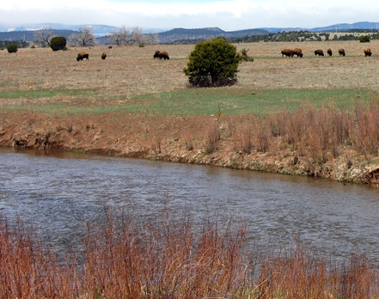
Rio Mora National Wildlife Refuge (near Las Vegas, NM)

The MULTI STEM SRS (Student Research Showcase) could be an opportunity for students to present their research projects using data they have collected. If they have used GLOBE protocols, they can present their data for the GLOBE International Virtual Science Symposium (IVSS) and the GLOBE Regional SRS (travel grants available for 2020 Southwest Region symposium in May in Austin, Texas).
Teachers Stipends for Education Research
MULTI has been supported through a National Science Foundation grant. A crucial aspect of the grant has been exploring successful approaches in STEM classroom implementation and teacher professional development. We are offering many opportunities for teachers to contribute to this effort. This includes stipends for sharing your experiences through surveys and interviews in addition to participation in Watercoolers, Student Research Symposia, and for submitting data to the GLOBE database. We’d love to hear from you about your experiences with hands-on activities using GLOBE data and incorporating the “focal student” approach.

Classroom Visits from Scientists
Participants at our MULTI Summer Institutes may recall hearing from Community College of Denver students about their research at Rio Mora National Wildlife Refuge. Several students have been visiting schools to share their research experiences and assist students with field data collection and research methods. STEM majors from Metro State University are also available for school visits. We also are supporting scientists from various informal science education organizations to share their expertise and exciting programs. These groups have partnered with us for STEM Expo events we have sponsored. Let us know of your interest and we can help find groups that meet your needs.
MULTI Teacher Field Camp in July
After 3 years of the MULTI Summer Institute in Denver, we are doing something different this summer! During the week of July 13-17, we will be leading field investigations at the Rio Mora National Wildlife Refuge in Northern New Mexico. This is a great opportunity to learn field methods and interact with field biologists and MULTI faculty and students. Look for an announcement soon for how Colorado and New Mexico teachers can apply for this opportunity.

