Volume 1, Issue 1

MULTI Newsletter

A Community Approach to Engaging Students
and Teachers in Effective STEM Education

October 2019
www.msudenver.edu/case/multi
Contact Us at
Janelle Johnson
jjohn428@msudenver.edu
Rich Wagner
wagnerri@msudenver.edu
Linda Sivertson
lsivert@msudenver.edu
Dawn Cummings
Dawn.Cummings@ccd.edu

In this Issue
1. November Watercooler
2. February Student Research Symposium
3. Teachers Assisting STEM Educational Research
4. Classroom Visits from Scientists and Undergraduates
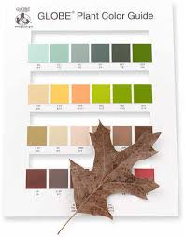

November Teacher Watercooler
Citizen Science: From Start-Up to Symposium
Join teacher Kate Goss as she shares experiences and insights on how to get a GLOBE citizen science program started from ground zero, engage students in meaningful questioning, support focal students, and begin collecting data for research to share at a GLOBE Symposium.
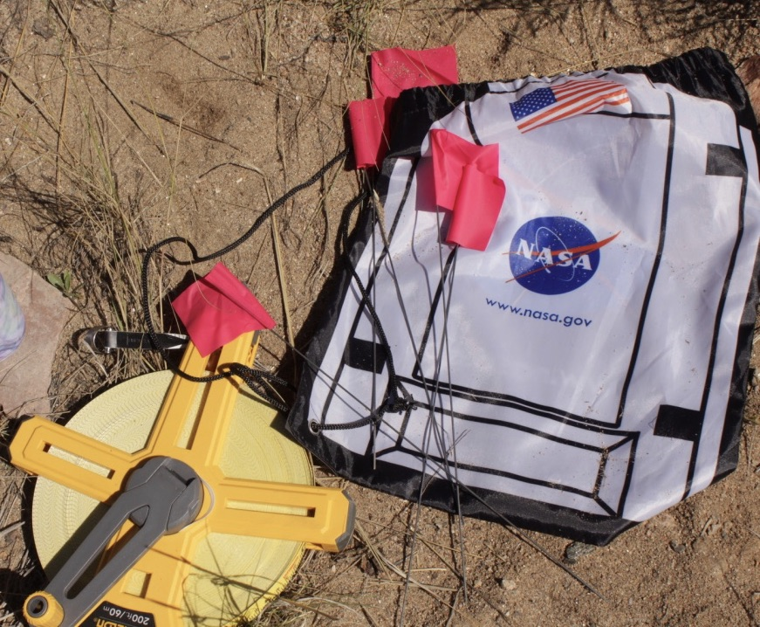
Saturday, November 2; 9-10am via ZOOM
Register on GLOBE:
https://www.globe.gov/get-trained/workshops/workshop/jT1U/127902

Upcoming Events
Feb. 8
Student Research Symposium
Grades K-12
Auraria Campus, Denver
Virtual Participants Welcome
March 10
GLOBE International Virtual
Science Symposium (IVSS)
Projects Due

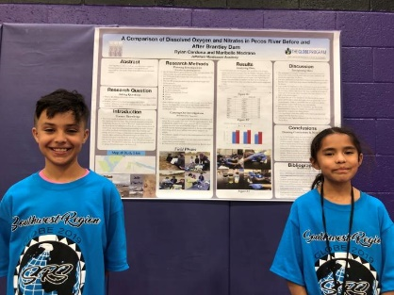

MULTI Webpage
www.msudenver.edu/case/multi
Colorado MULTI Student Research Symposium
MULTI is hosting a student research symposium on February 8, 2002. This is an opportunity for students to present their research projects using data they have collected. If they have used GLOBE protocols, they can also present their data for the GLOBE International Virtual Science Symposium (IVSS) and the GLOBE Regional SRS (travel grants available for 2020 Southwest Region symposium tentatively scheduled in May in Austin, Texas).
The target age is Grades 3-10, but all grades K-12 are eligible. Students can also view research by Community College of Denver and Metropolitan State University undergraduates. These undergraduates will also serve as reviewers, giving feedback to students researchers. Families are welcome to attend to support their students.
Teachers Assisting MULTI Education Research
MULTI has been supported through a National Science Foundation grant. A crucial aspect of the grant has been exploring successful approaches in STEM classroom implementation and teacher professional development. We are offering many opportunities for teachers to contribute to this effort. This includes stipends for sharing your experiences through surveys and interviews in addition to participation in Watercoolers, Student Research Symposia, and for submitting data to the GLOBE database.

We’d love to hear from you about your experiences with hands-on activities using GLOBE data and incorporating the “focal student” approach.
Classroom Visits from Scientists
Participants at our MULTI Summer Institutes may recall hearing from Community College of Denver students about their research at Rio Mora National Wildlife Refuge. Two of the student, Brittany and Lexi, have been visiting school to share their research experiences and assist students with field data collection and research methods. STEM majors from Metro State University are also available for school visits.
We also are supporting scientists from various informal science education organizations to share their expertise and exciting programs. These groups have partnered with us for STEM Expo events we have sponsored. Let us know of your interest and we can help find groups that meet your needs.

