**\*\* Fox 29 Philadelphia (Live Broadcast Sept 1, 2021) \*\***



Meteorologist Kathy Orr reporting (my **AMS DataStreme** Colleague)

<https://www.youtube.com/watch?v=tQrFk8OKtnQ>

**Public Information Statement:**



**National Weather Service Mount Holly NJ**

**1155 PM EDT Thu Sep 2 2021**

**...7 CONFIRMED TORNADOES SO FAR...**

The National Weather Service office in Mount Holly, NJ has conducted several storm surveys for damage from storms on Wednesday, September 1. Additional surveys may be conducted on

Friday.

**Some Preliminary Tornado Information...**

1) Mullica Hill, NJ area (Gloucester County): Confirmed EF-3 with estimated peak winds up to 150 mph tornado.

2) Fort Washington/Upper Dublin Twp. to Horsham Twp., PA (Montgomery County): Confirmed EF-2 with estimated peak winds up to 130 mph.

**3) Edgewater Park, NJ (Burlington County) to Bristol, PA (Bucks County): Confirmed EF-1 with estimated peak winds up to 90 mph. \***

4) Oxford, PA (Chester County): Confirmed EF-1 tornado with estimated peak winds up to 95 mph.

5) Buckingham Twp., PA (Bucks County): Confirmed EF-1 with estimated peak winds up to 100 mph.

6) Princeton, NJ (Mercer County): Confirmed EF-0 with estimated peak winds up to 75 mph.

7) Upper Makefield Township, PA (Bucks County): Confirmed EF-1 with estimated peak winds up to 90 mph.

**The storm survey information will also be available on our website at** [**http://www.weather.gov/phi**](http://www.weather.gov/phi)

**Harrisonville-Mullica Hill-Deptford tornado...**

Rating: EF-3

Estimated Peak Wind: 150 mph

Path Length /statute/: 12.6 miles

Path Width /maximum/: 400 yards

Fatalities: None.

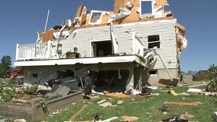

Injuries: 2 injuries

Start Date: Sep 01 2021

Start Time: 610 PM EDT

Start Location: 1 SE Harrisonville, NJ

Start Lat/Lon: *39.6769/-75.2500

End Date: Sep 01 2021

End Time: 630 PM EDT

End Location: 1 SE of Deptford, NJ

End Lat/Lon: *39.82/-75.11

The tornado touched down near Harrisonville, NJ doing mostly damage to trees and limbs before strengthening and moving northeast. As it moved to the northeast, it crossed into the Cedar Grove area producing more significant damage to trees with many trees uprooted. The tornado moved into the Willow Oaks subdivision strengthening further and producing significant damage to trees, as well as serious structural damage to a number of homes. Several homes had exterior walls completely collapsed, a number of homes lost roofs and upper story walls, and one home had only a few interior walls remaining. Vehicles were tossed around and moved, and damage from flying debris was observed in several spots. The tornado continued to move to the northeast to Bridgeton Pike where multiple trees had trunks snapped and most of the barns and storage buildings at a large commercial farm were completely destroyed. The tornado also reached its maximum width at this location and was estimated to be around 400 yards wide. The tornado then continued northeast through the woods with multiple trees snapped before entering the subdivision at Salvatore Drive. Here the tornado`s most significant damage was observed with one home completely destroyed with no interior or exterior walls standing. Other homes in the subdivision had exterior walls collapsed along with garage collapses and vehicles being tossed around by the tornadic winds. The tornado continued to the northeast damaging trees and structures along its path before reaching a large commercial dairy farm where extensive damage occurred. Barns were destroyed and two large grain silos were toppled. The tornado then crossed Jefferson Road and crossed Eachus Road snapping multiple trees. Thereafter, the tornado moved into the Breakneck Road area producing complete deforestation with nearly 100 percent of the trees in a thickly wooded area snapped. The tornado path crossed Main St, just south of Chestnut Branch Park in Mantua Township snapping and uprooting a number of trees before reaching the Delaware Valley Florist commercial greenhouse mostly destroying the structure. The tornado damage path then continued to the northeast reaching Wenonah, snapping and uprooting a number of trees, a few homes lost roofs and one structure collapsed. Less severe tree damage persisted to the northeast along the tornado`s path toward Deptford where the tornado lifted.

**EF Scale: The Enhanced Fujita Scale classifies tornadoes into the following categories:**

EF0...Weak......65 to 85 mph

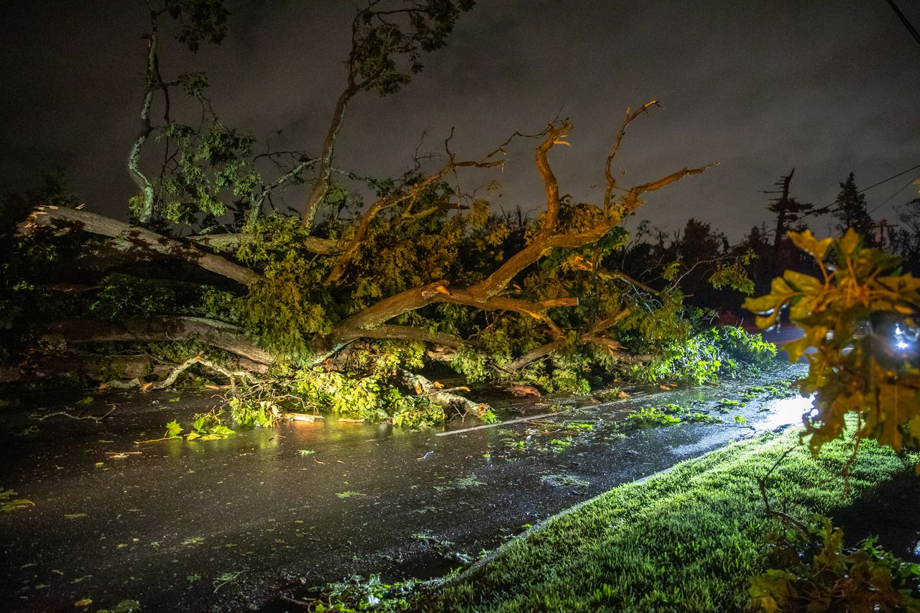

EF1...Weak......86 to 110 mph

EF2...Strong....111 to 135 mph

EF3...Strong....136 to 165 mph

EF4...Violent...166 to 200 mph

EF5...Violent...>200 mph

**NOTE:**

The information in this statement is preliminary and subject to change pending final review of the event and publication in NWS Storm Data.

**The National Weather Service in Mount Holly would also like to thank local enforcement and emergency management for their assistance in the storm survey.**

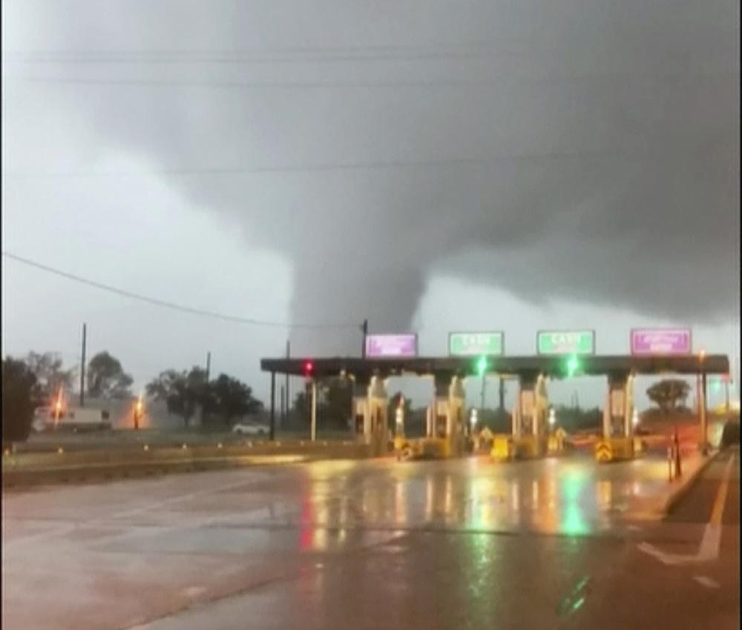

*Our **Institute for Earth Observations GLOBE Partnership (NJ)** is a part of the Burlington County Bridge Commission. This photo was taken at the Toll Plaza of the Burlington Bristol Bridge n the Delaware River. The tornado passes directly over the bridge. This photo is about approximately 10 miles north of our Center at Palmyra Cove Nature Park. (J. Moore)