PLITVICA
Plitvica is a river in Croatia, right tribuary of the river Drava that originates from the Macel Highland area, north from the village Plitvica Voćanska. The lenght of the flow is about 65 km. The average depth is from half meter to one meter. The bottom is predominantly gravelly, but in places of slower flow the bottom is muddy and sandy. The river is two to eight meters wide, on average four to five meters. The river Plitvica flows through the village Jalkovec where it's exposed to anthropogenic influences of local villages, agriculture and sewage. It's our first hydrological station. The coordinates of the river are 46°28ʹ n. g. latitude and 16°32ʹ e. g. longitude.
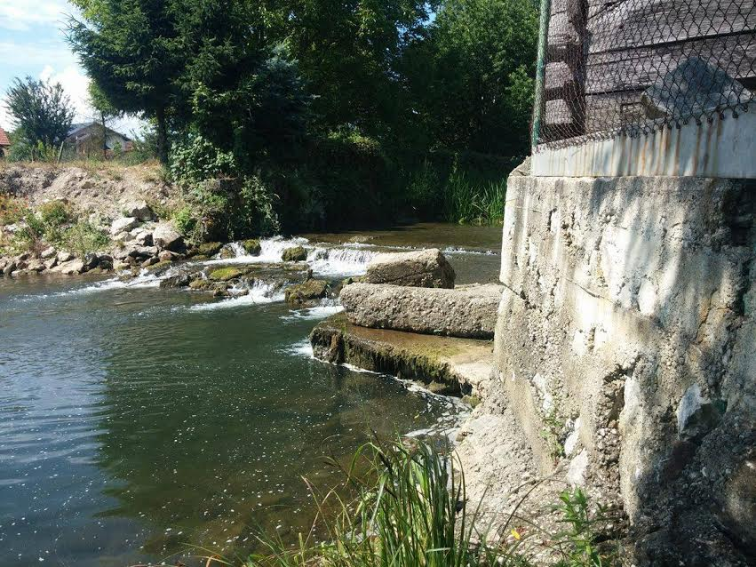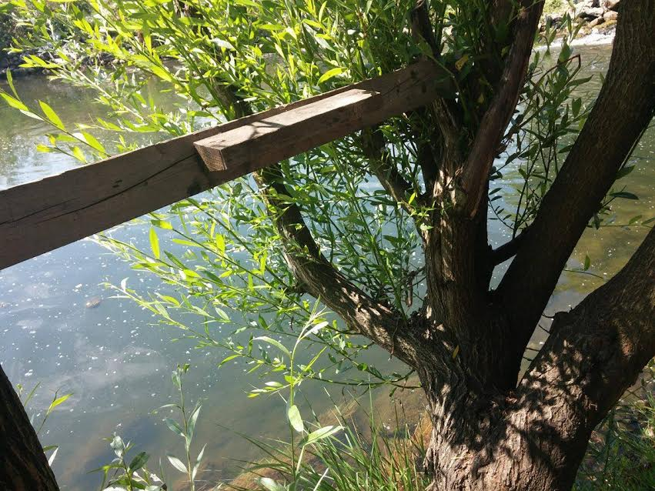
For 2 years already we have been measuring physicochemical properties of water such as temperature, alkalinity, nitrates and nitrites, pH of water, the amount of oxygen and transparency of water. The measurings are done at least once a month.
The lowest recorded temperature is 3°C and the highest is 19.3°C.
The lowest recorded alkalinity is 2 and the highest is 6.
Amount of nitrates ranges from 2.1 mg/l to 30.1 mg/l and the amount of nitrites ranges from 0 mg/l to 0.1 mg/l.
Highest pH of water is 7.7 and the lowest is 6.5.
The lowest amount of oxygen in the water is 7.4 mg/l and the highest is 12.2 mg/l.
The lowest transparency of water is 11 cm and the highest is 117.5 cm.

