Class Green-Up Cards
To submit your class’ Green-Up Cards, insert photos and any sketches into this document, then save as a pdf. Please name file using the following naming convention <Genus_Species_lat_lon_school>. For example, Acer_Negundo_40.03509_-105.24366_Fairview.pdf. You can then upload this file to the “Class Green-Up Cards” folder in the Phenology and Climate Project Group Documents at http://www.globe.gov/web/phenology-and-climate/documents.
School Name:Beit Hanina Comrehensive School for Girls
School location (Country, State, City):Beit hanina,Jerusalem,isreal
Teacher’s Name :Amal abu Hijleh
Class: 8th& 9th
Plant Type (Genus, Species): Ficus carica
Describe Plant’s Location:surrounding the school

Latitude: 31.49 Longitude:35.13 Elevation:780

Insert photos and sketches (if available) and label sequentially through Green-Up. For example, Dormant photo would be 1, Swelling 2, etc. Describe each below. If photo taken during Leaf Growth, let us know leaf length.
Photo/Sketch 1
Insert Photo and sketch, if available:
Date:February,19,20
Time:13:30
Green-Up Phase :pud formation

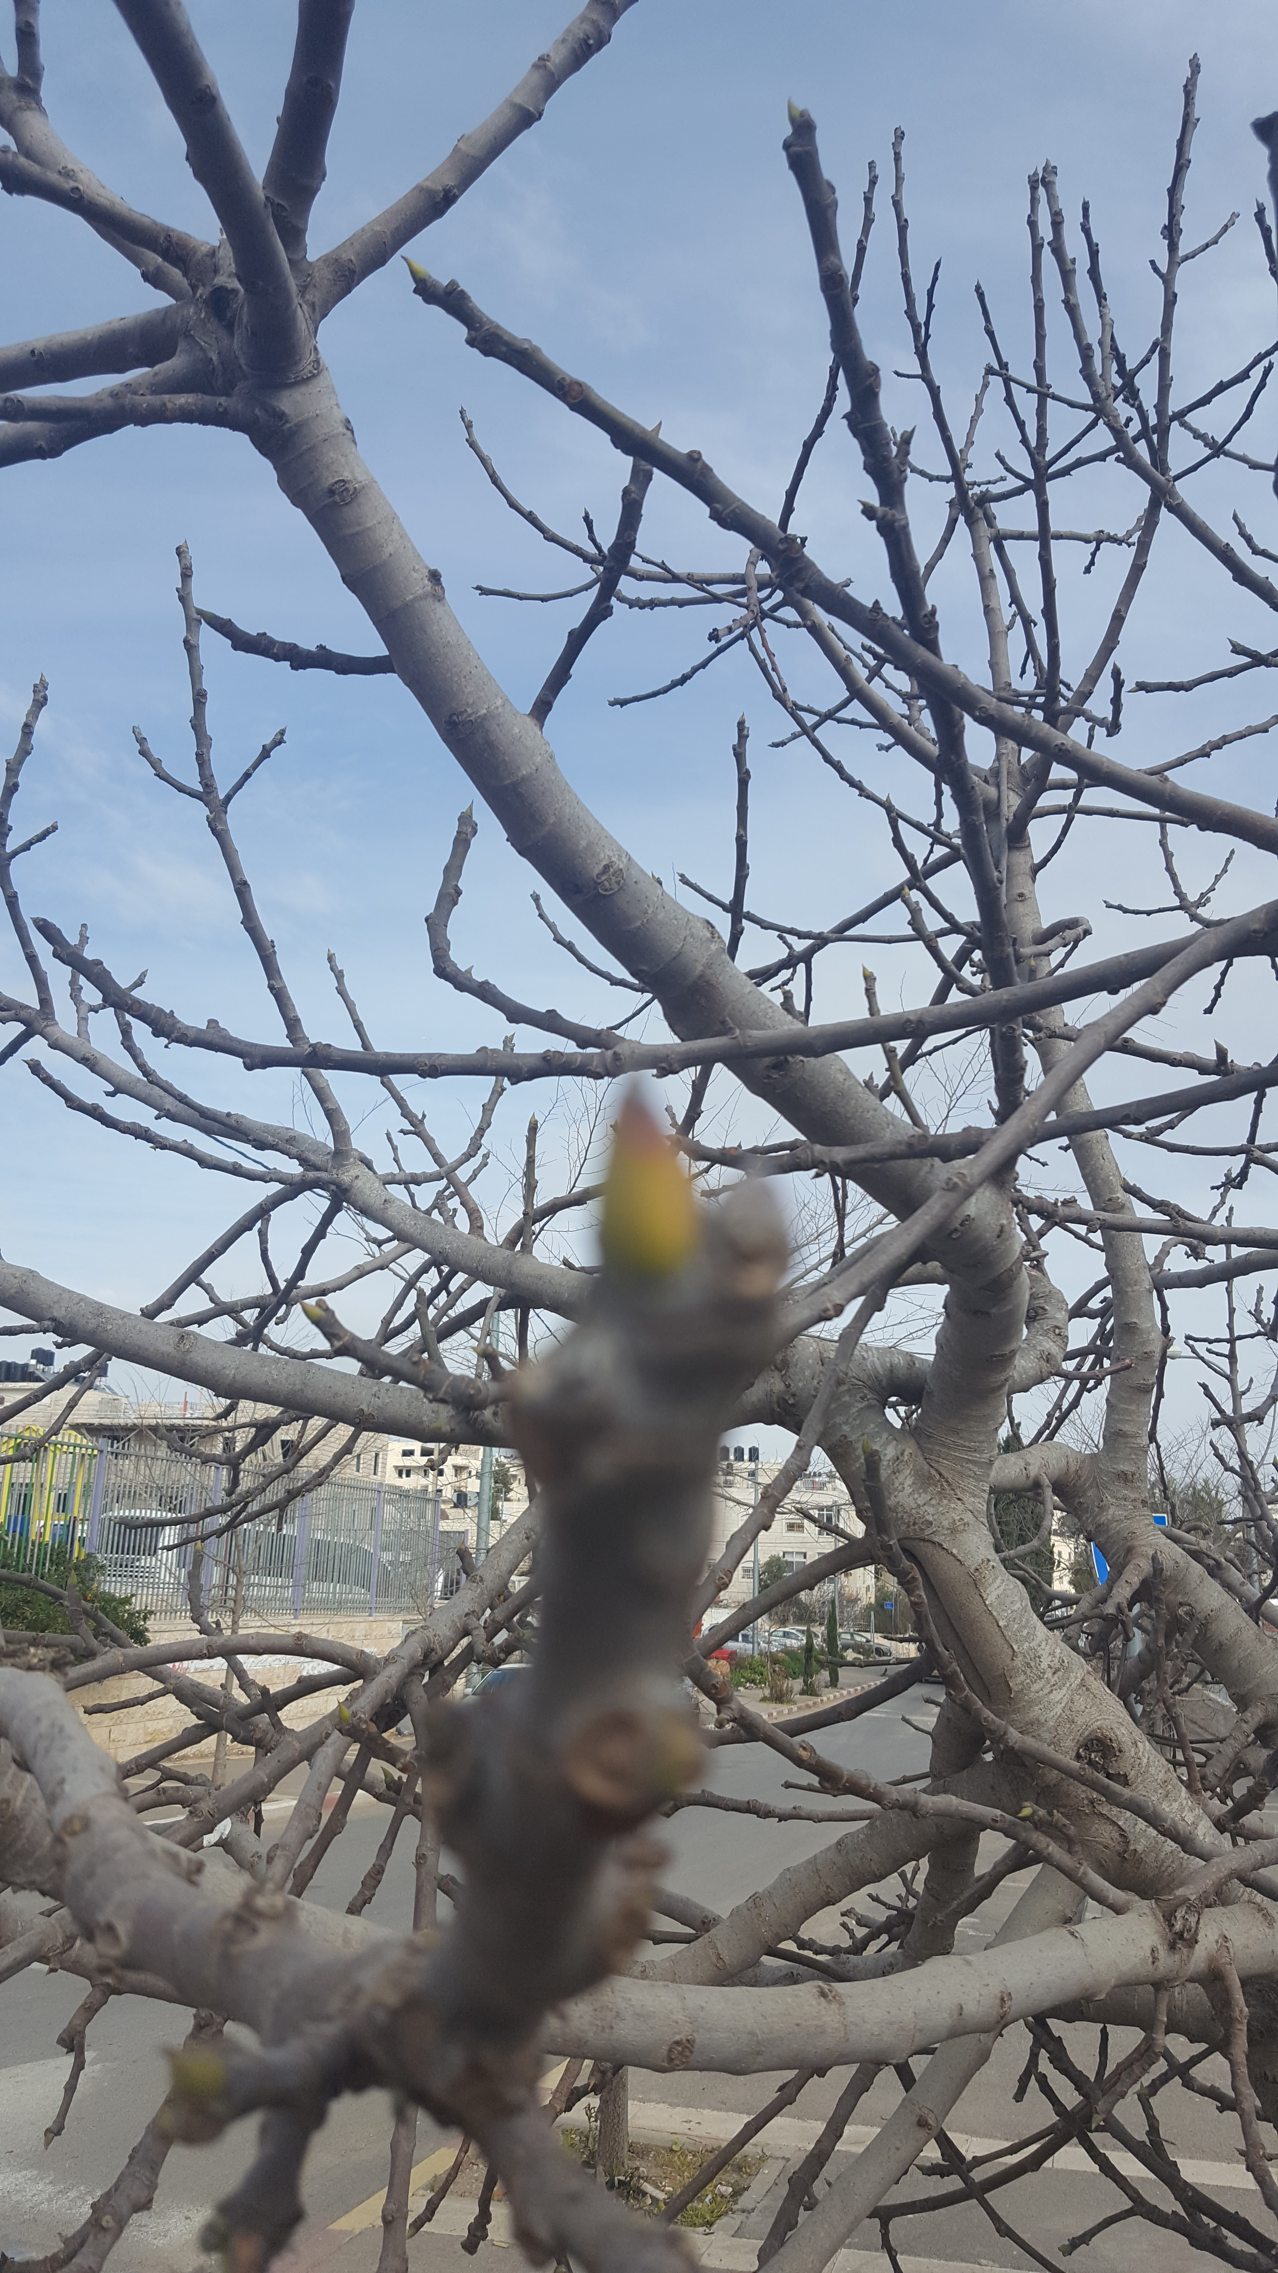
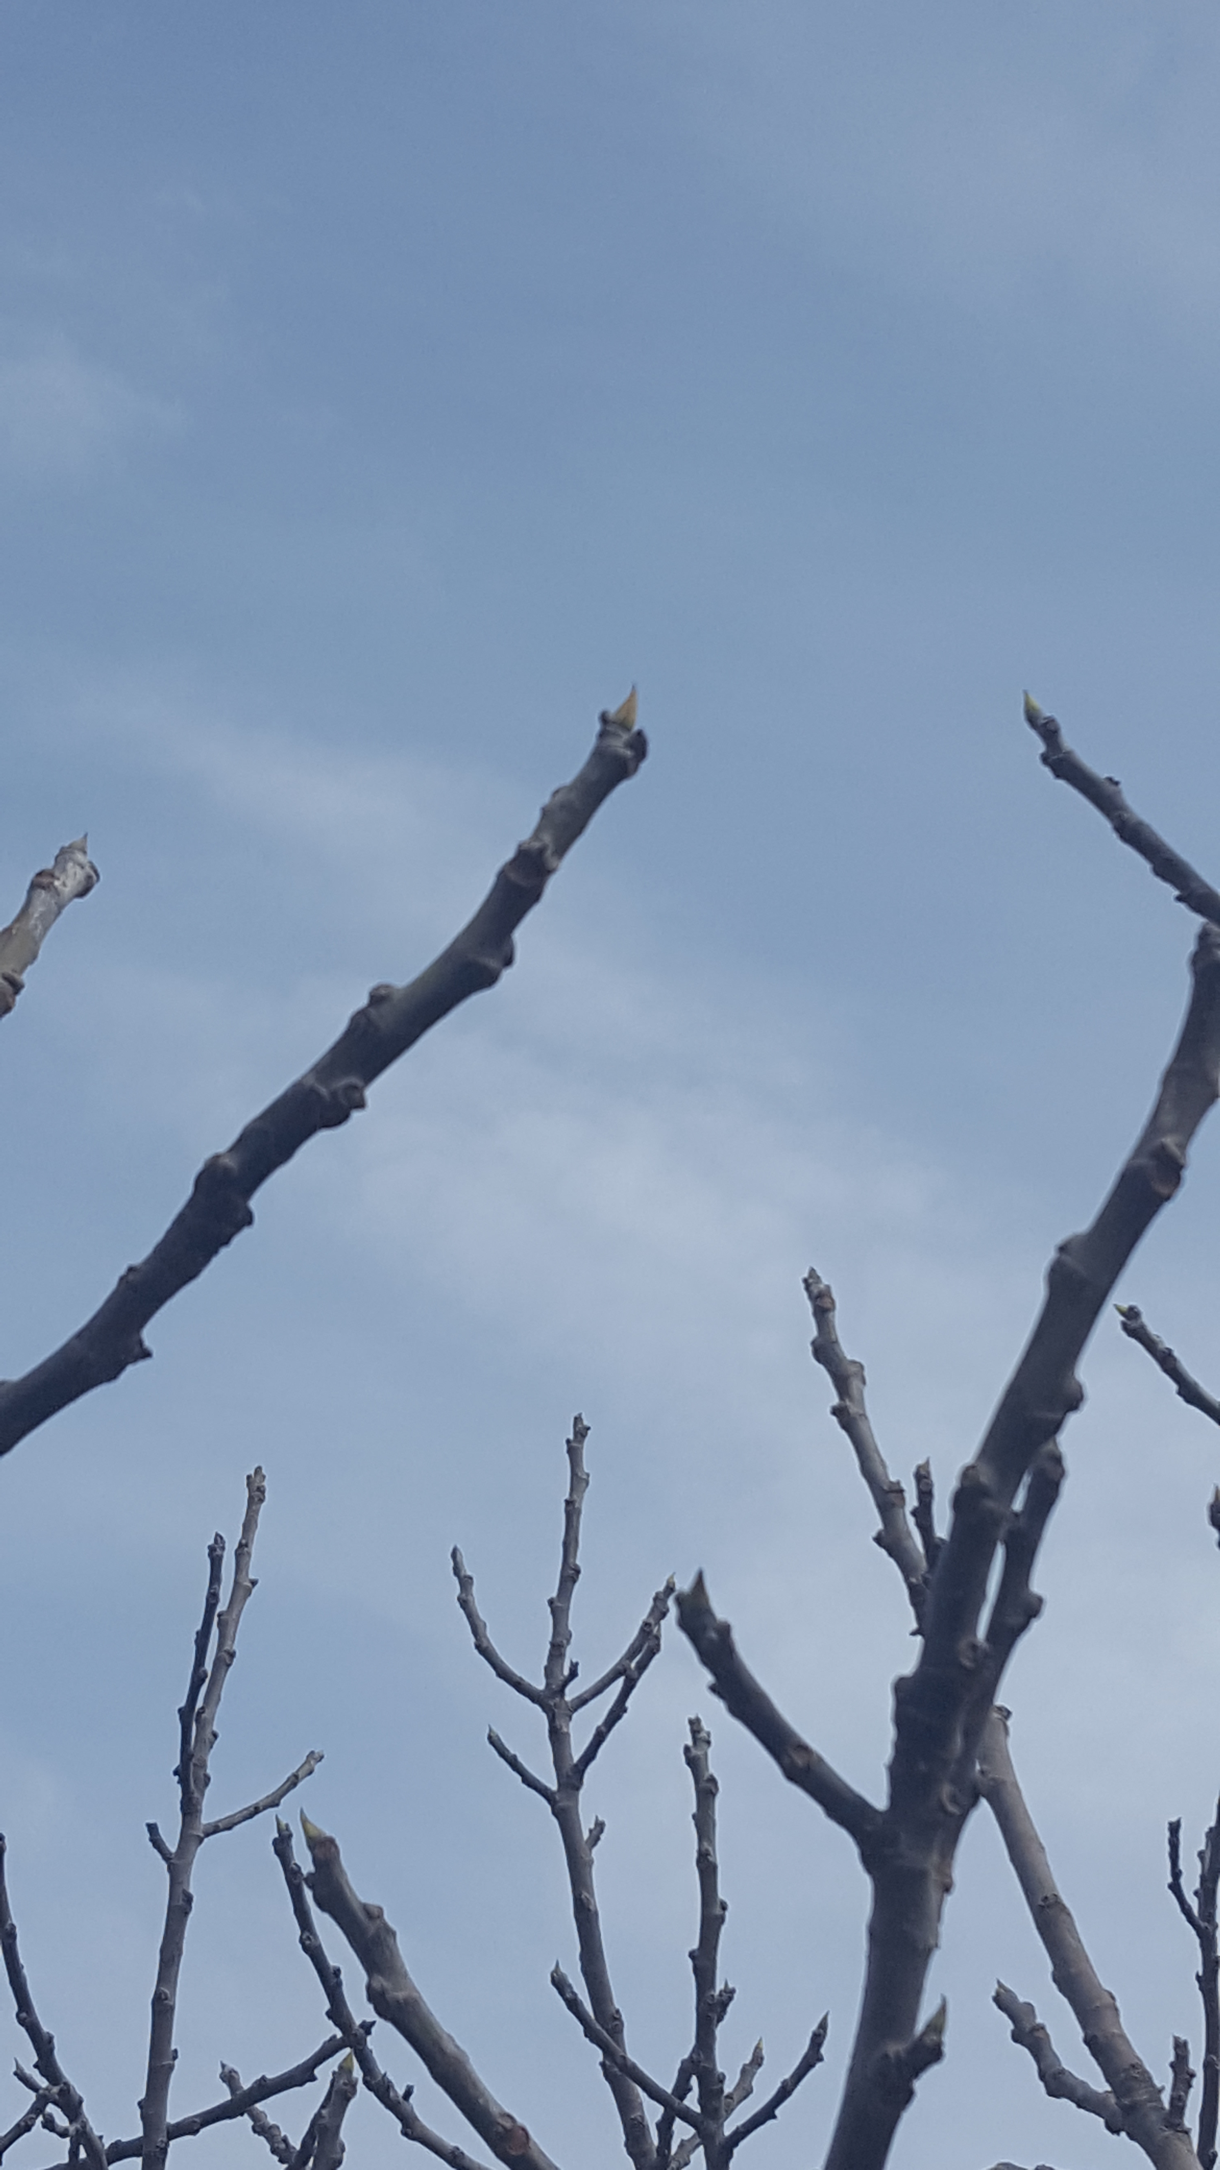

Photo/Sketch 2
Insert Photo and sketch, if available:
Date:march,8,2018
Time:13:00
Green-Up Phase:leaf and fruit formation

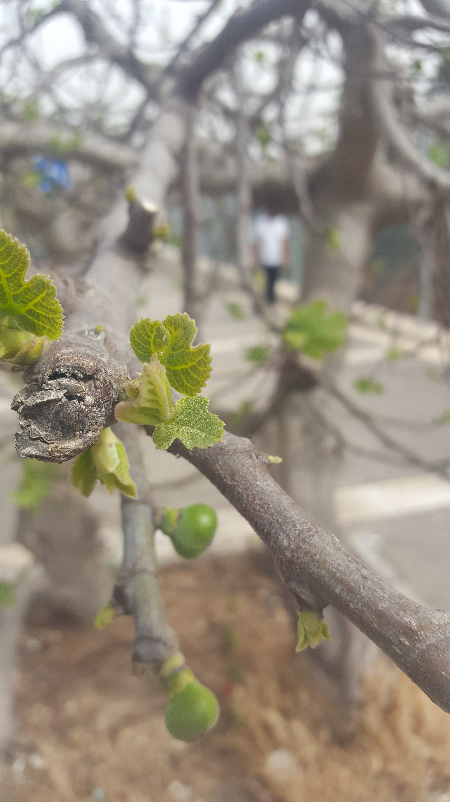
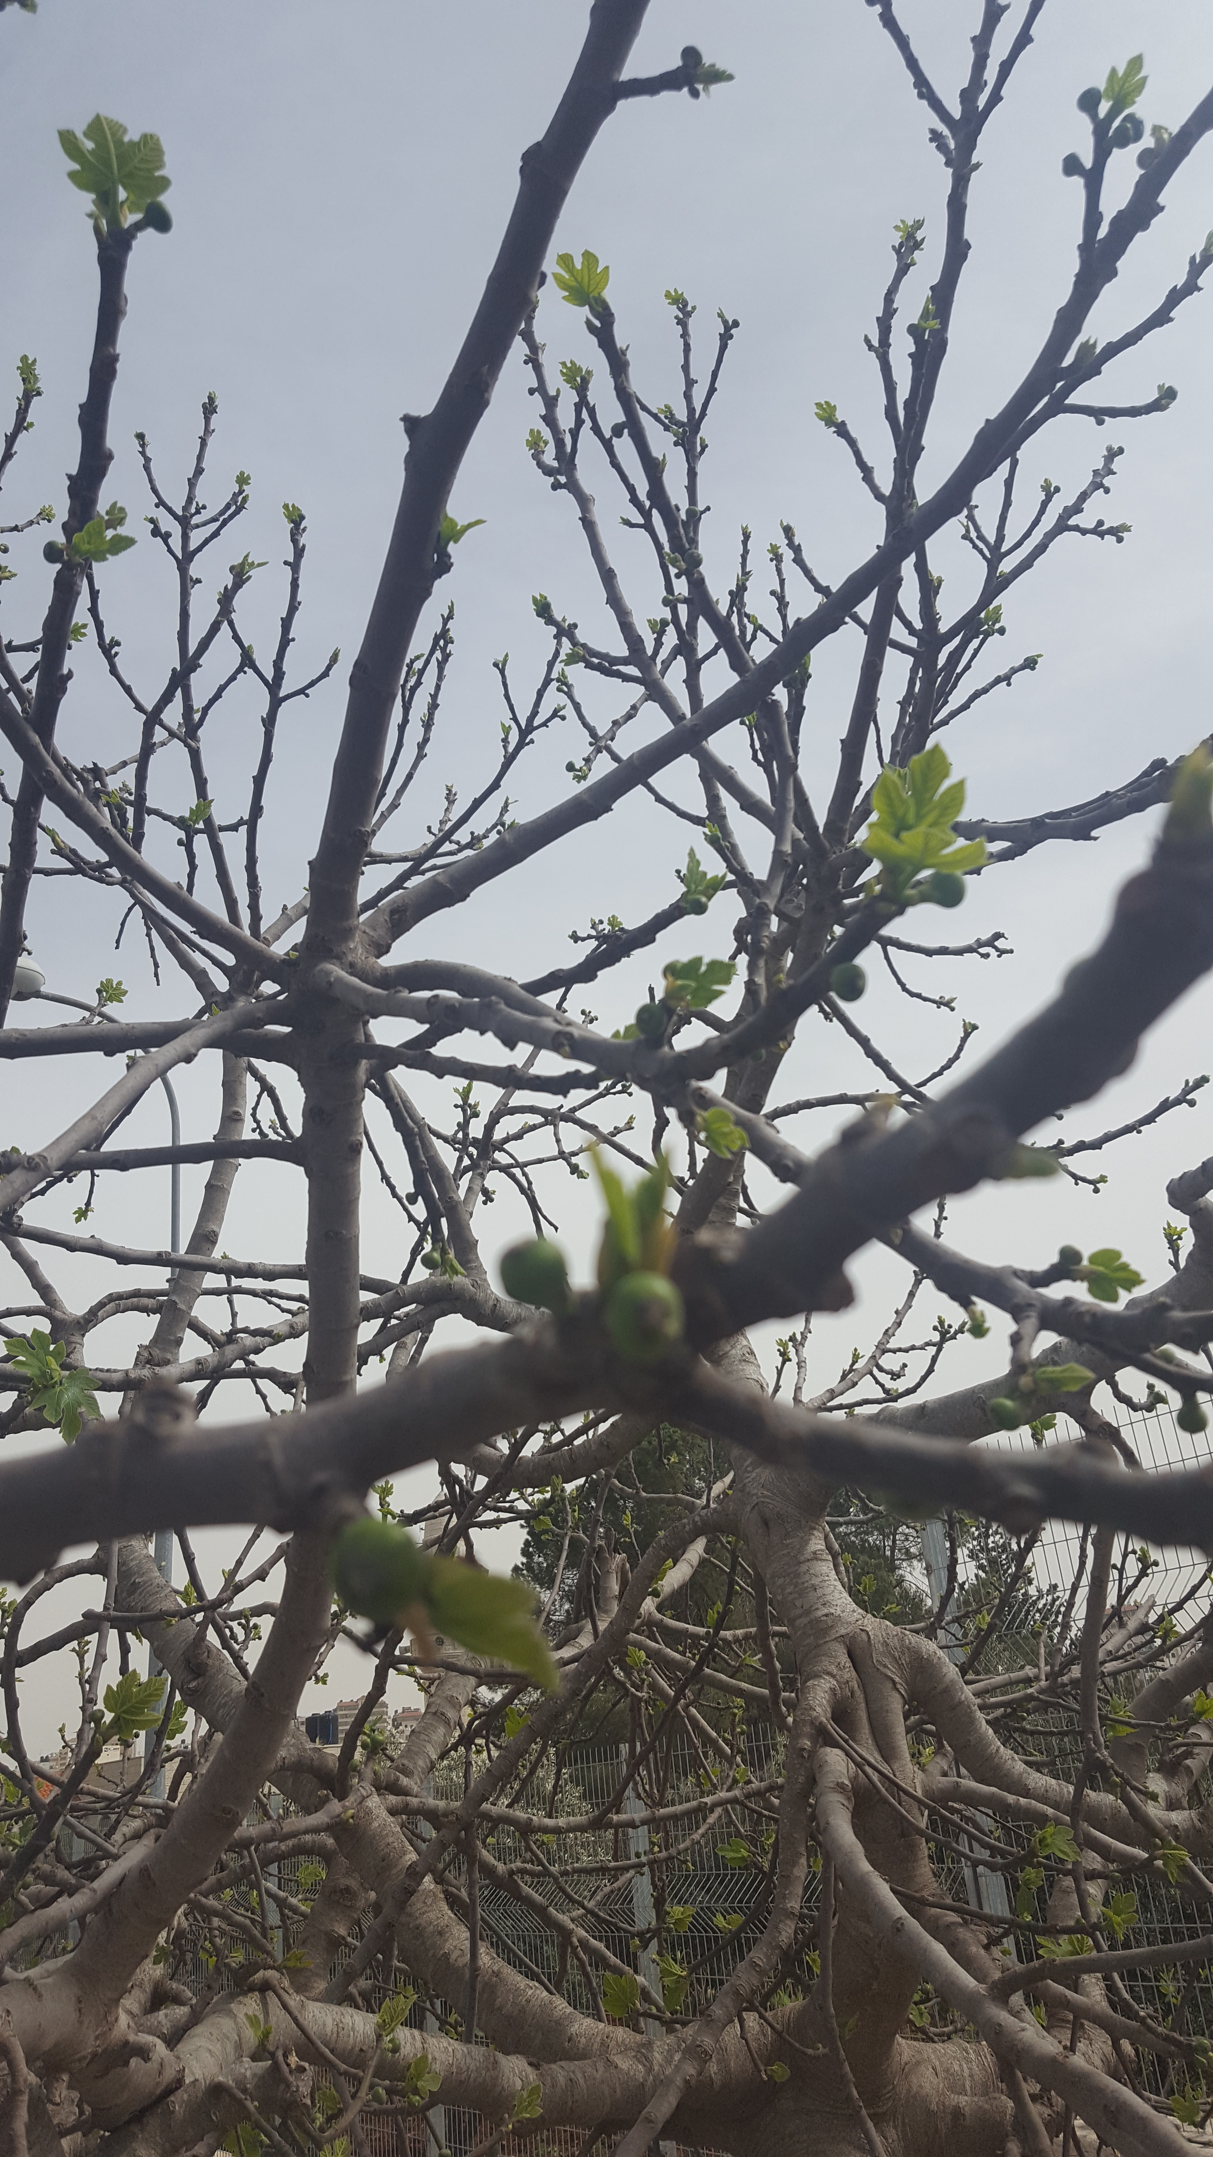
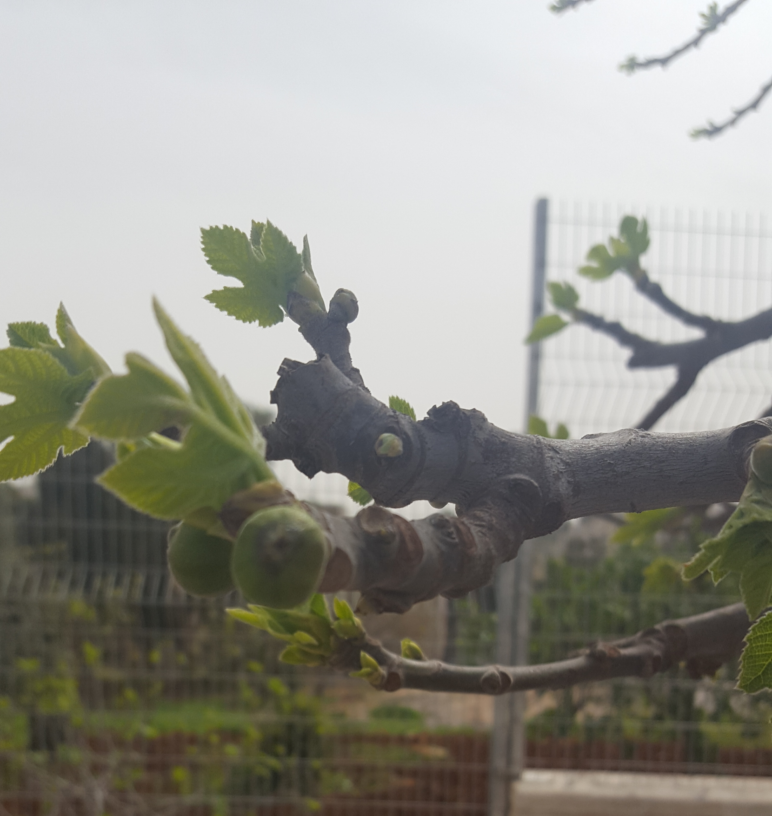

Photo/Sketch 3
Insert Photo and sketch, if available:

Date:
Time:
Green-Up Phase or Length:
Photo/Sketch 4
Insert Photo and sketch, if available:

Date:
Time:
Green-Up Phase or Length:
Photo/Sketch 5
Insert Photo and sketch, if available:

Date:
Time:
Green-Up Phase or Length:

