GrowApp Assignment A

Introduction
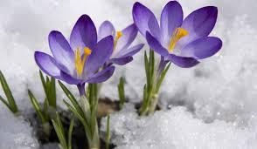
Every year consists of a cycle of seasons. Every season influences the life of plants, animals and humans. Even though nature now plays a less prominent role in our lives compared to the past, every season fills us with a different feeling. Plants and animals are more drastically influenced by the seasons than we are. Trees, like some animal species, show some kind of hibernation too. They breathe through their roots, stem and branches but no longer take up food. When the sun starts to rise higher and stronger again in spring, trees start to get green again.
Research that deals with this yearly cycle in nature, from the first leaves on a tree to the first bird that crawls out of its egg, is called phenology.

You are going to capture this change in nature by making pictures on your phone. These photos function as observations, that will help you to draw conclusions. The GrowApp helps you to take these pictures and add useful information to them. First you need to download the GrowApp from the Playstore or Apple store.

Step 1: download the GrowApp

Orientate
Step 2: Go outside!
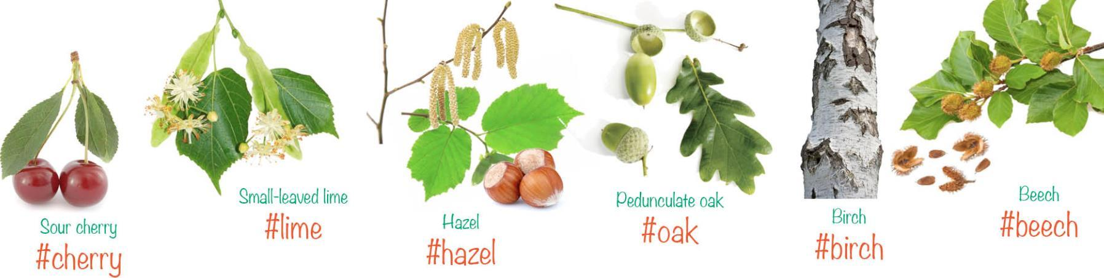
Look for trees of one of the following species: cherry, lime, hazel, oak, birch and beech (see picture below). These are the target species of the European GrowApp campaign. Have you found one? Choose a tree that you can take a picture of on a daily basis.

Gather data
Step 3: Take a picture.
Take a picture of your tree with the GrowApp but pay attention to the following:
- What is your point of orientation? Try to take a picture with your back to the sun.
- What time of the day is it? How does this influence the light? Try to take a picture of your tree at the same time every day.
- Before saving your picture add the following #’s (hashtags)
  - #species, use the hashtags from the picture above if you are photographing one of the target species
  - #your school, ask your teacher for the correct #, so you and your classmates use the same one.
  - #eps, to show you are part of the European Pilot Study!
  - #any hashtag you would like to add to find your tree on the GrowApp website

Step 4: Take a picture every day
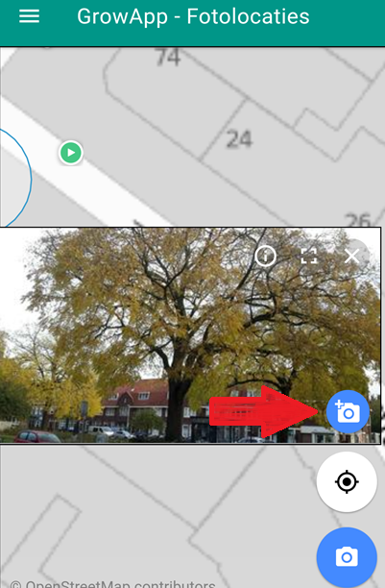
Now take a picture of your tree every day until you have your next lesson on the GrowApp. Stand in the same spot and use the add picture button as indicated with the red arrow on the right. You will see your previous picture transparently now. Make sure you frame the tree in the exact same way. Press save. Congratulations! You now have a time-lapse video of your tree.

Write down
Step 5: phenophases
Answer the following questions, use the internet to answer them if needed.
- What are phenophases?
- When are the phenophases of your tree of choice?
Bring your answers to the next lesson.

