Teacher’s manual GrowApp European Pilot Study (phase A)

Introduction
Dear teacher, thank you for wanting to participate in our GrowApp European Pilot Study (EPS)! This pilot study focuses on phenology, the science of seasonal change in nature, in an international light. Internationalisation has always been a core value of the GLOBE program. We from GLOBE Netherlands feel this value could use some more attention. During this pilot your students will study a tree over time, analyse their results and compare them to another tree in Europe. We hope to link your class to another class in Europe so you can present your findings to each other digitally.

Learning goals:
Working with the GrowApp, students are developing the following learning goals:
- Students will become more aware of nature and their surroundings.
- Students will be more aware that changes in nature are caused by environmental circumstances (temperature, moisture, location, type of soil, etc.)
- Students will be more aware of the current global climate issue and how that is translated to observations in their own surroundings. As well as the consequences for ecosystems, food production, plants, animals, humans and our health.
- Students are introduced to scientific research procedures and learn to work in an organised way, this allows data to be processed in a data bank.

GrowApp
The GrowApp is an app that allows students to easily capture the continuous changes in nature with the aid of time-lapse videos. Their beloved smartphone is the instrument in this research. The student doesn’t need to be an expert on nature to contribute to the GrowApp’s research project, because everyone student is able to take a picture.
Nature’s calendar
The GrowApp is part of Nature’s calendar from Wageningen University. The goals of this research is to investigate the effect of climate change on nature. The research complies of records of yearly returning phenomena in nature. We call this type of research ‘phenology’. Plant related phenology research usually complies of recording the moment of flowering, leaf unfolding, the ripening of fruit, leaf colouring and leaf detachment. Observations are being used for scientific research (watch a TEDed video about phenology here: https://www.youtube.com/watch?v=RNs3XpRmRfI).

European campaign on six target species
In order to compare trees more easily, we kindly ask you to choose one of the species below for your project. These trees are part of the European GrowApp campaign, they have been chosen because of their widespread presence through Europe.

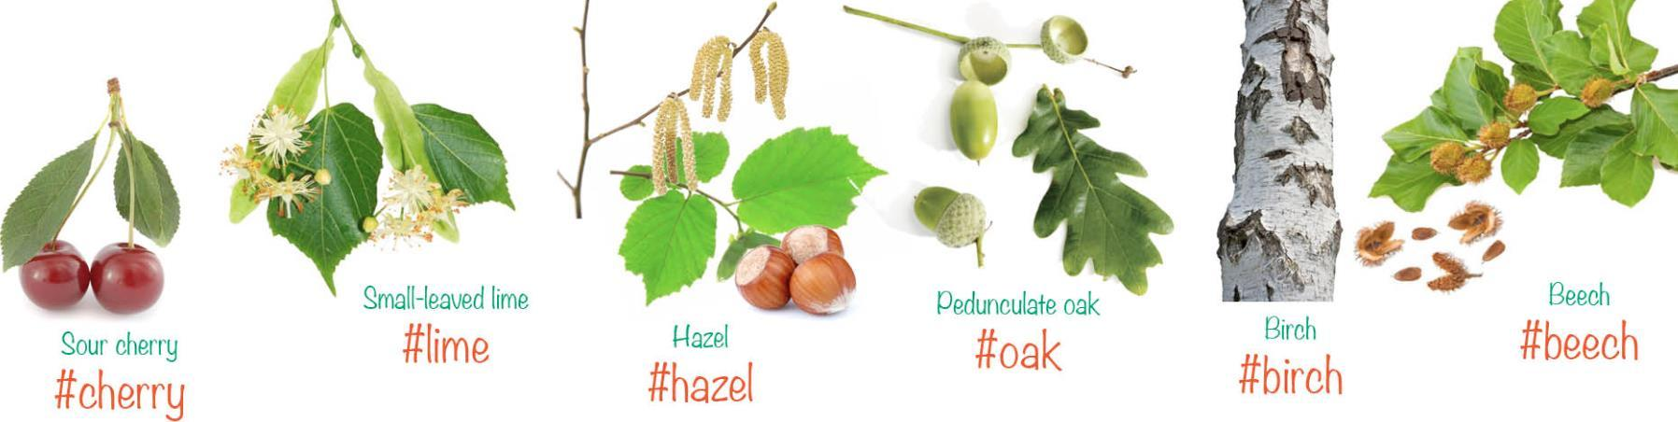

Hashtags
When you or a student take a picture of a tree we would like to ask you to add a couple of #’s (hashtags)
- #species, use the exact hashtags above when investigating one of the target species.
- #yourschool, add a hashtag with your school’s name, this helps you to filter on all pictures made by your students. Communicate your chosen hashtag to your students, to make sure you all use the same one.
- #EPS, to show you are part of the European Pilot Study.
- #Studentname, students can choose to even add a unique hashtag, in order to find their picture more easily.
It is important that at least one of the pictures in your time-lapse has the above hashtags.
Filter
With the filter function in the left-hand corner of the www.growapp.today website, you can easily filter on one of the above hashtags. Press the filter button and type in the hashtag name that you would like to filter on. You can also click on one of the six target species.
Figure 1 illustrates the lay-out of the www.growapp.today website. The blue dots indicate the number of pictures within that area. By zooming in you can find the exact locations of the pictures. In the bottom of the screen you can find a selection of the pictures that are found in your current frame. When clicking one of the pictures, the map will show you the location of the picture. In case the picture is part of a time-lapse, you will be able to see the time-lapse immediately. Clicking the ‘i’ in the righthand corner when the picture is shown, will provide you with date and time details of the picture. The optional description and hashtags will also be shown. 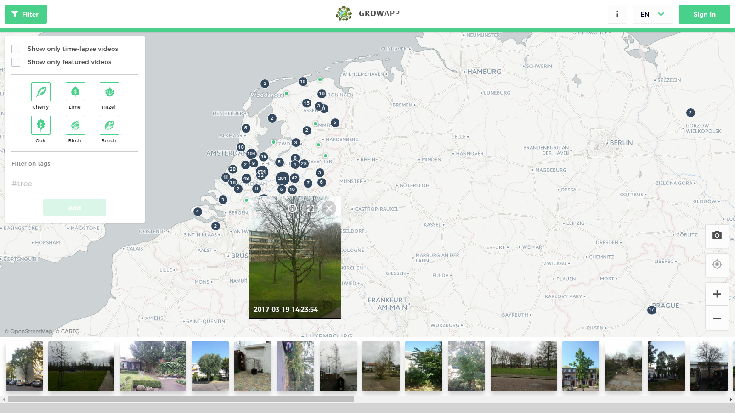
Figuur 1: Screenshot of www.GrowApp.today. The upper left corner shows the filter menu.

Phase A
Please try to start with phase A before the 1st of May. Students should take pictures in a time-span of at least two weeks. You can introduce the GrowApp to your class with the aid of the presentation that can be found here: https://drive.google.com/open?id=0B7eICVmkinfobFdBYlpRcEdjUWs

During this introduction lesson, you can introduce the GrowApp to your class and you can even go outside to let your students test it. It is up to you how much time you want spend on this introduction. You can choose to do assignment A together as a class or give it as homework to your students. This also depends on the level of independence of your students.

