ABSTRACT

“A GLOBEal Window of Opportunity”
(A study conducted using GLOBE protocols to analyze how the weather changes during the two-hour solar noon window for data collection.)
Bayleigh J. Jetton
Elizabeth Hernandez
6th grade Alpena Middle School

"How do the components of the atmosphere, Aerosols, Surface Temperature, and Cloud Cover change during the two-hour solar noon window for GLOBE observations and data collection?" Air and surface temperatures would increase, barometric pressure, relative humidity, and cloud cover would decrease. AOT readings would show a significant difference.

During 15 days, the researchers followed GLOBE protocols for observing and collecting data for Aerosol Optical Thickness (AOT), surface temperature, cloud cover, air temperature, relative humidity, and barometric pressure. Data was collected at the beginning of the 2-hour solar noon window, at solar noon and at the end window, then entered into the GLOBE database.

Beginning of solar noon AOT: blue=0.080, Green=0.064, red=0.077. Solar noon blue=0.123, Green=0.113, red=0.110. End of solar noon blue=0.068, Green=0.053, red=0.066. Surface temperature beginning=18.5˚C, solar noon =18.7˚C, end=20.3˚C. Air temperature at the beginning=14.6˚C, solar noon =15.5˚C. end=16.4˚C. Relative humidity at the beginning=14.6˚C, solar noon=15.5˚C, end=16.4˚C. Barometric pressure at the beginning=974.3mb, solar noon=973.5mb, end=972.9mb. Cloud cover at the beginning=45.3%, solar noon=45.3%, end=43.3%. 10 days recorded no change in cloud cover, 2 days a 20% change and the 3 days 10% change.

As predicted, the air and surface temperatures increased and the barometric pressure, and relative humidity decreased as the window progresses from the beginning of the solar noon window to the close. The cloud over showed little change. The solar noon AOT readings were 58% higher than the beginning and 85% higher than the end of the solar noon window.

“A GLOBEal Window of Opportunity”

(A study conducted using GLOBE protocols to analyze how the weather changes during the two-hour solar noon window for data collection).

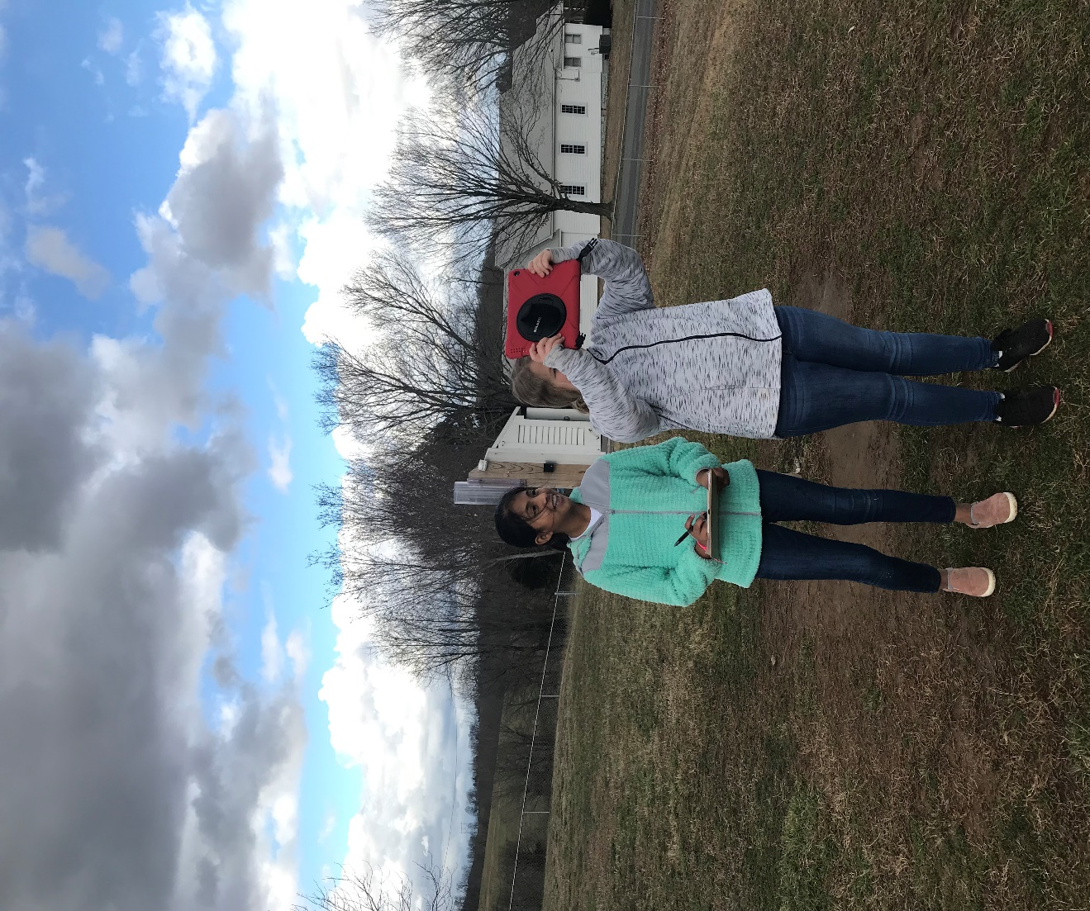

Bayleigh Jetton
Elizabeth Hernandez
6th grade Alpena Middle School
Roger Rose – Science Teacher
March 12th 2020

TABLE OF CONTENTS

Abstract…………………………………………….…….......... 1
Title Page and Table of Contents ……………........... 2-3
Research Question and Hypothesis………….……….. 4
Methods & Materials……………………………….………… 5
Data Summary (Chart & Graph) ……………………………... 6 - 13
Analysis & Results…………………............................. 14
Conclusions……………………………………….…............ 15
Discussion…………………………………………...………… 15
Acknowledgements………………………………............. 15
Pictures of Data Collection ………………………… 16 – 17
Display Board ……………………………………………. 18 - 19
References/Bibliography…………………………………… 19

INTRODUCTION & RESEARCH QUESTION
Have you ever noticed how the clouds in the sky changes continuously? No matter what type of clouds are in the sky they are constantly changing shapes and moving around. And, even if there aren't any clouds in the sky, the components of the atmosphere are constantly changing as the sun heats up the air causing it to rise and then cooler air moves into its place. The air temperature, barometric pressure, humidity, particles in the air are constantly changing even if we can't see it. The international network called GLOBE "Global Learning and Observations to Benefit the Environment" is a science and education program that is made up of scientist, teachers, and students from more than 122 countries. The GLOBE program offers participants the opportunity to collect data that can be used by scientist to study and better understand the interactions between earth's systems. The GLOBE program is anchored by protocols that are used to make observations and collect data about the world that we live in. Many of the GLOBE atmospheric observations and data collections are conducted during a two-hour window centered around local solar noon for the observer's area. According to GLOBE, "Solar noon is the time during the day when the sun appears to have reached its highest point in the sky. Astronomers refer to this time as local apparent noon. Usually, this is not the same time as "clock noon". The relationship between clock noon and solar noon depends on your location within your time zone and the time of year. Solar noon always occurs half-way between local sunrise and sunset."
The GLOBE atmospheric observations and data collections for Aerosols, Surface Temperature, and Cloud Cover, are centered around the two-hour window around local solar noon. The research question being addressed in this investigation is, "How do the components of the atmosphere, Aerosols, Surface Temperature, and Cloud Cover change during the two-hour solar noon window for GLOBE observations and data collection?"

HYPOTHESIS
Based on the researcher's previous experience in making solar noon observations for GLOBE, it was predicted that the air and surface temperatures would increase and the barometric pressure, relative humidity, and cloud cover would decrease as the window progresses from the beginning of the solar noon window to the close. It is predicted that there will be a significant difference in the AOT readings from the beginning to the end of the solar noon window. It is also predicted that 40% of the days, (2 out of every 5), will show a significant difference in cloud cover.

GLOBE Protocol Used
Aerosols (AOT) Surface Temperature
Cloud Cover Barometric Pressure
Air Temperature Relative Humidity

RESEARCH METHODS & MATERIALS
For the past year, the researchers have been making observations and collecting data using the GLOBE protocols for Aerosols, Surface Temperature, and Cloud Cover. Over a period of 15 days, the observers followed the GLOBE protocols for making observations and collecting data for Aerosols, Surface Temperature, and Cloud Cover. The first set of observations and data collections were conducted during the beginning of the solar noon window that occurred during the noon recess right after lunch. The researchers collected the solar noon and ending of solar noon window data during their science classes over the next two hours. A Calitoo meter was used to collect Aerosol Optical Thickness (AOT). AOT data was only available on the days when clouds were not blocking the sun. GLOBE Cloud charts were used to analyze the types of clouds and cloud cover. A digital infrared thermometer was used to collect the surface temperature. An iPad was used to record the cloud observations. All data collected was recorded on GLOBE data sheets and then entered into the GLOBE website data base according to the GLOBE protocols for each type of observation. *Risk and Safety Concerns to be addressed: There were no specific risk or concerns to be addressed for this project. Observations and data collections will be conducted at the school’s weather station location on the school campus. The researchers have been trained in using the GLOBE protocols for making the observations, collecting the data, and submitting the data to GLOBE. *Data Analysis: Once all the data was collected, it was analyzed by placing the information in charts and graphs in order to determine the extent of the weather changes during the solar noon window of opportunity.
MATERIALS: Calitoo Sun Photometer, Cloud Observation Sheets, Digital Infrared Thermometer, GLOBE Protocol pdf documents, iPad for data collection
Dates of Data Collection for Solar Noon Windows
 | Test Date | Clouds | Surface Temperature | Aerosols
Week #1 | 10/15 | X | X | NA
 | 10/16 | X | X | X
 | 10/17 | X | X | X
 | 10/18 | X | X | X
 | 10/19 | X | X | NA
Week #2 | 10/21 | X | X | X
 | 10/22 | X | X | X
 | 10/23 | X | X | X
 | 10/24 | X | X | NA
 | 10/25 | X | X | NA
Week #3 | 10/28 | X | X | NA
 | 10/29 | X | X | NA
 | 10/30 | X | X | NA
 | 10/31 | X | X | X
 | 11/01 | X | X | X
DATA SUMMARY

Aerosol Data Collection Results for Solar Noon Windows
(Recorded in three different wavelength with a CALITOO meter as AOT (Aerosol Optical Thickness)
 | Beginning of the  Solar Noon Window |  |  | Solar Noon |  |  | End of the  Solar Noon Window
 | Channel Wavelength |  |  | Channel Wavelength |  |  | Channel Wavelength
Test Date | Blue  465 | Green  540 | Red  619 | Blue  465 | Green  540 | Red  619 | Blue  465 | Green  540 | Red  619
10/16 | 0.091 | 0.071 | 0.081 | 0.084 | 0.0.65 | 0.077 | 0.084 | 0.064 | 0.074
10/17 | 0.075 | 0.059 | 0.075 | 0.078 | 0.061 | 0.075 | 0.080 | 0.062 | 0.077
10/18 | 0.088 | 0.072 | 0.088 | 0.151 | 0.136 | 0.155 | 0.060 | 0.045 | 0.058
10/21 | 0.072 | 0.060 | 0.077 | 0.208 | 0.169 | 0.174 | 0.064 | 0.052 | 0.064
10/22 | 0.073 | 0.059 | 0.072 | 0.204 | 0.246 | 0.191 | 0.068 | 0.055 | 0.068
10/23 | 0.071 | 0.056 | 0.072 | 0.074 | 0.059 | 0.075 | 0.076 | 0.061 | 0.076
10/31 | 0.134 | 0.112 | 0.113 | 0.150 | 0.139 | 0.124 | 0.069 | 0.056 | 0.065
11/01 | 0.040 | 0.030 | 0.045 | 0.042 | 0.032 | 0.048 | 0.041 | 0.032 | 0.048
Total | 0.644 | 0.519 | 0.623 | 0.991 | 0.907 | 0.879 | 0.542 | 0.427 | 0.530
Mean | 0.080 | 0.064 | 0.077 | 0.123 | 0.113 | 0.110 | 0.068 | 0.053 | 0.066
Overall Mean AOT | 0.073 AOT  Beginning of the Solar Noon Window |  |  | 0.115 AOT  Solar Noon |  |  | 0.062 AOT  End of the Solar  Noon Window

Surface Temperature Data Collection Results for Solar Noon Windows
(recorded as average °C)
Test Date | Beginning of the  Solar Noon Window | Solar Noon | End of the  Solar Noon Window
10/15 | 21.6 | 21.1 | 26.7
10/16 | 21.8 | 22.5 | 25.6
10/17 | 27.5 | 27.6 | 26.0
10/18 | 26.9 | 30.6 | 35.7
10/19 | 18.7 | 20.6 | 25.9
10/21 | 24.6 | 23.6 | 23.5
10/22 | 23.0 | 22.6 | 23.4
10/23 | 25.3 | 27.7 | 24.3
10/24 | 12.6 | 10.6 | 3.6
10/25 | 9.3 | 8.6 | 9.1
10/28 | 20.3 | 19.6 | 29.8
10/29 | 8.6 | 9.6 | 9.6
10/30 | 10.2 | 7.1 | 10.1
10/31 | 9.3 | 10.2 | 10.5
11/01 | 18.2 | 18.8 | 20.3
Total | 277.9 | 280.8 | 304.1
Mean  Surface Temperature | 18.5°C | 18.7°C | 20.3°C

Cloud Coverage Data Collection Results for Solar Noon Windows
(recorded as average % of Cloud Cover)
Scale used for calculating Cloud Cover:
None = 0, Few = 10%, Isolated = 20%, Scattered = 40%, Broken = 70%, Overcast = 90%
Test Date | Beginning of the  Solar Noon Window | Solar Noon | End of the  Solar Noon Window
10/15 | 90 | 90 | 70
10/16 | 0 | 0 | 10
10/17 | 0 | 0 | 10
10/18 | 40 | 40 | 20
10/19 | 70 | 90 | 70
10/21 | 10 | 0 | 0
10/22 | 10 | 10 | 10
10/23 | 10 | 10 | 10
10/24 | 90 | 90 | 90
10/25 | 90 | 90 | 90
10/28 | 70 | 70 | 70
10/29 | 90 | 90 | 90
10/30 | 90 | 90 | 90
10/31 | 20 | 10 | 20
11/01 | 0 | 0 | 0
Total | 680 | 680 | 650
Mean  Cloud Cover | 45.3% | 45.3% | 43.3%

Air Temperature Data Collection Results for Solar Noon Windows
(recorded as average °C during Cloud Observations)
Test Date | Beginning of the  Solar Noon Window | Solar Noon | End of the  Solar Noon Window
10/15 | 23.5 | 22.9 | 23.1
10/16 | 12.5 | 13.8 | 15.0
10/17 | 18.8 | 19.4 | 22.2
10/18 | 21.8 | 23.1 | 23.6
10/19 | 17.8 | 19.7 | 21.9
10/21 | 16.3 | 17.3 | 19.3
10/22 | 16.4 | 17.6 | 18.2
10/23 | 22.7 | 23.8 | 23.9
10/24 | 10.5 | 10.8 | 10.0
10/25 | 808 | 9.7 | 10.2
10/28 | 18.2 | 20.2 | 19.6
10/29 | 8.0 | 8.0 | 8.6
10/30 | 7.3 | 7.7 | 7.7
10/31 | 3.6 | 4.8 | 6.1
11/01 | 12.4 | 14.8 | 15.8
Total | 218.6 | 233.0 | 245.3
Mean  Air Temperature | 14.6°C | 15.5°C | 16.4°C

Barometric Pressure Data Collection Results for Solar Noon Windows
(recorded as average mb during Cloud Observations)
Test Date | Beginning of the  Solar Noon Window | Solar Noon | End of the  Solar Noon Window
10/15 | 969 | 969 | 968
10/16 | 977 | 977 | 977
10/17 | 976 | 973 | 974
10/18 | 970 | 969 | 968
10/19 | 966 | 965 | 964
10/21 | 964 | 964 | 964
10/22 | 975 | 974 | 972
10/23 | 973 | 972 | 972
10/24 | 980 | 979 | 979
10/25 | 980 | 978 | 977
10/28 | 973 | 972 | 971
10/29 | 977 | 977 | 976
10/30 | 973 | 972 | 971
10/31 | 981 | 982 | 980
11/01 | 981 | 980 | 981
Total | 14,615 | 14,603 | 14,594
Mean  Barometric Pressure | 974.3mb | 973.5mb | 972.9mb

Relative Humidity Data Collection Results for Solar Noon Windows
(recorded as % Relative Humidity during Cloud Observations)
Test Date | Beginning of the  Solar Noon Window | Solar Noon | End of the  Solar Noon Window
10/15 | 95 | 95 | 95
10/16 | 69 | 64 | 57
10/17 | 59 | 63 | 63
10/18 | 63 | 59 | 54
10/19 | 95 | 85 | 73
10/21 | 56 | 51 | 50
10/22 | 43 | 38 | 34
10/23 | 37 | 30 | 52
10/24 | 95 | 95 | 95
10/25 | 95 | 95 | 95
10/28 | 95 | 84 | 72
10/29 | 95 | 95 | 95
10/30 | 95 | 95 | 95
10/31 | 64 | 58 | 56
11/01 | 37 | 30 | 29
Total | 1,093 | 1,037 | 1,019
Mean  Relative Humidity | 72.9% | 69.1% | 67.7%

ANALYSIS AND RESULTS

AEROSOL RESULTS:
Aerosol data was collected on 8 different days when the sun was not covered by clouds. The Calitoo meter measures AOT in three wavelengths, Blue-465 nanometers, Green-540 nanometers, and Red-619 nanometers.
The beginning of solar noon readings averaged blue=0.080, Green=0.064, and red=0.077, for an overall average of 0.073. The solar noon readings averaged blue=0.123, Green=0.113, and red=0.110, for an overall average of 0.115. The end of solar noon readings averaged blue=0.068, Green=0.053, and red=0.066, for an overall average of 0.062.

SURFACE TEMPERATURE RESULTS:
Surface Temperature results were collected on all 15 days. According to the GLOBE protocols, 9 temperatures were recorded for each observation for a total of 405 total surface temperatures recorded and analyzed. The average surface temperature at the beginning of the window was 18.5˚C. The average surface temperature for solar noon was 18.7˚C. The average surface temperature at the ending of the window was 20.3˚C.

CLOUD OBSERVATIN RESULTS:
Cloud data was collected on 15 different days. The average air temperature at the beginning of the window was 14.6˚C. The average air temperature for solar noon was 15.5˚C. The average air temperature at the ending of the window was 16.4˚C. According to the data, the air temperature increased by 0.9˚C each hour resulting in a 6% per hour increase in temperature.

The average relative humidity at the beginning of the window was 14.6˚C. The average relative humidity for solar noon was 15.5˚C. The average relative humidity at the ending of the window was 16.4˚C. According to the data, the relative humidity decreased by 3.8% the first hour and then only by 1.4% the last hour of the solar noon window.

The average barometric pressure at the beginning of the window was 974.3mb. The average barometric pressure for solar noon was 973.5mb. The average barometric pressure at the ending of the window was 972.9mb. According to the data, the barometric pressure decreased by 0.8mb the first hour and then only by 0.6mb the last hour of the solar noon window.

The average cloud cover at the beginning of the window was 45.3%. The average cloud cover for solar noon was 45.3. The average cloud cover at the ending of the window was 43.3. According to the data, the cloud cover only decreased by 2% during the last hour of the solar noon window. 8 of the days recorded no change in cloud cover, 2 days recorded a 20% decrease in cloud cover, 1 day recorded a 105 decrease in cloud cover, 2 days showed a 10% increase in cloud cover, and 2 days recorded a difference at solar noon but were the same at both ends of the solar noon window.

CONCLUSION
The hypothesis was mostly supported by the data. As predicted, the air and surface temperatures increased and the barometric pressure, and relative humidity decreased as the window progresses from the beginning of the solar noon window to the close. However, the cloud over did not change very much during the solar noon window. Sometimes it increased slightly and sometimes it decreased slightly resulting in only a 2% change in cloud cover. The most significant differences recorded during the solar noon window were the readings for AOT. The solar noon AOT readings were 58% higher than the beginning of the window and 85% higher than the readings recorded at the end of the solar noon window. After reviewing all of the data, the researchers have concluded that the overall weather conditions change only slightly during the solar noon window of opportunity for data collection. The researchers recommend that when collecting the solar noon weather data, it would be best to always try and collect it during the same part of the solar noon window in order to make the observations more consistent.

DISCUSSION
The researchers learned a lot about collecting and analyzing weather data during this investigation. It was interesting that for the most part, the weather did not change a lot during the two-hour solar noon window for data collection. The data was collected during the winter and it would be very interesting to see how the data would look if the investigation was conducted during the spring time when there are a lot more storms moving through our area during the day.

ACKNOLWEDGEMENTS
The researchers want to thank their science teacher, Mr. Rose for teaching them about GLOBE and supervising them while they collected the data for their project. Ms. Tammy also helped supervise the researchers while they were collecting data when Mr. Rose was teaching his regular science classes.
Collecting Data

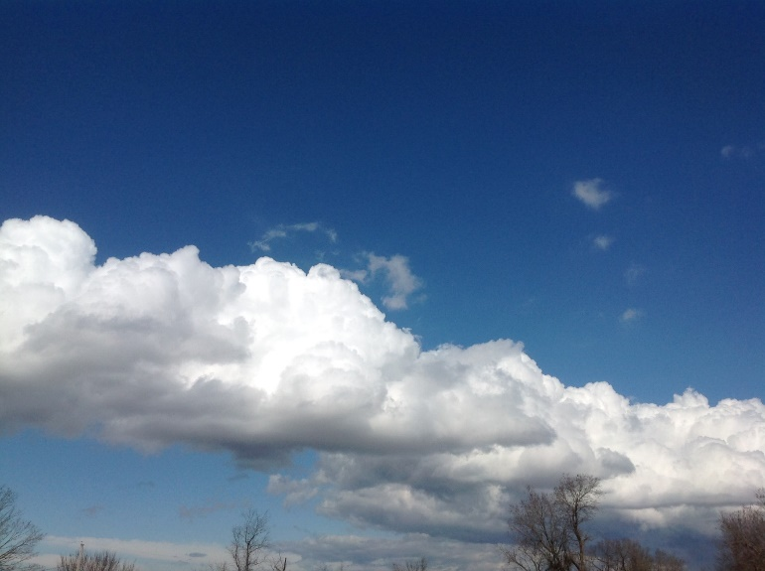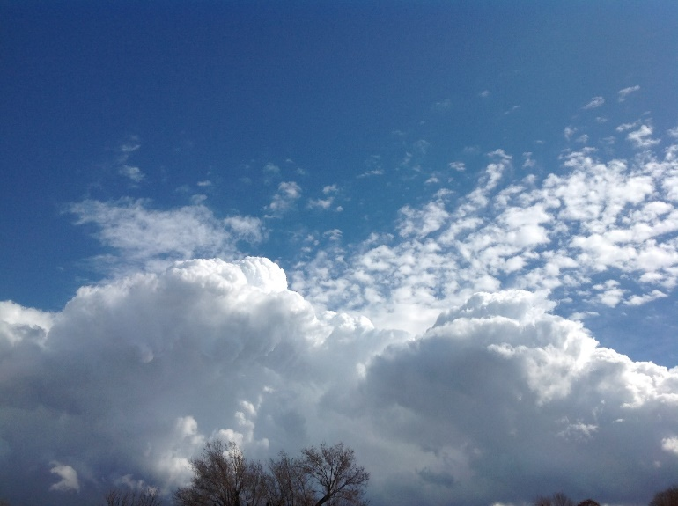

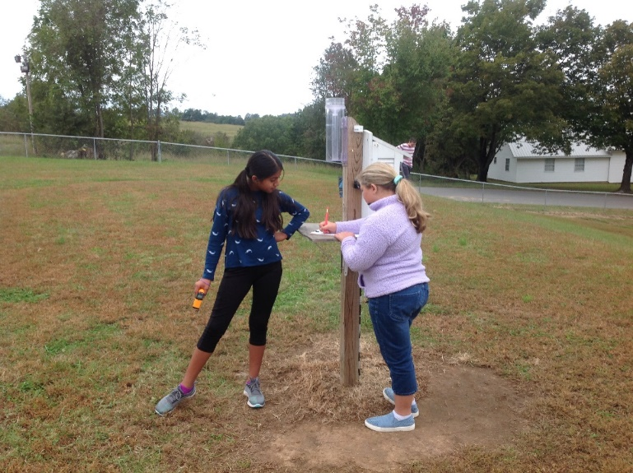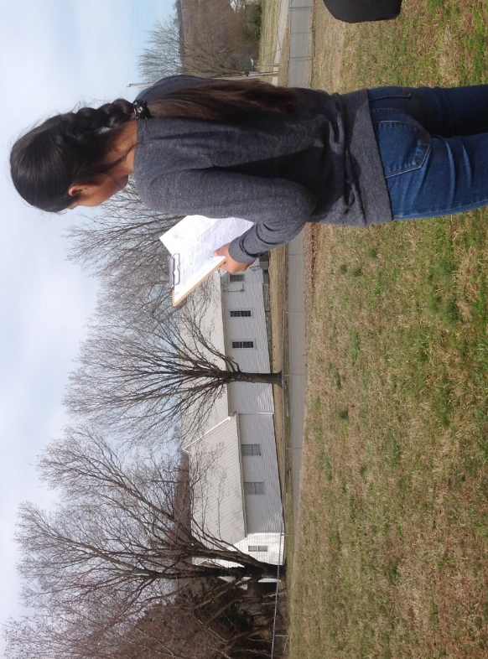

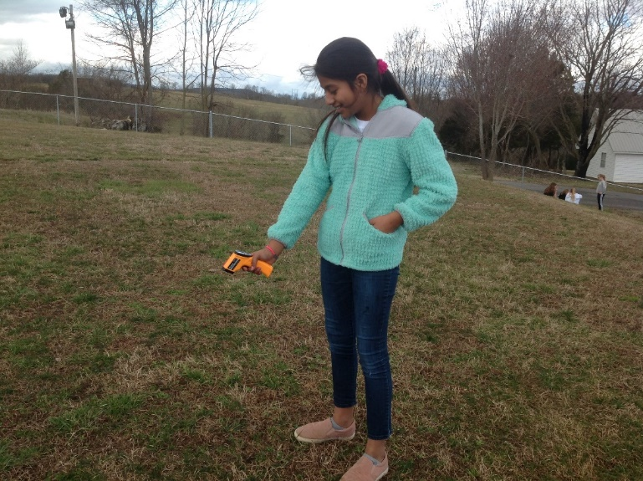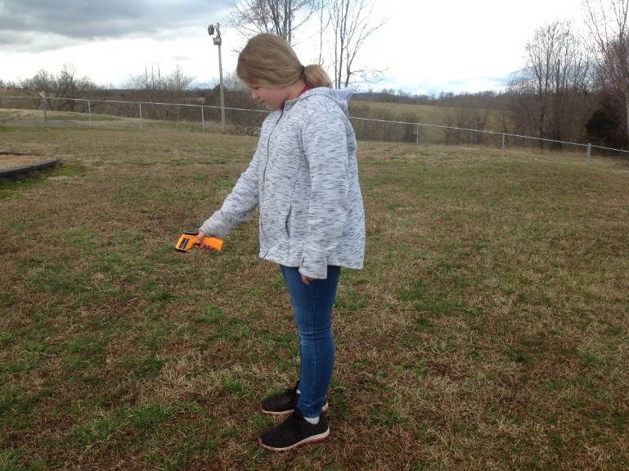

Collecting Data
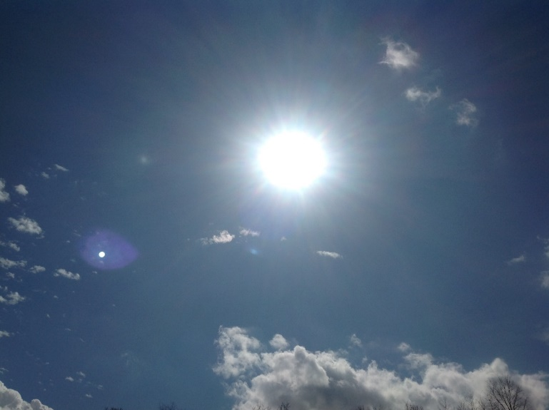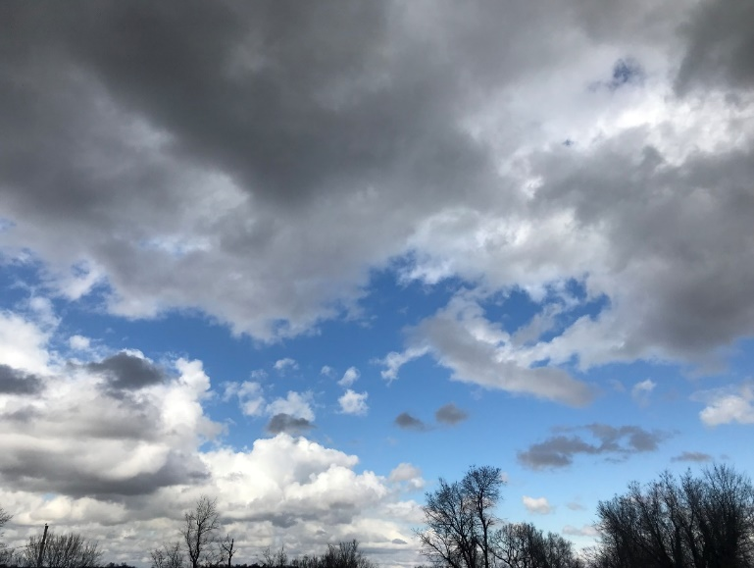

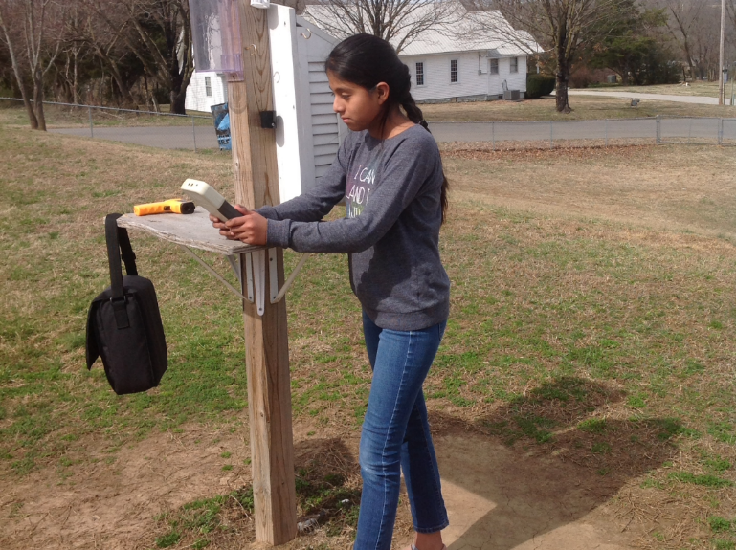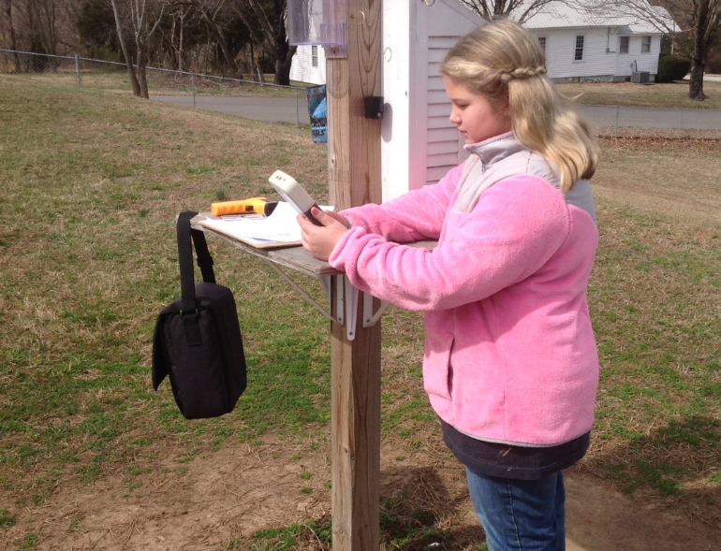

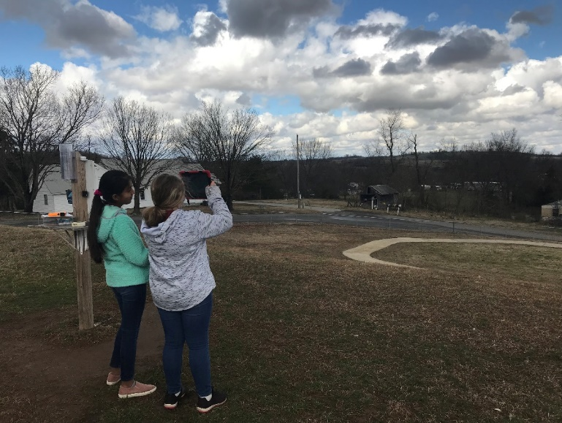

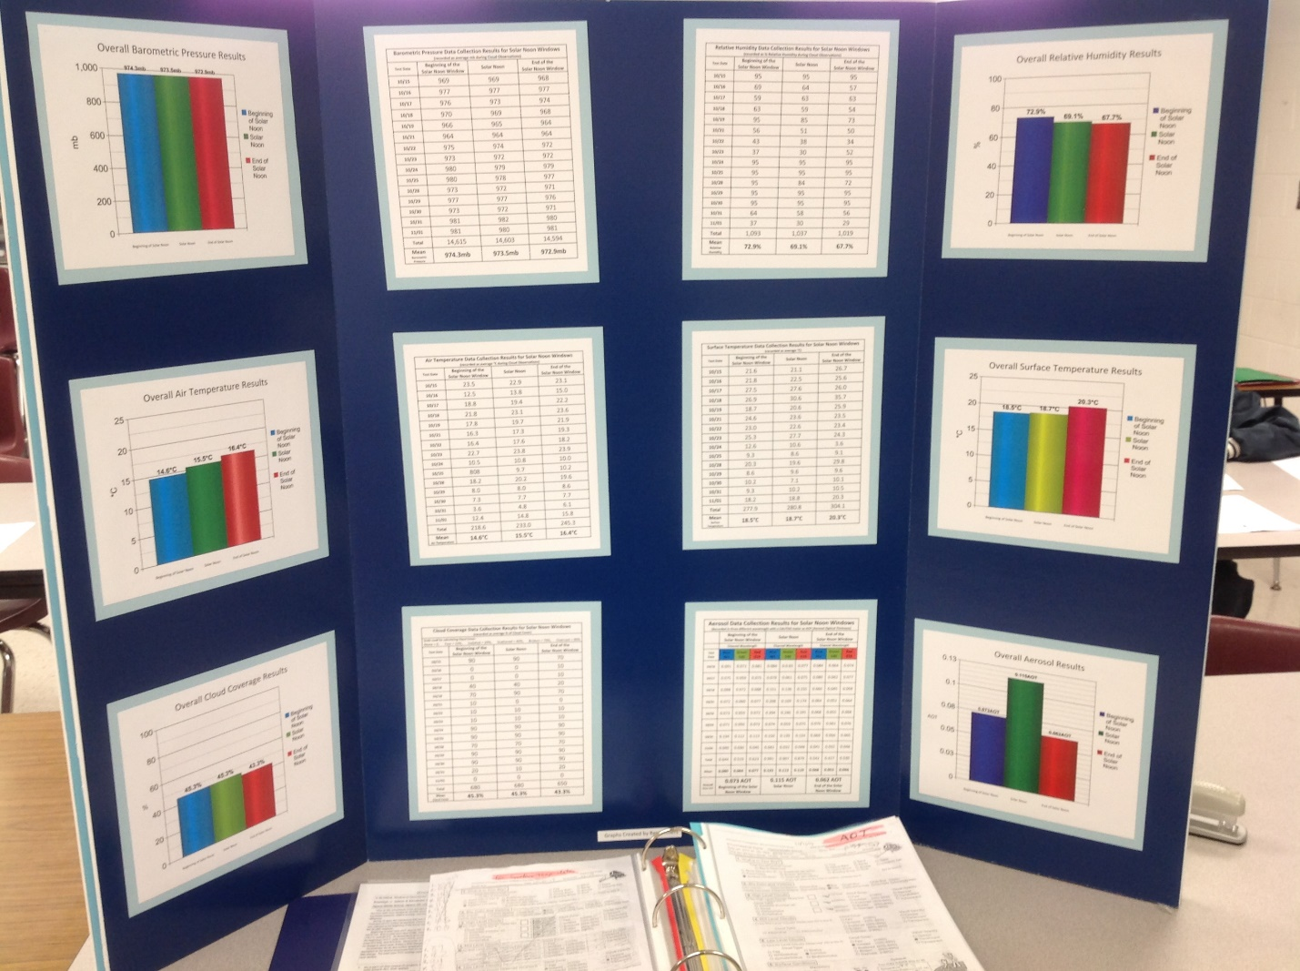
BIBLIOGRAPHY

Boucher, Olivier, et al. "Clouds and Aerosols." Climate change 2013: the physical science basis. Contribution of Working Group I to the Fifth Assessment Report of the Intergovernmental Panel on Climate Change. Cambridge University Press, 2013. 571-657.

Brooks, David R., and Forrest M. Mims. "Development of an inexpensive handheld LED‐based Sun photometer for the GLOBE program." Journal of Geophysical Research: Atmospheres 106.D5 (2001): 4733-4740.

Brooks, David R. "Scientist-Teacher-Student Partnerships for Aerosol Optical Thickness Measurements in Support of Ground Validation Programs for Remote Sensing Spacecraft." 54th International Astronautical Congress of the International Astronautical Federation, the International Academy of Astronautics, and the International Institute of Space Law. 2003.

Butler, Dixon M., and Ian D. MacGregor. "GLOBE: Science and education." Journal of Geoscience Education 51.1 (2003): 9-20.

Calitoo, Oct 3, 2016 - CALITOO. SunPhotometer. User Manual. October 2016. 21, avenue de Fondeyre - 31200 TOULOUSE CEDEX - FRANCE. Tél. : 05 62 24 48 92 ...

retrieved from the Internet on 09/21/2019 at www.calitoo.fr/uploads/documents/en/usermanual_2016_en.pdf

King, Michael D., et al. "Cloud and aerosol properties, precipitable water, and profiles of temperature and water vapor from MODIS." IEEE Transactions on Geoscience and Remote Sensing 41.2 (2003): 442-458.

Kolb, C. E., et al. "An overview of current issues in the uptake of atmospheric trace gases by aerosols and clouds." Atmospheric Chemistry and Physics 10.21 (2010): 10561-10605.

McClatchey, Robert A., et al. Optical properties of the atmosphere. No. AFCRL-72-0497. AIR FORCE CAMBRIDGE RESEARCH LABS HANSCOM AFB MA, 1972.

Paulson, Ca A. "The mathematical representation of wind speed and temperature profiles in the unstable atmospheric surface layer." Journal of Applied Meteorology 9.6 (1970): 857-861.
Rodgers, Clive D. "Retrieval of atmospheric temperature and composition from remote measurements of thermal radiation." Reviews of Geophysics 14.4 (1976): 609-624.

