ABSTRACT

"Cool Concrete"
"A study using the GLOBE Surface Temperature Protocol to analyze the temperature on six different surfaces".
Annabelle Melton
Alpena Middle School

This project is the result of an investigation conducted using the GLOBE Surface Temperature Protocol to analyze the surface temperature of six different surfaces. It is predicted that the sand surface temperature will be the lowest and the asphalt surface temperature will be the highest compared to the average air temperature.

During the GLOBE solar noon data collection window, the researcher collected surface temperature on six different surfaces close to the school's GLOBE weather station site: short grass, sand, bare ground, concrete, asphalt, and tall grass. An infrared thermometer was used to collect 9 samples for each surface on 5 different days, for a total of 30 Surface Temperature/Cloud Observations and 270 temperatures. Following the GLOBE Surface Temperature Protocol, sky conditions, surface conditions, air temperature, barometric pressure and humidity were collected and submitted to GLOBE.

The average air temperature was 14.82*C. The average temperature for short grass was 14.44˚C, sand was 11.82˚C, bare ground was 15,33˚C, concrete was 10.79˚C, asphalt was 15.38˚C, and tall grass was 14.53˚C.

The hypothesis was not completely supported by the data. Concrete provided the coldest average temperature, -27% colder than the air. Asphalt had the highest average temperature, +3.7% hotter than the air. The surface temperatures were collected during the winter when the sun's rays were striking the surface at about a 30˚angle. It is predicted that the asphalt would have a much higher percentage of increase in temperature during the summer months, when the sun's rays strike the earth at a more direct angle.

"Cool Concrete"

A study using the GLOBE Surface Temperature Protocol
to analyze the temperature on six different surfaces.

Annabelle Melton
5th grade Alpena Middle School
Roger Rose – Science Teacher
March 12th 2020

TABLE OF CONTENTS

Abstract…………………………………………….…….......... 1
Title Page and Table of Contents ……………........... 2-3
Research Question and Hypothesis………….……….. 4
Methods & Materials……………………………….….. 5 - 7
Data Summary (Chart & Graph) ……………………………... 8 - 9
Analysis & Results…………………............................. 10
Conclusions……………………………………….…............ 10
Discussion…………………………………………...………… 10
Acknowledgements………………………………............. 11
Display Board …………………………………………………. 11
References/Bibliography…………………………………… 11

RESEARCH QUESTION

Have you ever noticed heat waves going up from asphalt surfaces, or walked barefoot across a hot sandy beach while trying to get to the water? The heat from the sun affects many aspects of Earth's surface. Coastal winds are created because water and soil heat up and cool down at different rates. Areas in cities covered with bricks, concrete, and asphalt, have higher temperatures than the greener rural areas close by. Sometimes the heat coming off of a parking lot surface can literally take your breath away when you get out of your car. Over the past few years, GLOBE has conducted a Urban Heat Island/Surface Temperature Campaign, collecting data in a variety of areas with different surface covering. The type of surface covering can affect the temperature differently depending on the time of year. For instance, in the summer, you would want something that would stay cool and in the winter, a warmer surface would most likely be preferred. This project is the result of an investigation conducted using the GLOBE Surface Temperature Protocol to analyze the surface temperature of six different surfaces in the winter: short grass, tall grass, sand, bare ground, concrete, and asphalt.

HYPOTHESIS

This fall and winter, there has been a lot of rain in the Ozarks, and it is predicted that the water in the sand will result in the lowest average surface temperature compared to the average air temperature. It is also predicted that since the asphalt is the darkest color surface, asphalt will have the highest average surface temperature compared to the average air temperature. Therefore, it is predicted that the sand surface temperature will be the lowest and the asphalt surface temperature will be the highest.

GLOBE Protocol Used

Surface Temperature Cloud Coverage
Air Temperature Barometric Pressure
Relative Humidity

RESEARCH METHODS

The student was instructed in collecting surface temperatures using the GLOBE Surface Temperature Protocol. During the GLOBE solar noon data collection window, the researcher collected the surface temperature on six different surfaces close to the school's GLOBE weather station site. The six types of surfaces were short grass, sand, bare ground, concrete, asphalt, and tall grass. A digital infrared thermometer was used to collect 9 temperature samples during each data collection for each type of surface. Surface temperatures were collected on 5 different days, which resulted in a total of 30 Surface Temperature/Cloud Observations and 270 surface temperatures collected to analyze. The current air temperature for each surface temperature collection time was also recorded. Following the GLOBE protocol for collecting surface temperature, a cloud observation was conducted, recording the current sky conditions, surface conditions, air temperature, barometric pressure and humidity. All the surface temperature data and sky conditions data were collected using an iPad and then submitted to the GLOBE data base. DATA ANALYSIS: Once all the data was collected, it was analyzed by creating charts and graphs to help analyze it further. T-tests were used to analyze the significance difference between the temperatures of the surfaces.

MATERIALS

Digital Infrared Thermometer Digital Air Thermometer
Digital Hygrometer Digital Barometer
GLOBE Weather Station iPad for Documentation

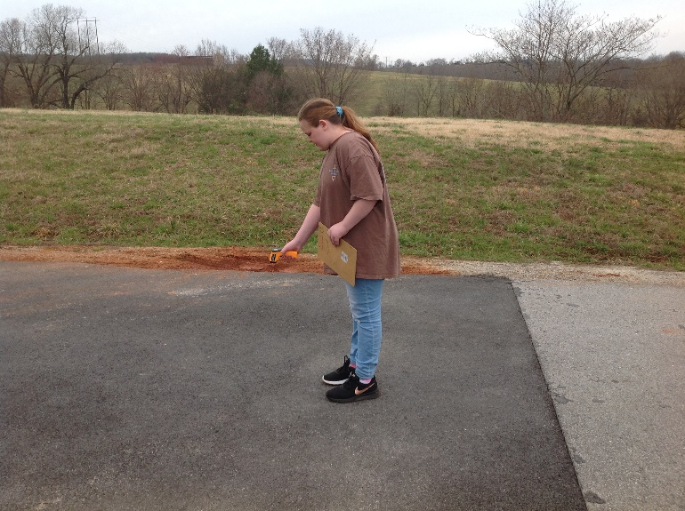

DATA SUMMARY

Surface Temperature Overall Test Results for Different Surfaces during Solar Noon
(Recorded as °C)
Overall Average of the 9 Daily Temperatures Recorded for Each Type of Surface
(270 Surface Temperatures Collected)
Date | Air Temp  (Control) | Short Grass  (-1.5cm) | Sand | Bare Ground | Concrete | Asphalt | Tall Grass  (+15cm)
01/07/2020 | 11.20 | 17.69 | 10.10 | 11.32 | 7.68 | 13.35 | 13.48
01/08/2020 | 19.60 | 19.00 | 16.89 | 18.44 | 13.35 | 20.85 | 19.55
01/09/2020 | 14.00 | 10.45 | 10.22 | 10.70 | 10.75 | 11.80 | 12.49
01/10/2020 | 17.60 | 15.01 | 14.83 | 14.68 | 14.53 | 15.15 | 16.18
01/13/2020 | 11.70 | 10.06 | 7.08 | 10.23 | 7.67 | 16.49 | 10.97
Overall Total | 74.10 | 72.21 | 59.12 | 76.69 | 53.98 | 76.92 | 72.67
Overall Mean | 14.82°C | 14.44°C | 11.82°C | 15.33°C | 10.79°C | 15.38°C | 14.53°C
% Difference | ------- | - 2.5% | - 20% | + 3.4% | - 27% | + 3.7% | - 2.0%

DATA SUMMARY (continued)

SURFACE TEMPERATURE TEST RESULTS

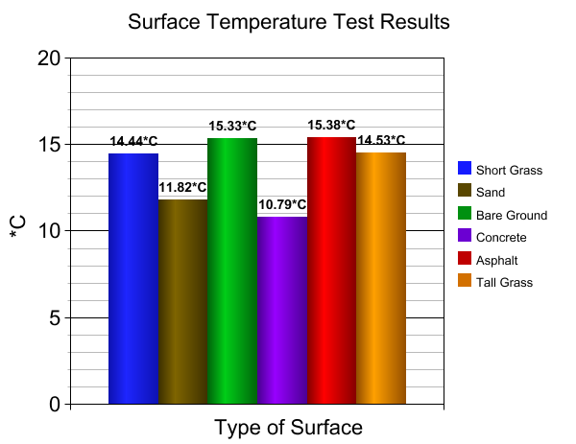
ANALYSIS AND RESULTS

The average air temperature for the surface temperature data collections was 14.82*C. A total of 270 surface temperatures were collected and analyzed in order to determine the average surface temperature for short grass, and, bare ground, concrete, asphalt, and tall grass. The average surface temperature for short grass was 14.44˚C.The average surface temperature for sand was 11.82˚C. The average surface temperature for bare ground was 15,33˚C. The average surface temperature for concrete was 10.79˚C. The average surface temperature for asphalt was 15.38˚C. The average surface temperature for tall grass was 14.53˚C.

CONCLUSION

The hypothesis was not completely supported by the data. Concrete provided the coldest average temperature, averaging 27% colder than the air temperature. Asphalt did have the highest average temperature, averaging 3.7% hotter than the air temperature. The surface temperatures were collected during the winter when the sun's rays were striking the surface at about a 30˚angle. It is predicted that the asphalt would have a much higher percentage of increase in temperature during the summer months, when the sun's rays strike the earth at a more direct angle.

DISCUSSION

It would be interesting to analyze the different surfaces at various times of the year to determine how they change during the different seasons. The bricks on the west end of the school building also appeared to warm up in the afternoon. It would be interesting to measure the surface temperature at measured distanced away from buildings and other stationary objects that absorb or reflects the sun’s energy.

ACKNOLWEDGEMENTS

My science teacher, Mr. Rose helped guide me through the data collection and analysis process for this GLOBE investigation about surface temperature.

BIBLIOGRAPHY

Board, Ocean Studies, and National Research Council. Climate intervention: Reflecting sunlight to cool earth. National Academies Press, 2015.

Bondoc, Alfredo A., et al. "Asphalt surfaces" U.S. Patent No. 4,717,614. 5 Jan. 1988.

Butler, Dixon M., and Ian D. MacGregor. "GLOBE: Science and education." Journal of Geoscience Education 51.1 (2003): 9-20.

Döscher, H., et al. "Sunlight absorption in water–efficiency and design implications for photoelectrochemical devices." Energy & Environmental Science 7.9 (2014): 2951-2956.

ENERGY, TERRESTRIAL SUNLIGHT. "Spectral distribution of sunlight under various air mass conditions." Terrestrial photovoltaic measurements: workshop proceedings, March 19-21, 1975, Cleveland, Ohio. Vol. 71802. Lewis Research Center, National Aeronautics and Space Administration, 1975.

Mehta, Povindar Kumar. "Concrete. Structure, properties and materials." (1986).

Oke, Timothy R. "The energetic basis of the urban heat island." Quarterly Journal of the Royal Meteorological Society 108.455 (1982): 1-24.

Pomerantz, Melvin. "The effect of pavements' temperatures on air temperatures in large cities." (2000).

Sobrino, José A., Juan C. Jiménez-Muñoz, and Leonardo Paolini. "Land surface temperature retrieval from LANDSAT TM 5." Remote Sensing of environment 90.4 (2004): 434-440.

Voogt, James A. "Urban Heat Islands." Encyclopedia of Natural Resources-Water and Air-Vol II. CRC Press, 2014. 1071-1077.

