ABSTRACT

"Everything Ends Up Downstream"
"A study conducted using the GLOBE protocols to analyze Long Creek water samples collected from upstream and downstream of Alpena, Arkansas".
Lindsay K. Dunsing
Alpena Middle School
6th grade

This project is the result of an investigation using GLOBE protocols to analyze the water quality of Long Creek before and after is passes through Alpena, Arkansas. It is predicted that the Long Creek water samples collected downstream from Alpena will have significantly higher levels of phosphates, nitrates, nitrites, ammonia, alkalinity, TDS (total dissolved solids), and EC (electrical conductivity), than the samples collected upstream from the town. It is also predicted that the downstream samples will have significantly lower levels of dissolved oxygen, pH, and transparency.

Long Creek water samples were collected at two similar locations upstream and downstream from Alpena, AR. Using the GLOBE protocols for Integrated Hydrology, samples were tested for temperature, phosphates, nitrates, nitrites, ammonia, alkalinity, TDS, EC, dissolved oxygen, pH, and transparency. 5 tests were conducted for each location.

Water Temperature: Location-A=10.0˚C, Location-B=9.98˚C, Water Transparency: Location-A=107.8cm, Location-B=80.6cm, EC: Location-A=162 µS/cm, Location-B=194.8 µS/cm, TDS: Location-A=77.2ppm, Location-B=99.6ppm,pH Location-A=7.96pH, Location-B=7.52pH, Dissolved Oxygen: Location-A=9.76mg/L, Location-B=9.8mg/L, Alkalinity: Location-A=73.6mg/L, Location-B=84mg/L, Nitrate: Location-A=2.58mg/L, Location-B=2.56mg/L, Phosphate: Location-A=0.2ppm, Location-B=0.45ppm, All of the tests for Nitrite and Ammonia showed 0.0 levels for each.

The hypothesis was mostly supported. The statistics t-Test showed a significant difference in Water Transparency, EC, TDS, pH, Alkalinity, and Phosphates. However, according to the t-Tests there was not a significant difference in Dissolved Oxygen. The samples downstream had the less desirable readings. In the future, the researcher would like to continue to test the locations for Long Creek to monitor them in the spring, summer, fall and adding more locations.

TABLE of CONTENTS

Abstract…………………………………………….…….......... 1
Title Page and Table of Contents ……………........... 2-3
Research Question and Hypothesis………….……….. 4
Methods & Materials……………………………….….. 5 - 6
Data Summary (Chart & Graph) ……………………………... 7 - 11
Analysis & Results…………………............................. 11
Conclusions……………………………………….…............ 12
Discussion…………………………………………...………… 12
Acknowledgements………………………………............. 12
Additional Data Charts ………………………………. 13 – 16
Satellite Images of Stream Locations ………….. 17 - 18
Display Board ……………………………………………. 19 - 21
References/Bibliography…………………………………… 22

Everything Ends Up Downstream

"A study conducted using the GLOBE protocols to analyze Long Creek water samples collected from upstream and downstream of Alpena, Arkansas".

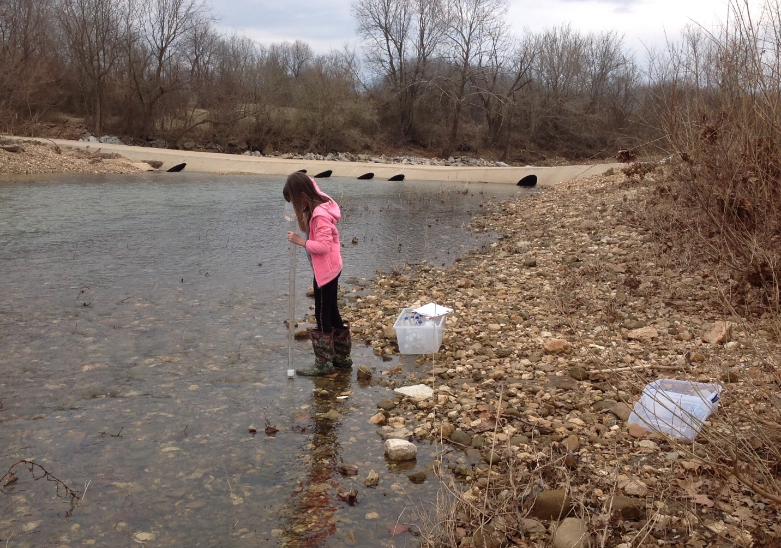

Lindsay Dunsing
6th grade Alpena Middle School
Roger Rose – Science Teacher
Tammy Rose – GLOBE Sponsor
March 12th 2020

RESEARCH QUESTION
The Ozarks has many rivers and streams that fill into area lakes which empty into other rivers that eventually wind up in the Gulf of Mexico. Along their path, the rivers and streams pass along roads, highways, through farmland and in and around towns and cities. While on their path, the rivers and streams can collect minerals and contaminants from the area around them. Oil and chemicals from nearby roadways can run off into the rivers and streams when it rains. Water from the towns and cities runs across paved areas further carrying contaminants into the waterways. The city of Alpena, Arkansas is the only town located along Long Creek as it runs through Carroll and Boone counties on its way to Table Rock Lake. Any contaminants Long Creek picks up as it travels toward Table Rock Lake can diminish the overall quality of the lake water. Water samples will be collected at two different locations, one upstream from Alpena, and one downstream from Alpena. The latitude, longitude, and elevation for the locations will be charted and set-up in the GLOBE data base. The results of the water samples will be uploaded into the GLOBE data base and also sent to the Arkansas Stream Team data base. This project is the result of an investigation using GLOBE protocols to analyze the water quality of Long Creek before and after is passes through Alpena, Arkansas.

HYPOTHESIS
It is predicted that the Long Creek water samples collected downstream from Alpena will have significantly higher levels of phosphates, nitrates, nitrites, ammonia, alkalinity, TDS (total dissolved solids), and EC (electrical conductivity), than the samples collected upstream from the town. It is also predicted that the downstream samples will have significantly lower levels of dissolved oxygen, pH, and transparency.

GLOBE Hydrosphere Protocols Used

Alkalinity Water Temperature
Conductivity Water Transparency
Dissolved Oxygen Nitrate

GLOBE Atmosphere Protocols Used

Clouds Barometric Pressure
Air Temperature Relative Humidity

RESEARCH METHODS

The water samples were collected at two different locations where low-water concrete slabs cross over Long Creek. The upstream location was where Cemetery Road crosses over Long Creek, approximately 1/2 mile upstream from Alpena. The downstream location was where Long Creek Road crosses over Long Creek, approximately 1/2 mile downstream from Alpena. Five water samples were collected from each location. During each time water samples are collected, a GLOBE Cloud Observation was conducted, to document the current weather conditions, cloud cover, air temperature, barometric pressure, and humidity. The GLOBE Protocol for collecting and analyzing stream water samples was used. During each water sample collection, a turbidity tube was used to analyze water turbidity. The water temperature was also collected on site. Then, the water samples were taken back to the middle school science lab and analyzed for Dissolved Oxygen, Alkalinity, Nitrates, Nitrites, Phosphates, and Ammonia, using API and LaMotte chemical test kits for water. Digital electronic meters were used to analyze the water samples for pH, Total Dissolved Solids, and Electrical Conductivity. All of the chemical testing, of the water samples, was conducted in the middle school science lab under the direct supervision of a designated supervisor, who is trained for appropriate safety procedures, the collection, testing, and analysis of water samples using the GLOBE Protocols and water sample test kits. The student researcher was also trained in the safety practices that were needed in completing the analysis of the water samples. Testing was conducted on an open counter lab table setting, and protective clothing, gloves and eye protection was used according to the directions for the water test kit. The designated supervisor disposed of the water samples, once they had been tested according to the directions provided on the water test kit, and the school's disposal procedures. All unused chemical reagents, from the water test kits, were placed back into the original container and stored in the middle school science lab according to the school's chemical storage procedures.

Risk & Safety Concerns:
The potential risk involved in this project were falling into the stream while collecting the water samples and exposure to the chemical reagents in the water test kits. The designated supervisor supervised and assist as needed during collecting of the water samples and he also supervised all aspects of the chemical testing procedures in the middle school science lab. The researcher followed the testing procedures outlined in the instructions for the water test kits as well as wearing protective lab clothing and equipment, (lab coat, gloves, safety glasses).

Data Analysis:
Once all the data was collected, it was used to create charts and graphs to help analyze it further. Using Microsoft Excel, a statistics t-Test was also used to analyze if there was a significant difference in the readings.

MATERIALS

API and LaMotte water chemical test kits for Dissolved Oxygen, Alkalinity, Nitrates, Nitrites, Phosphates, and Ammonia. Digital electronic meters used to analyze the water samples for pH, Total Dissolved Solids, and Electrical Conductivity. Turbidity Tube, Clean Water Bottles, Rubber Boots.

DATA SUMMARY

Water Test Results for Long Creek
(Location-A: Cemetery Rd. & Dunkard Rd., Upstream from Alpena, AR)
Test | Air  Temp  (°C) | Water  Temp  (°C) | Water  Transparency  (cm) | Electrical  Conductivity  (µS/cm) | Total Dissolved Solids  (ppm) | pH  (1-14)
1 | 19.3 | 10.0 | 90 | 162 | 66 | 8.2
2 | 19.3 | 10.0 | 105 | 162 | 78 | 8.0
3 | 19.2 | 10.0 | 116 | 160 | 80 | 7.9
4 | 19.3 | 10.0 | 117 | 162 | 81 | 7.9
5 | 19.2 | 10.0 | 111 | 164 | 81 | 7.8
Total | 96.3 | 50.0 | 539 | 810 | 386 | 39.8
Mean | 19.26°C | 10.0°C | 107.8cm | 162µS/cm | 77.2ppm | 7.96pH
Water Test Results for Long Creek
(Location-B: 1013 WPA Rd. & Long Creek, Downstream from Alpena, AR)
Test | Air  Temp  (°C) | Water  Temp  (°C) | Water  Transparency  (cm) | Electrical  Conductivity  (µS/cm) | Total Dissolved Solids  (ppm) | pH  (1-14)
1 | 19.1 | 10.0 | 76 | 182 | 96 | 7.6
2 | 19.1 | 10.0 | 78 | 184 | 99 | 7.5
3 | 19.2 | 9.9 | 85 | 204 | 101 | 7.5
4 | 19.3 | 10.0 | 80 | 200 | 102 | 7.5
5 | 19.3 | 10.0 | 84 | 204 | 100 | 7.5
Total | 95.9 | 49.9 | 403 | 979 | 498 | 37.6
Mean | 19.18°C | 9.98°C | 80.6cm | 194.8µS/cm | 99.6ppm | 7.52pH

DATA SUMMARY (continued)

Water Test Results for Long Creek
(Location-A: Cemetery Rd. & Dunkard Rd., Upstream from Alpena, AR)
Test | Dissolved  Oxygen  (mg/L) | Alkalinity  (mg/L as CaCO₃) | Nitrate(NO₃1)  (mg/L) | Nitrite(NO₂-)  (mg/L) | Ammonia  (mg/L) | Phosphate  ppm
1 | 9.8 | 74 | 2.5 | 0.0 | 0.0 | 0.25
2 | 9.4 | 72 | 3.0 | 0.0 | 0.0 | 0.25
3 | 10.2 | 72 | 2.6 | 0.0 | 0.0 | 0.0
4 | 9.8 | 76 | 2.4 | 0.0 | 0.0 | 0.0
5 | 9.6 | 74 | 2.4 | 0.0 | 0.0 | 0.5
Total | 48.8 | 368 | 12.9 | 0.0 | 0.0 | 1.0
Mean | 9.76mg/L  (95% saturated) | 73.6mg/L | 2.58mg/L | 0.0mg/L | 0.0mg/L | 0.2ppm
Water Test Results for Long Creek
(Location-B: 1013 WPA Rd. & Long Creek, Downstream from Alpena, AR)
Test | Dissolved  Oxygen  (mg/L) | Alkalinity  (mg/L as CaCO₃) | Nitrate(NO₃1)  (mg/L) | Nitrite(NO₂-)  (mg/L) | Ammonia  (mg/L) | Phosphate  (ppm)
1 | 10.0 | 96 | 2.7 | 0.0 | 0.0 | 0.5
2 | 9.6 | 80 | 2.6 | 0.0 | 0.0 | 0.5
3 | 9.8 | 78 | 2.5 | 0.0 | 0.0 | 0.25
4 | 9.8 | 84 | 2.4 | 0.0 | 0.0 | 0.5
5 | 9.8 | 82 | 2.6 | 0.0 | 0.0 | 0.5
Total | 49.0 | 420 | 12.8 | 0.0 | 0.0 | 2.25
Mean | 9.8mg/L  (95% saturated) | 84mg/L | 2.56mg/L | 0.0mg/L | 0.0mg/L | 0.45ppm

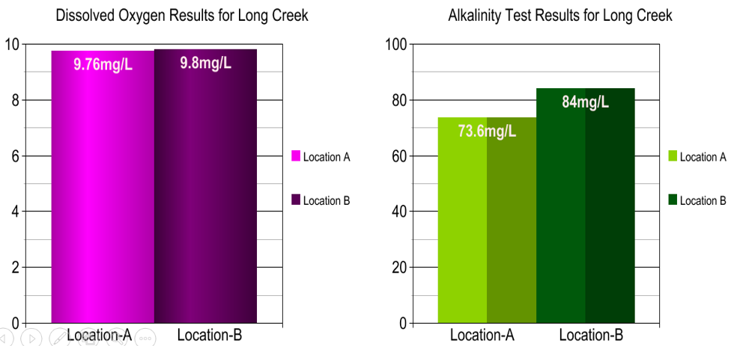

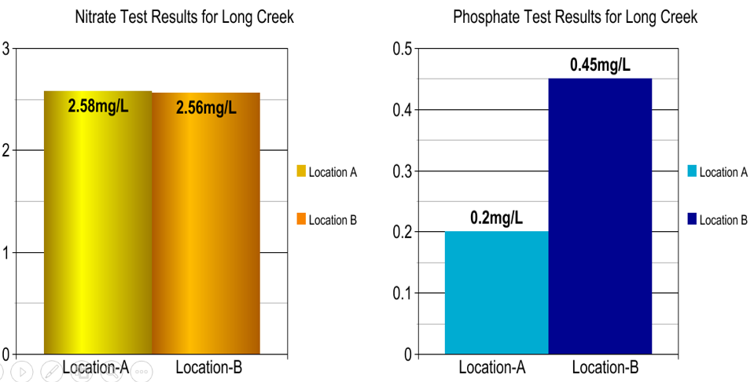

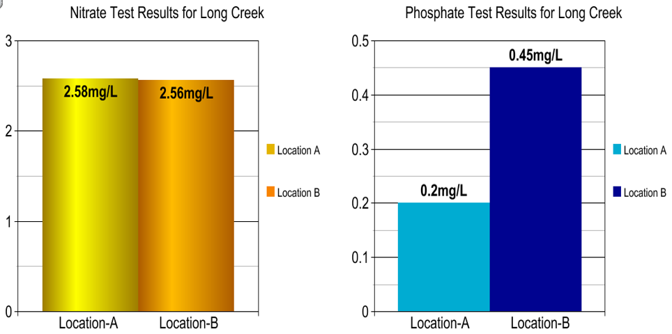

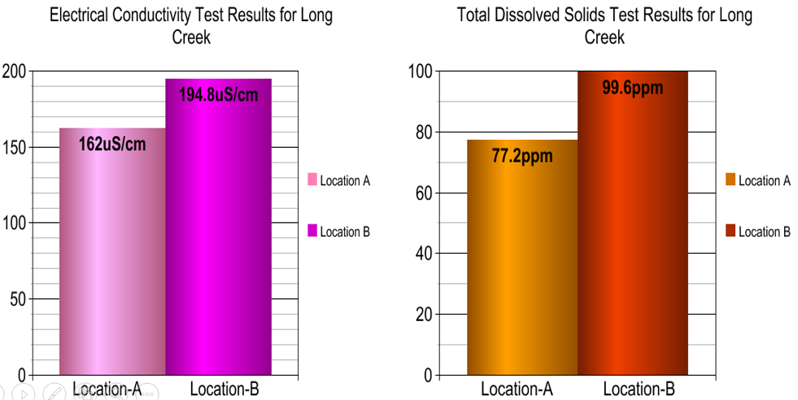

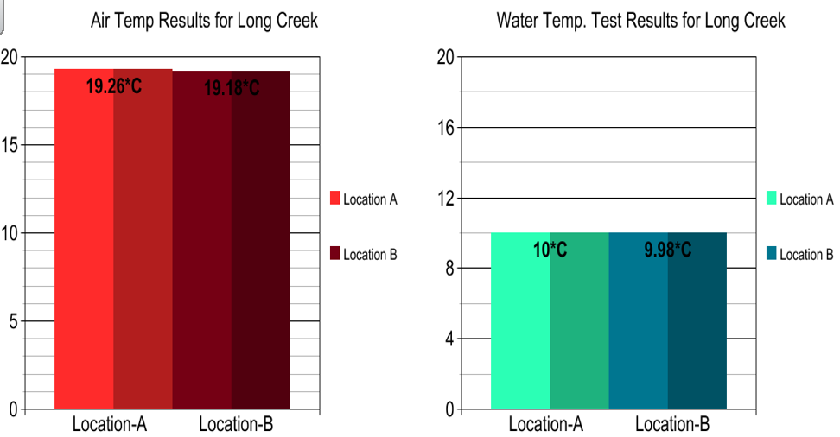

ANALYSIS AND RESULTS

Water Temperature: Location-A=10.0˚C, Location-B=9.98˚C,
Water Transparency Location-A=107.8cm, Location-B=80.6cm,
Electrical Conductivity Location-A=162 µS/cm, Location-B=194.8 µS/cm,
Total Dissolved Solids Location-A=77.2ppm, Location-B=99.6ppm,
pH Location-A=7.96pH, Location-B=7.52pH,
Dissolved Oxygen Location-A=9.76mg/L, Location-B=9.8mg/L,
Alkalinity Location-A=73.6mg/L, Location-B=84mg/L,
Nitrate Location-A=2.58mg/L, Location-B=2.56mg/L,
Phosphate Location-A=0.2ppm, Location-B=0.45ppm,
Nitrite and Ammonia all showed 0.0 levels for each.

CONCLUSION
The hypothesis was mostly supported by the data. The statistics t-Test showed a significant difference in Water Transparency, Electrical Conductivity, Total Dissolved Solids, pH, Alkalinity, and Phosphates. However, according to the t-Tests there was not a significant difference in Dissolved Oxygen. The samples downstream had the less desirable readings. In the future, the researcher would like to continue to test the locations for Long Creek to monitor them in the spring and summer. It would also be interesting to analyze water samples from further upstream and downstream from the current locations tested.

DISCUSSION
The stream where I live is constantly changing with the seasons and with the agriculture industries that are located around it. I think it would be interesting to analyze the components of the stream throughout the year during the different seasons to gain a better understanding of how things change. I did my testing during the winter months. In the spring, I want to do more testing where I can investigate the macroinvertebrates that are in the stream. Also, during the spring time, is when farmers are spreading fertilizers on the fields that border the stream and there is usually more runoff water because of more rainfall.

ACKNOWLEDGEMENTS
My science teacher, Mr. Rose taught me about the GLOBE program while I have been in his science class for 5th & 6th grades. During the process, I became interested in doing a project and sending data to GLOBE. He helped me come up with the idea and supervised all of my testing procedures. Ms. Tammy, supported me and helped me with the GLOBE protocols at school. My mom and dad have supported my efforts in completing this project.
Additional Data Charts

Water Test Results for Long Creek
(Location-A: Cemetery Rd. & Dunkard Rd., Upstream from Alpena, AR)
 | Air  Temp  (°C) | Water  Temp  (°C) | Water  Transparency  (cm) | Electrical  Conductivity  (µS/cm) | Total Dissolved Solids  (ppm) | pH  (1-14)
1 | 19.3 | 10.0 | 90 | 162 | 66 | 8.2
2 | 19.3 | 10.0 | 105 | 162 | 78 | 8.0
3 | 19.2 | 10.0 | 116 | 160 | 80 | 7.9
4 | 19.3 | 10.0 | 117 | 162 | 81 | 7.9
5 | 19.2 | 10.0 | 111 | 164 | 81 | 7.8
Total | 96.3 | 50.0 | 539 | 810 | 386 | 39.8
Mean | 19.26°C | 10.0°C | 107.8cm | 162µS/cm | 77.2ppm | 7.96pH

Water Test Results for Long Creek
(Location-A: Cemetery Rd. & Dunkard Rd., Upstream from Alpena, AR)
 | Dissolved  Oxygen  (mg/L) | Alkalinity  (mg/L as CaCO₃) | Nitrate(NO₃1)  (mg/L) | Nitrite(NO₂-)  (mg/L) | Ammonia  (mg/L) | Phosphate  ppm
1 | 9.8 | 74 | 2.5 | 0.0 | 0.0 | 0.25
2 | 9.4 | 72 | 3.0 | 0.0 | 0.0 | 0.25
3 | 10.2 | 72 | 2.6 | 0.0 | 0.0 | 0.0
4 | 9.8 | 76 | 2.4 | 0.0 | 0.0 | 0.0
5 | 9.6 | 74 | 2.4 | 0.0 | 0.0 | 0.5
Total | 48.8 | 368 | 12.9 | 0.0 | 0.0 | 1.0
Mean | 9.76mg/L  (95% saturated) | 73.6mg/L | 2.58mg/L | 0.0mg/L | 0.0mg/L | 0.2ppm

Water Test Results for Long Creek
(Location-B: 1013 WPA Rd. & Long Creek, Downstream from Alpena, AR)
 | Air  Temp  (°C) | Water  Temp  (°C) | Water  Transparency  (cm) | Electrical  Conductivity  (µS/cm) | Total Dissolved Solids  (ppm) | pH  (1-14)
1 | 19.1 | 10.0 | 76 | 182 | 96 | 7.6
2 | 19.1 | 10.0 | 78 | 184 | 99 | 7.5
3 | 19.2 | 9.9 | 85 | 204 | 101 | 7.5
4 | 19.3 | 10.0 | 80 | 200 | 102 | 7.5
5 | 19.3 | 10.0 | 84 | 204 | 100 | 7.5
Total | 95.9 | 49.9 | 403 | 979 | 498 | 37.6
Mean | 19.18°C | 9.98°C | 80.6cm | 194.8µS/cm | 99.6ppm | 7.52pH

Water Test Results for Long Creek
(Location-B: 1013 WPA Rd. & Long Creek, Downstream from Alpena, AR)
 | Dissolved  Oxygen  (mg/L) | Alkalinity  (mg/L as CaCO₃) | Nitrate(NO₃1)  (mg/L) | Nitrite(NO₂-)  (mg/L) | Ammonia  (mg/L) | Phosphate  (ppm)
1 | 10.0 | 96 | 2.7 | 0.0 | 0.0 | 0.5
2 | 9.6 | 80 | 2.6 | 0.0 | 0.0 | 0.5
3 | 9.8 | 78 | 2.5 | 0.0 | 0.0 | 0.25
4 | 9.8 | 84 | 2.4 | 0.0 | 0.0 | 0.5
5 | 9.8 | 82 | 2.6 | 0.0 | 0.0 | 0.5
Total | 49.0 | 420 | 12.8 | 0.0 | 0.0 | 2.25
Mean | 9.8mg/L  (95% saturated) | 84mg/L | 2.56mg/L | 0.0mg/L | 0.0mg/L | 0.45ppm

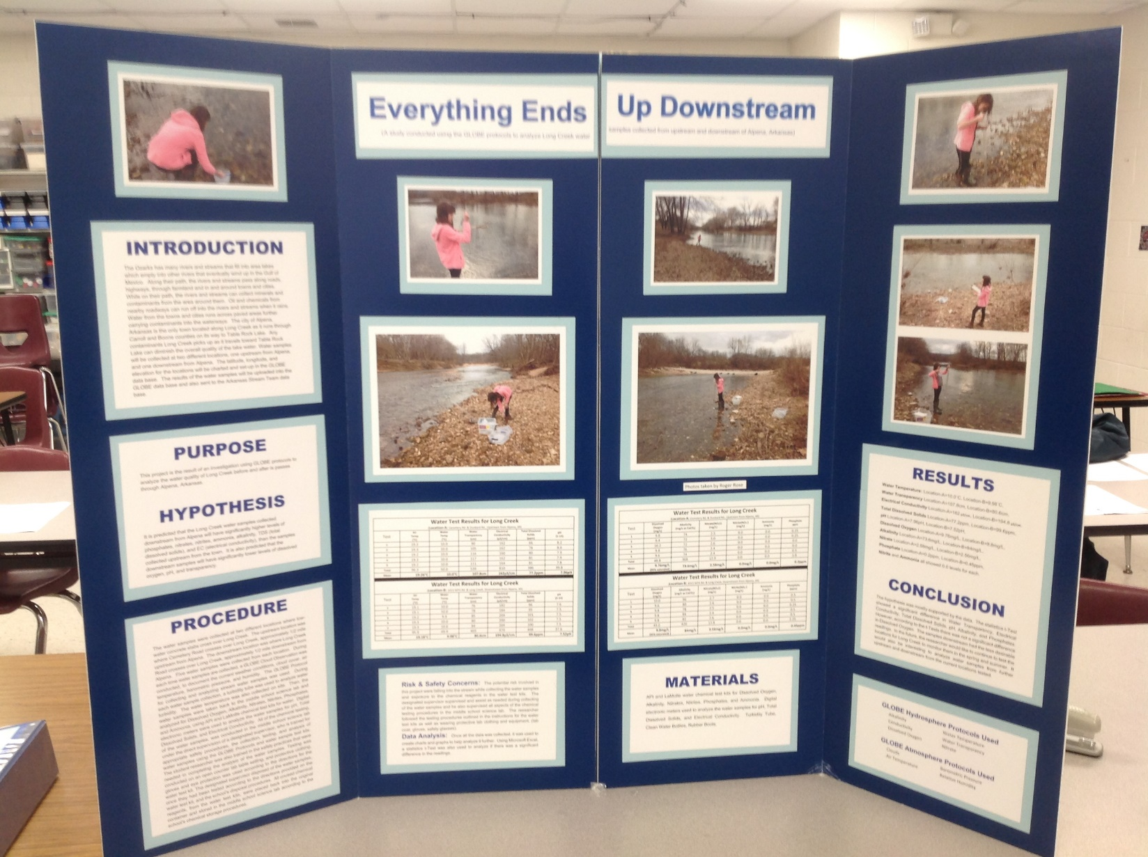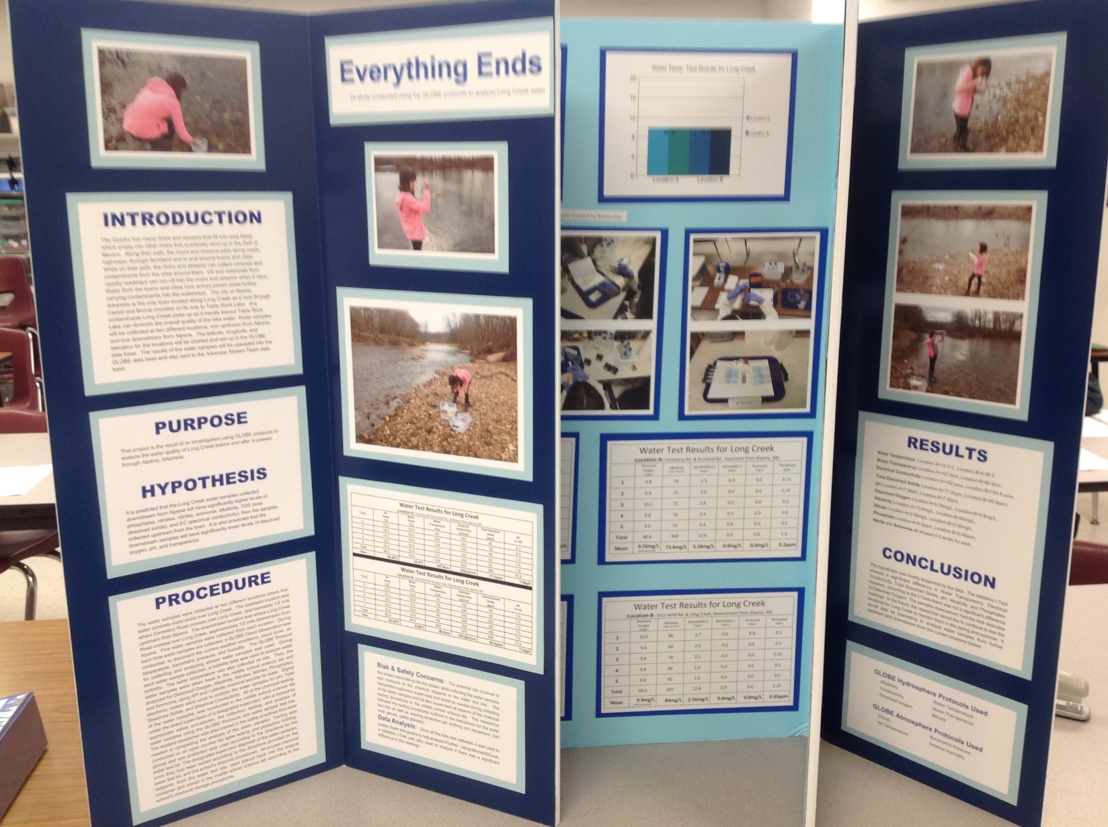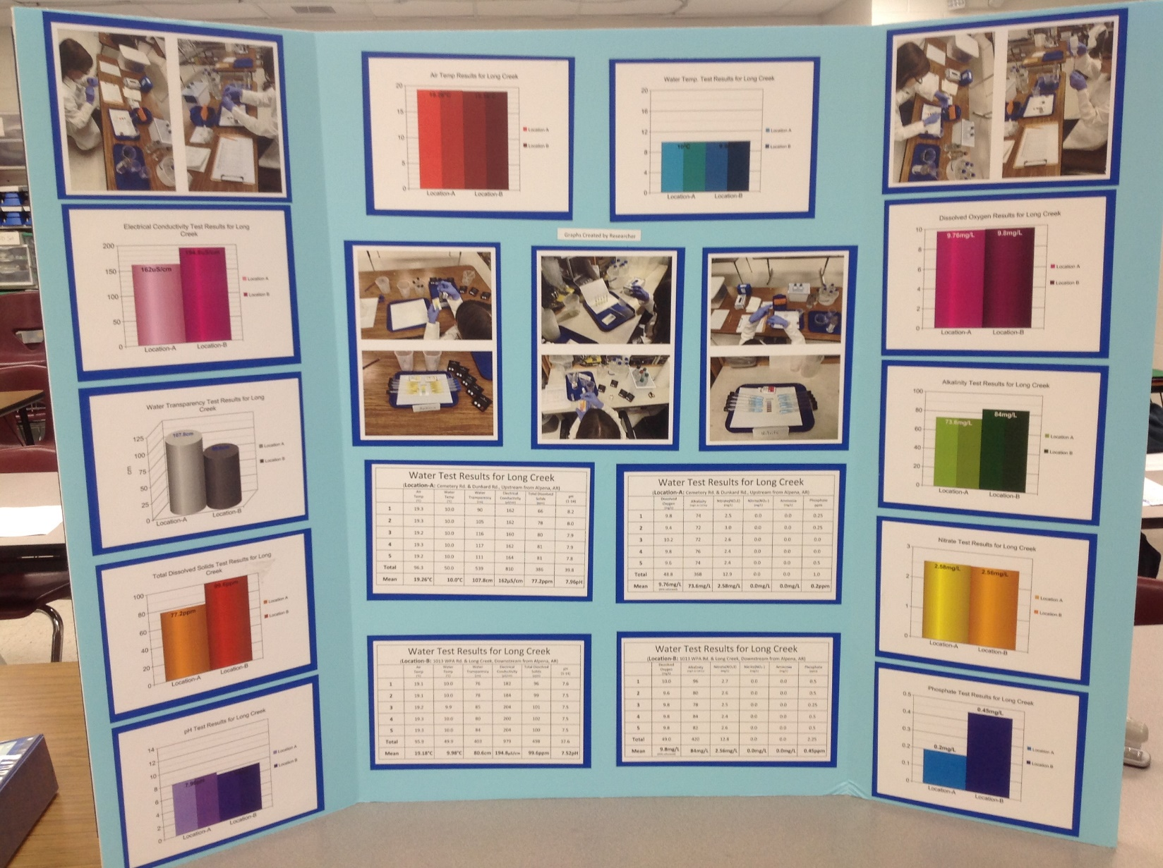
BIBLIOGRAPHY

Butler, Dixon M., and Ian D. MacGregor. "GLOBE: Science and education." Journal of Geoscience Education 51.1 (2003): 9-20.

Davies‐Colley, R. J., and D. G. Smith. "Turbidity suspeni) ed sediment, and water clarity: a review 1." JAWRA Journal of the American Water Resources Association 37.5 (2001): 1085-1101.

Henriksen, A. "Alkalinity and acid precipitation research." Vatten 38 (1982): 83-85.Klein, Richard D. "Urbanization and stream quality impairment 1." JAWRA Journal of the American Water Resources Association 15.4 (1979): 948-963.

Irvine, Robin F., and Michael J. Schell. "Back in the water: the return of the inositol phosphates." Nature reviews Molecular cell biology 2.5 (2001): 327-338.

Kaiho, Kunio. "Benthic foraminiferal dissolved-oxygen index and dissolved-oxygen levels in the modern ocean." Geology 22.8 (1994): 719-722.

Kramer, Donald L. "Dissolved oxygen and fish behavior." Environmental biology of fishes 18.2 (1987): 81-92.

Leopold, Luna Bergere. Water, rivers, and creeks. University Science Books, 1997.

Mitchell, A. C., and W. J. Nellis. "Equation of state and electrical conductivity of water and ammonia shocked to the 100 GPa (1 Mbar) pressure range." The Journal of Chemical Physics 76.12 (1982): 6273-6281.

Roberts, James M. "The atmospheric chemistry of organic nitrates." Atmospheric Environment. Part A. General Topics 24.2 (1990): 243-287.

Weibel, Sebastian R., Robert J. Anderson, and Richard L. Woodward. "Urban land runoff as a factor in stream pollution." Journal (Water Pollution Control Federation) (1964): 914-924.

