ABSTRACT

“SMAP, Searching for Moisture”
(A study conducted using the GLOBE SMAP method to analyze soil moisture in fertilized and unfertilized soil during the morning and evening)
Grady M. Massengale
Alpena Middle School
Earth Science

This was an investigation comparing moisture levels in soil fertilized with poultry litter and non-fertilized soil, in the morning and evening. It is predicted that the fertilized soil samples in the evening will have the highest moisture levels.

The GLOBE SMAP Soil Moisture Protocol was used. Volume and weight of soil collection canisters was calculated. Then, in the morning and evening on the fertilized soil and unfertilized soil, samples were collected and dried in a soil oven. Wet soil weight, dry soil weight, water weight, gravimetric soil moisture, volumetric soil moisture, sample bulk density were calculated by entering the information into the GLOBE SMAP Soil Moisture website and analyzed with a statistics t-Test.

Fertilized morning samples: wet soil=333.0g, dry soil=255.6g, water weight=77.4g, gravimetric soil moisture=0.32g/g, volumetric soil moisture=0.31ml/ml, bulk density=0.93g/ml. Fertilized evening samples: wet soil=369.3g, dry soil=283.6g, water weight=85.6g, gravimetric soil moisture=0.33g/g, volumetric soil moisture=0.35ml/ml, bulk density=1.04g/ml. Unfertilized morning samples: wet soil=376.1g, dry soil=293.1g, water weight=48.9g, gravimetric soil moisture=0.31g/g, volumetric soil moisture=0.34ml/ml, bulk density=1.08g/ml. Unfertilized evening samples: wet soil=376.6g, dry soil=313.2g, water weight=63.4g, gravimetric soil moisture=0.22g/g, volumetric soil moisture=0.25ml/ml, bulk density=1.16g/ml.

The hypothesis was supported by the data. Fertilized samples averaged 45% more water weight, 22% higher gravimetric soil moisture, 10% higher volumetric soil moisture, and was 12% less dense. Morning samples averages 15% less water weight, had a 14% higher gravimetric soil moisture reading, a 10% higher volumetric soil moisture reading, and was 10% less dense than the evening samples. Evening fertilized samples had the best results.

“SMAP”SMAP: Soil Moisture Active Passive satellite soil analysis program.
Searching for Moisture
A study conducted using the GLOBE SMAP method to analyze soil
moisture in fertilized and unfertilized soil during the morning and evening.

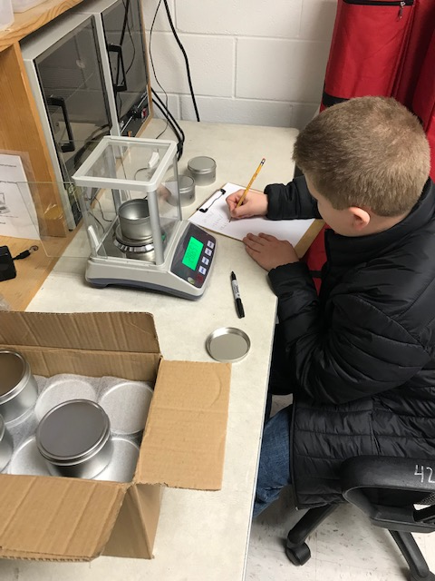
Grady Massengale
5th grade Alpena Middle School
Roger Rose – Science Teacher
March 12th 2020

TABLE OF CONTENTS

Abstract…………………………………………….…….......... 1
Title Page and Table of Contents ……………........... 2-3
Research Question and Hypothesis………….……….. 4
Methods & Materials……………………………….……….. 5
Data Summary (Chart & Graph) ……………………………... 6 - 7
Analysis & Results…………………............................. 8
Conclusions……………………………………….…............ 9
Discussion…………………………………………...………… 9
Acknowledgements………………………………............. 9
Display Board ….……………………………………………. 10
Additional Data Charts and Graphs ……………..11 - 15
References/Bibliography………………………………… 16

INTRODUCTION & RESEARCH QUESTION
Soil moisture is important for climate, land, animals, plants, and water conservation. In addition, it is essential to weather patterns. As the moisture evaporates from the soil it creates humidity in the atmosphere. This can help with the formation of clouds. Farmers depend on soil moisture for production of grass. The researcher lives on a farm and wanted to do this project to if fertilized soil has more moisture than unfertilized soil. The researcher is curious because he helps with cattle and hay. The researcher wonders how the soil moisture compared to fertilized and unfertilized soil samples. This information can help farmers determine if fertilizing the soil is beneficial for vegetation. The researcher had to study and learn some new terminology in order to better understand the testing. Gravimetric soil moisture represents the mass of water per mass of dry soil. Volumetric soil moisture represents the volume of water per volume of dry soil. The sample bulk density reading represents how compacted the soil is the weight of the soil in a given volume. Soils with a sample bulk density greater than 1.6g/ml can begin to restrict root growth.
This project is the result of an investigation comparing the moisture of soil that has been fertilized with poultry liter to soil that has not been fertilized, using the GLOBE SMAP protocols for analyzing soil moisture. The second objective for the investigation will be to compare the soil moisture amounts collected in the morning to the evening samples.

HYPOTHESIS
It is predicted that soil samples collected for the fertilized soil will average more moisture than the samples taken from the unfertilized soil, because the grass in that area will insulate the ground and help prevent evaporation. It is also predicted that the soil moisture levels will be higher in the evening samples than in the morning samples, unless it rains during the day.

GLOBE Protocol Used
SMAP for Soil Moisture, Cloud Coverage, & Surface Temperature

RESEARCH METHODS
The soil sampling procedures outlined in the GLOBE SMAP Soil Moisture Protocol were used to analyze the soil samples. Soil sample canisters were weighed using a digital balance scale in the school science lab. The volume for the containers was calculated by observing the amount of water it takes to fill them up. Soil samples from each location was taken in the morning and again in the evening on at 5 different days. Soil from 5cm deep was used to fill the canisters. The filled soil canisters were weighed on the digital balance scale and recorded. Then, the filled canisters were placed in a soil oven set at 95˚C. The canisters were weighed after 12 hours, and then again at regular intervals afterward until the weight stabilized and did not change. Then, the weight of the dried soil canisters was recorded and the amount of water that evaporated from the soil was calculated using the GLOBE SMAP data collection sheet. The latitude, longitude, and elevation for the soil sample locations was charted and set-up in the GLOBE data base. The results of the soil moisture samples were uploaded into the GLOBE data base following the SMAP soil moisture protocol. Each time soil samples were collected, the GLOBE protocol for Surface Temperature was also used to collect the surface temperature and to record the surface and cloud conditions, as well as documenting the air temperature, barometric pressure and humidity. Cloud Conditions were also observed, following the GLOBE protocols for both, and then the data was recorded and sent in to the GLOBE database.
Risk and Safety: The only risk involved in this investigation is using the soil oven which was set at approximately 95°C (203°F). The researcher was trained in proper safety procedures by a designated supervisor in using the soil oven. The researcher was also supervised while putting samples in and taking them out of the soil oven.
Data Analysis: Once all the data was collected, charts and graphs were used to analyze it further.

MATERIALS
Barometer, Anemometer, Hygrometer, Digital Scale, iPhone app for GPS (latitude, longitude, elevation), iPad, Digital Infrared Thermometer, Soil Oven, Tin Canisters, Oven Mitts, and Beakers.

DATA SUMMARY

SMAP Soil Moisture Overall Averages
Samples | Wet Soil  (g) | Dry Soil  (g) | Empty Container  Weight  (g) | Dry Soil  Weight  (g) | Water Weight  (g) | Gravimetric Soil Moisture  (g/g) | Volumetric Soil Moisture  (ml/ml) | Sample Bulk  Density  (g/ml)
Morning Samples
Morning-F | 333.0g | 255.6g | 28.5g | 232.4g | 77.4g | 0.32(g/g) | 0.31ml/ml | 0.93g/ml
Morning-UF | 376.1g | 293.1g | 28.6g | 264.5g | 48.9g | 0.31(g/g) | 0.34ml/ml | 1.08g/ml
Overall Morning | 354.6g | 274.4g | 28.6g | 248.5g | 63.2g | 0.32(g/g) | 0.33ml/ml | 1.01g/ml
Evening Samples
Evening-F | 369.3g | 283.6g | 28.6g | 255.0g | 85.6g | 0.33(g/g) | 0.35ml/ml | 1.04g/ml
Evening-UF | 376.6g | 313.2g | 28.6g | 284.6g | 63.4g | 0.22(g/g) | 0.25ml/ml | 1.16g/ml
Overall Evening | 373.0g | 298.5g | 28.6g | 269.8g | 74.5g | 0.28(g/g) | 0.30ml/ml | 1.11g/ml
Samples | Wet Soil  (g) | Dry Soil  (g) | Empty Container  Weight  (g) | Dry Soil  Weight  (g) | Water Weight  (g) | Gravimetric Soil Moisture  (g/g) | Volumetric Soil Moisture  (ml/ml) | Sample Bulk  Density  (g/ml)
Fertilized Samples
Morning-F | 333.0g | 255.6g | 28.5g | 232.4g | 77.4g | 0.32(g/g) | 0.31ml/ml | 0.93g/ml
Evening-F | 369.3g | 283.6g | 28.6g | 255.0g | 85.6g | 0.33(g/g) | 0.35ml/ml | 1.04g/ml
Overall Fertilized | 351.2g | 269.6g | 28.6g | 243.7g | 81.5g | 0.33(g/g) | 0.33ml/ml | 0.99g/ml
Unfertilized Samples
Morning-UF | 376.1g | 293.1g | 28.6g | 264.5g | 48.9g | 0.31(g/g) | 0.34ml/ml | 1.08g/ml
Evening-UF | 376.6g | 313.2g | 28.6g | 284.6g | 63.4g | 0.22(g/g) | 0.25ml/ml | 1.16g/ml
Overall Unfertilized | 376.4g | 303.2g | 28.6g | 274.6g | 56.2g | 0.27(g/g) | 0.30ml/ml | 1.12g/ml

DATA SUMMARY (continued)

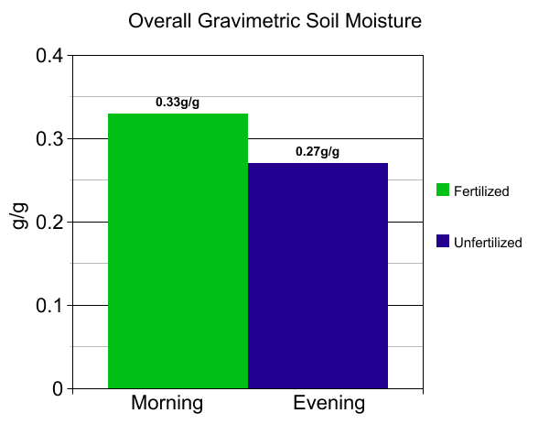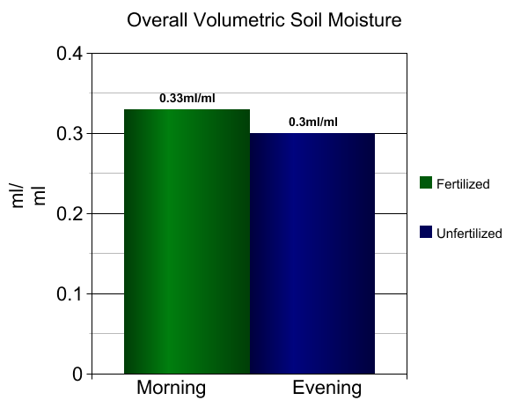

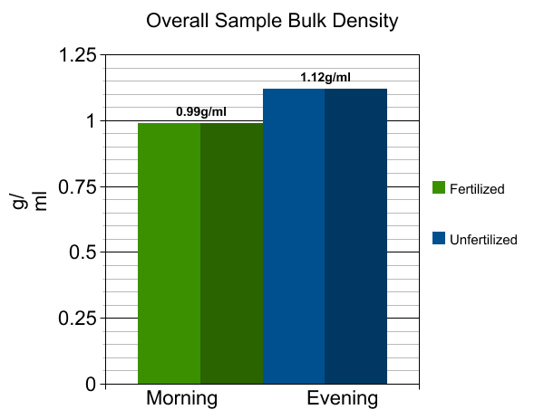

ANALYSIS AND RESULTS
Averages for the morning samples of the fertilized soil: Weight measurements: wet soil=333.0g, dry soil=255.6g, water weight=77.4g, gravimetric soil moisture=0.32g/g, volumetric soil moisture=0.31ml/ml, sample bulk density=0.93g/ml.

Averages for the morning samples of the unfertilized soil: Weight measurements: wet soil=376.1g, dry soil=293.1g, water weight=48.9g, gravimetric soil moisture=0.31g/g, volumetric soil moisture=0.34ml/ml, sample bulk density=1.08g/ml.

Averages for the evening samples of the fertilized soil: Weight measurements: wet soil=369.3g, dry soil=283.6g, water weight=85.6g, gravimetric soil moisture=0.33g/g, volumetric soil moisture=0.35ml/ml, sample bulk density=1.04g/ml.

Averages for the evening samples of the unfertilized soil: Weight measurements: wet soil=376.6g, dry soil=313.2g, water weight=63.4g, gravimetric soil moisture=0.22g/g, volumetric soil moisture=0.25ml/ml, sample bulk density=1.16g/ml.

OVERALL averages for fertilized soil: Weight measurements: wet soil=351.2g, dry soil=269.6g, water weight=81.5g, gravimetric soil moisture=0.33g/g, volumetric soil moisture=0.33ml/ml, sample bulk density=0.99g/ml.

OVERALL averages for unfertilized soil: Weight measurements: wet soil=376.4g, dry soil=303.2g, water weight=56.2g, gravimetric soil moisture=0.27g/g, volumetric soil moisture=0.30ml/ml, sample bulk density=1.12g/ml.

OVERALL averages for morning samples: Weight measurements: wet soil=354.6g, dry soil=274.4g, water weight=63.2g, gravimetric soil moisture=0.32g/g, volumetric soil moisture=0.33ml/ml, sample bulk density=1.01g/ml.

OVERALL averages for evening samples: Weight measurements: wet soil=373.0g, dry soil=298.5g, water weight=74.5g, gravimetric soil moisture=0.28g/g, volumetric soil moisture=0.30ml/ml, sample bulk density=1.11g/ml.

CONCLUSION

The hypothesis was supported by the data. When comparing the overall fertilized samples to the overall unfertilized samples: the fertilized samples averaged 45% more water weight per sample, 22% higher gravimetric soil moisture, 10% higher volumetric soil moisture, and was 12% less dense. When comparing the overall morning samples to the overall evening samples: the morning samples averages 15% less water weight per sample, had a 14% higher gravimetric soil moisture reading, a 10% higher volumetric soil moisture reading, and was 10% less dense than the evening samples. The samples that averaged the best readings was the evening fertilized samples. They had the highest gravimetric soil moisture reading of 0.33g/g, highest volumetric soil moisture reading of 0.35ml/ml, and next to the lowest average density of 1.04g/ml. All of the soil samples had an average bulk density reading less than 1.6g/ml.

DISCUSSION
Soil moisture is very important in order to grow crops and hay for cattle. I the future, I would like to try and apply fertilizer below the surface of the soil, close to the roots of the plants, in order to maybe help the grass, grow better. I think that as the grass grows, it will absorb moisture from the soil, but at the same time, the grass above the ground will shade and insulate the soil, keeping if from drying out as fast as ground that does not have a good grass cover over it. In the future, I will also collect sol temperature data at 5cm and 10cm deep into the soil while I am collecting the soil samples for moisture analysis. It would also be interesting to try the test on different types of grass coverage and different types of soil.

ACKNOLWEDGEMENTS

I would like to thank my mom and dad for helping me with my project. My dad teaches me about farming and the importance of using fertilizer to grow hay to feed our cattle. My mom is great in helping me with the data collection and analysis of the data. My science teacher taught me about the GLOBE program and how to do the testing and enter the data into the GKLOBE database.
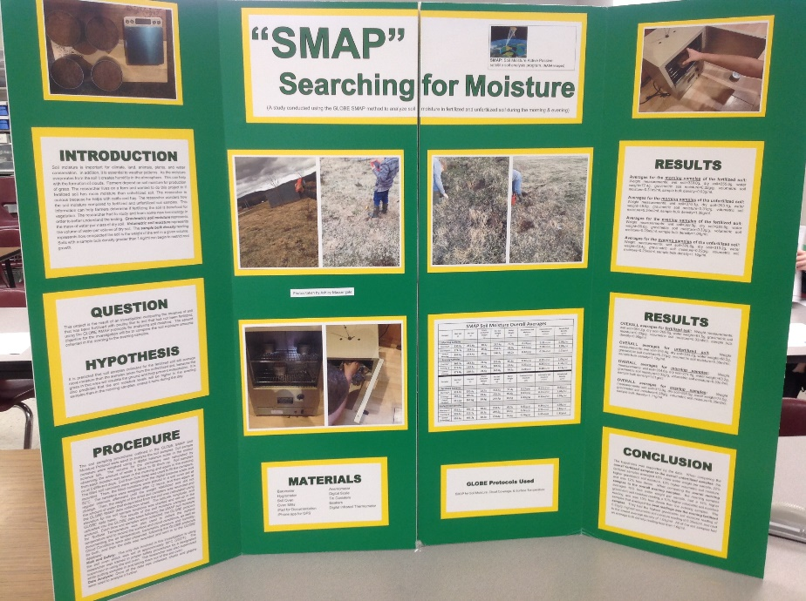

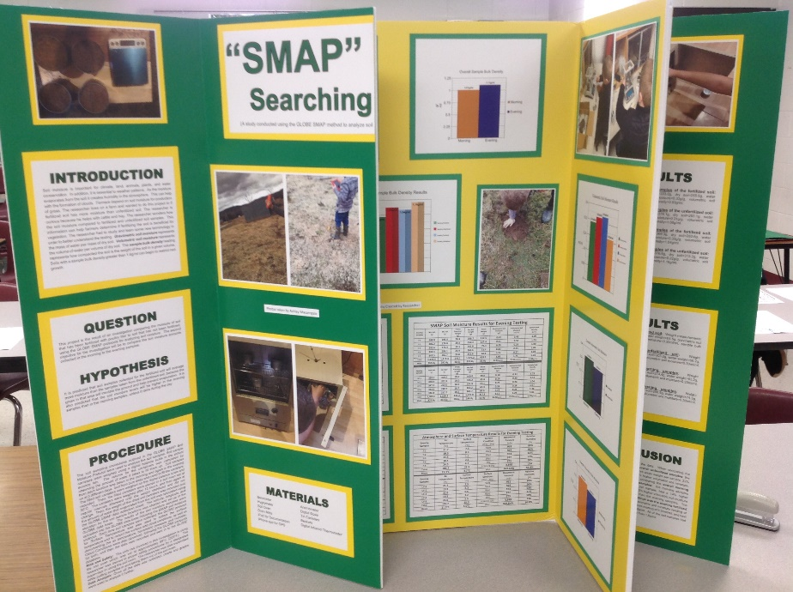

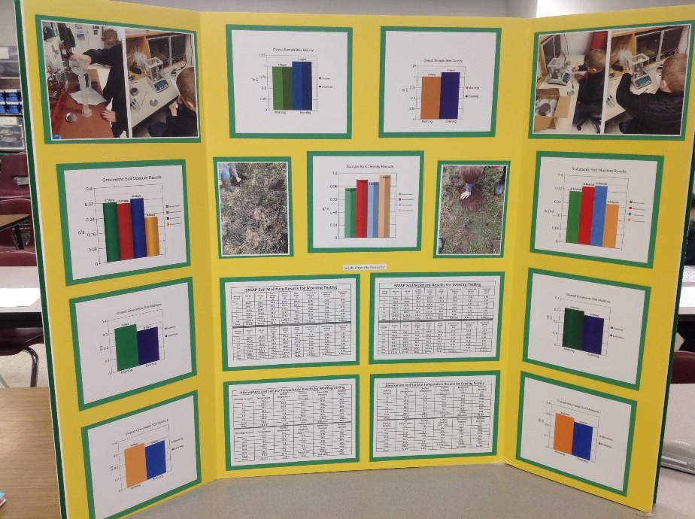
ADDITIONAL DATA CHARTS & GRAPHS
SMAP Soil Moisture Results for Morning Testing
Morning Samples | Wet Soil  (g) | Dry Soil  (g) | Empty Container  Weight  (g) | Dry Soil  Weight  (g) | Water Weight  (g) | Gravimetric Soil Moisture  (g/g) | Volumetric Soil Moisture  (ml/ml) | Sample Bulk  Density  (g/ml)
F-1 | 364.5 | 258.9 | 28.6 | 230.3 | 105.6 | 0.46 | 0.43 | 0.94
F-2 | 414.7 | 290.1 | 28.5 | 261.6 | 124.6 | 0.48 | 0.51 | 1.07
F-3 | 213.9 | 204.4 | 28.7 | 175.7 | 9.5 | 0.05 | 0.04 | 0.72
F-4 | 333.5 | 264.9 | 28.4 | 263.5 | 68.6 | 0.29 | 0.28 | 0.97
F-5 | 338.2 | 259.6 | 28.5 | 231.1 | 78.6 | 0.34 | 0.32 | 0.95
Total | 1,664.8 | 1,277.9 | 142.7 | 1,162.2 | 386.9 | 1.62 | 1.58 | 4.65
Mean | 333.0g | 255.6g | 28.5g | 232.4g | 77.4g | 0.32(g/g) | 0.31ml/ml | 0.93g/ml
Morning Samples | Wet Soil  (g) | Dry Soil  (g) | Empty Container  Weight  (g) | Dry Soil  Weight  (g) | Water Weight  (g) | Gravimetric Soil Moisture  (g/) | Volumetric Soil Moisture  (ml/ml) | Sample Bulk  Density  (g/ml)
UF-1 | 349.7 | 301.3 | 28.8 | 272.5 | 48.4 | 0.18 | 0.20 | 1.12
UF-2 | 414.5 | 310.3 | 28.7 | 281.6 | 104.2 | 0.37 | 0.43 | 1.15
UF-3 | 454.8 | 284.6 | 28.6 | 256.0 | 170.2 | 0.66 | 0.70 | 1.05
UF-4 | 331.9 | 268.4 | 28.7 | 239.7 | 63.5 | 0.26 | 0.26 | 0.98
UF-5 | 329.8 | 301.3 | 28.6 | 272.7 | 28.6 | 0.10 | 0.12 | 1.12
Total | 1,880.7 | 1,465.9 | 143.4 | 1,322.5 | 244.7 | 1.57 | 1.71 | 5.42
Mean | 376.1g | 293.1g | 28.6g | 264.5g | 48.9g | 0.31(g/g) | 0.34ml/ml | 1.08g/ml

SMAP Soil Moisture Results for Evening Testing
Evening Samples | Wet Soil  (g) | Dry Soil  (g) | Empty Container  Weight  (g) | Dry Soil  Weight  (g) | Water Weight  (g) | Gravimetric Soil Moisture  (g/) | Volumetric Soil Moisture  (ml/ml) | Sample Bulk  Density  (g/ml)
F-1 | 408.0 | 295.5 | 28.8 | 266.7 | 112.5 | 0.42 | 0.46 | 1.09
F-2 | 406.2 | 278.8 | 28.6 | 250.2 | 127.4 | 0.51 | 0.52 | 1.03
F-3 | 342.6 | 272.3 | 28.5 | 243.8 | 70.3 | 0.29 | 0.29 | 1.00
F-4 | 342.4 | 291.1 | 28.4 | 262.6 | 51.4 | 0.20 | 0.21 | 1.08
F-5 | 347.3 | 280.7 | 28.8 | 251.9 | 66.6 | 0.26 | 0.27 | 1.03
Total | 1,846.5 | 1,418.4 | 143.1 | 1,275.2 | 428.2 | 1.68 | 1.75 | 5.23
Mean | 369.3g | 283.6g | 28.6g | 255.0g | 85.6g | 0.33(g/g) | 0.35ml/ml | 1.04g/ml
Evening Samples | Wet Soil  (g) | Dry Soil  (g) | Empty Container  Weight  (g) | Dry Soil  Weight  (g) | Water Weight  (g) | Gravimetric Soil Moisture  (g/) | Volumetric Soil Moisture  (ml/ml) | Sample Bulk  Density  (g/ml)
UF-1 | 358.2 | 328.7 | 28.7 | 300.0 | 29.5 | 0.10 | 0.12 | 1.23
UF-2 | 448.4 | 352.8 | 28.6 | 324.2 | 95.6 | 0.29 | 0.39 | 1.33
UF-3 | 347.7 | 283.6 | 28.7 | 254.9 | 64.1 | 0.25 | 0.26 | 1.04
UF-4 | 352.2 | 288.9 | 28.7 | 260.2 | 63.3 | 0.24 | 0.26 | 1.07
UF-5 | 376.8 | 312.2 | 28.5 | 283.7 | 64.6 | 0.23 | 0.26 | 1.16
Total | 1,883.3 | 1,566.2 | 143.2 | 1,423.0 | 317.1 | 1.11 | 1.29 | 5.83
Mean | 376.6g | 313.2g | 28.6g | 284.6g | 63.4g | 0.22(g/g) | 0.25ml/ml | 1.16g/ml

Atmosphere and Surface Temperature Results for Morning Testing
Morning Samples | Air  Temperature  (°C) | Surface Temperature  (°C) | Surface  Condition  (Wet – Dry) | Barometric Pressure  (mb) | Relative  Humidity  (%)
F-1 | 19.7 | 13.3 | Wet | 970 | 70%
F-2 | 19.7 | 14.5 | Wet | 964 | 95%
F-3 | 18.4 | -1.5 | Wet | 970 | 80%
F-4 | 15.2 | 4.3 | Wet | 975 | 95%
F-5 | 18.2 | -3.3 | Wet | 973 | 60%
Total | 91.2 | 27.3 | 5-Wet | 4,852 | 400
Mean | 18.2°C | 5.5°C | Wet | 970.4mb | 80%
Morning Samples | Air  Temperature  (°C) | Surface Temperature  (°C) | Surface  Condition  (Wet – Dry) | Barometric Pressure  (mb) | Relative  Humidity  (%)
UF-1 | 19.7 | 13.1 | Wet | 970 | 70%
UF-2 | 19.7 | 14.4 | Wet | 964 | 95%
UF-3 | 18.4 | -2.5 | Wet | 970 | 80%
UF-4 | 15.2 | 5.5 | Wet | 975 | 95%
UF-5 | 18.2 | -3.2 | Dry | 973 | 60%
Total | 91.2 | 27.3 | 4-Wet/1-Dry | 4,852 | 400
Mean | 18.2°C | 5.5°C | Wet | 970.4mb | 80%

Atmosphere and Surface Temperature Results for Evening Testing
Evening  Samples | Air  Temperature  (°C) | Surface Temperature  (°C) | Surface  Condition  (Wet – Dry) | Barometric Pressure  (mb) | Relative  Humidity  (%)
F-1 | 21.7 | 7.3 | Wet | 961 | 88%
F-2 | 19.9 | 8.3 | Wet | 964 | 96%
F-3 | 22.6 | 1.1 | Wet | 973 | 63%
F-4 | 18.5 | 2.1 | Wet | 977 | 37%
F-5 | 24.0 | 4.7 | Dry | 973 | 50%
Total | 106.7 | 23.5 | 4-Wet/1-Dry | 4,848 | 334
Mean | 21.3°C | 4.7°C | Wet | 969.6mb | 66.8%
Evening  Samples | Air  Temperature  (°C) | Surface Temperature  (°C) | Surface  Condition  (Wet – Dry) | Barometric Pressure  (mb) | Relative  Humidity  (%)
UF-1 | 21.7 | 7.5 | Wet | 961 | 88%
UF-2 | 19.9 | 8.3 | Wet | 964 | 96%
UF-3 | 22.6 | 0.5 | Wet | 973 | 63%
UF-4 | 18.5 | 3.2 | Wet | 977 | 37%
UF-5 | 24.0 | 5.5 | Dry | 973 | 50%
Total | 106.7 | 25.0 | 4-Wet/1-Dry | 4,848 | 334
Mean | 21.3°C | 5.0°C | Wet | 969.6mb | 66.8%

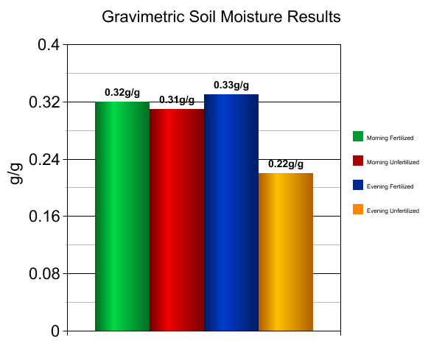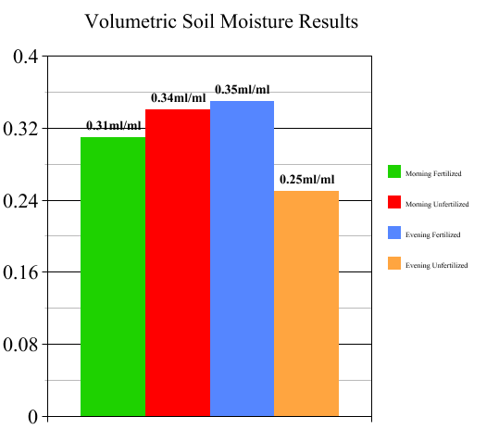

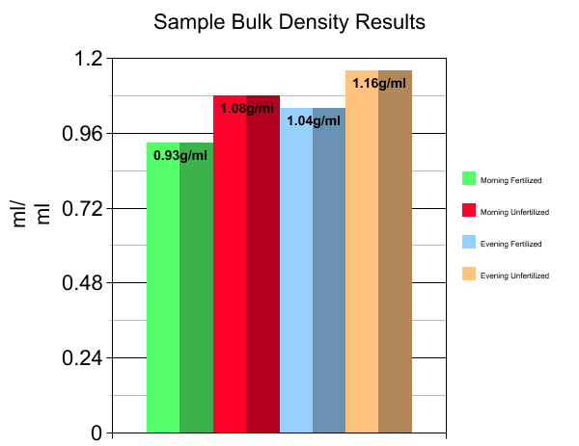
BIBLIOGRAPHY

Baker, J. M., and R. R. Allmaras. "System for automating and multiplexing soil moisture measurement by time‐domain reflectometry." Soil Science Society of America Journal 54.1 (1990): 1-6.

Blake, G. Rꎬ, and K. H. Hartge. "Bulk density." Methods of soil analysis: Part 1 Physical and mineralogical methods 5 (1986): 363-375.

Board, Ocean Studies, and National Research Council. Climate intervention: Reflecting sunlight to cool earth. National Academies Press, 2015.

Butler, Dixon M., and Ian D. MacGregor. "GLOBE: Science and education." Journal of Geoscience Education 51.1 (2003): 9-20.

Entekhabi, Dara, et al. "The soil moisture active passive (SMAP) mission." Proceedings of the IEEE 98.5 (2010): 704-716.

Herkelrath, W. N., S. P. Hamburg, and Fred Murphy. "Automatic, real‐time monitoring of soil moisture in a remote field area with time domain reflectometry." Water Resources Research 27.5 (1991): 857-864.

Heuscher, Sonja A., Craig C. Brandt, and Philip M. Jardine. "Using soil physical and chemical properties to estimate bulk density." Soil Science Society of America Journal 69.1 (2005): 51-56.

Manrique, L. A., and C. A. Jones. "Bulk density of soils in relation to soil physical and chemical properties." Soil Science Society of America Journal 55.2 (1991): 476-481.

Reynolds, S. G. "The gravimetric method of soil moisture determination Part IA study of equipment, and methodological problems." Journal of Hydrology 11.3 (1970): 258-273.

Richards, L. A. "Methods of measuring soil moisture tension." Soil Science 68.1 (1949): 95.

Shinn, James D., et al. "Development of a CPT deployed probe for in situ measurement of volumetric soil moisture content and electrical resistivity." Field Analytical Chemistry & Technology 2.2 (1998): 103-109.

Wagner, Wolfgang, Guido Lemoine, and Helmut Rott. "A method for estimating soil moisture from ERS scatterometer and soil data." Remote sensing of environment 70.2 (1999): 191-207.

