ABSTRACT

"Reflection = Perfection"
"An investigation using GLOBE Aerosol and Cloud protocols to help analyze the effect of using a mirror to reflect light on a solar panel ".
Kaylee Stephenson
6th grade Alpena Middle School

This project is the result of an investigation to analyze using a mirror to reflect sunlight onto a solar panel where the solar panel is facing away from the Sun from distances of 5m, 10m, and 15m. It is predicted that the reflected sunlight tests will produce at least 80% of the electricity as the control in direct sunlight.

A 9cm x 30cm solar panel was set up in direct sunlight. Lux and volt readings were collected. Then, the solar panel was setup facing away from the sun. Indirect sunlight Lux and volt readings were collected. Them, a 20cm x 50cm mirror was used to reflect sunlight on the solar panel from 5m, 10, and 15m. 10 readings were collected for each series of tests and analyzed with a statistics t-Test.

Readings for direct sunlight was 82,970Lux, with 21.46volts. Readings for indirect sunlight was 5,750Lux, with 9.52volts. Readings for sunlight reflected from 5m was 106,790Lux, with 21.7volts. Readings for sunlight reflected from 10m was 58,710Lux, with 20.99volts. Readings for sunlight reflected from 15m was 56,280Lux, with 20.77volts.

The hypothesis was partially supported by the data. Voltage output from light reflected at 5m was actually 1% higher than for the direct sunlight. According to the statistics t-Test, the difference was not significant. Readings from light reflected at 10m showed a 2% decrease in voltage and 15m showed a 3% decrease in voltage which were significant according to the t-test. The indirect sunlight tests resulted in a 56% decrease in voltage.

"Reflection = Perfection"

An investigation using GLOBE Aerosol and Cloud protocols to help analyze the effect of using a mirror to reflect sunlight on a solar panel”

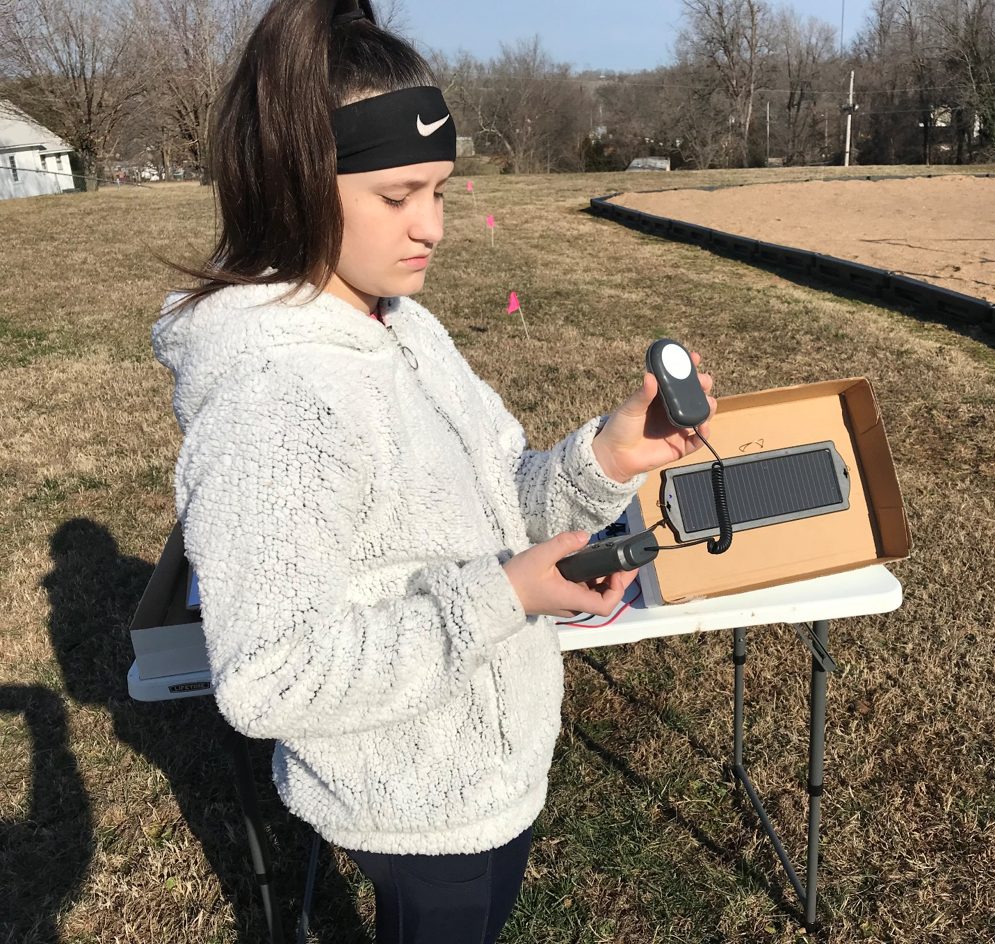

Kaylee Stephenson
6th grade Alpena Middle School
Roger Rose – Science teacher
Tammy Rose – GLOBE Sponsor
March 12th 2020

TABLE OF CONTENTS

Abstract…………………………………………….…….......... 1
Title Page and Table of Contents ……………........... 2-3
Research Question and Hypothesis………….………… 4
Methods & Materials……………………………….………… 5
Data Summary (Chart & Graph) ……………………………... 6 - 7
Analysis & Results…………………............................. 8
Conclusions……………………………………….…............ 9
Discussion…………………………………………...………… 9
Acknowledgements………………………………............. 9
References/Bibliography……………………………..10 - 11

RESEARCH QUESTION

Solar panels are being used more and more in residential housing applications. The use of solar panels can help cut electrical costs, save natural resources, and provide a clean electricity alternative. One of the drawbacks to residential application of solar panels in rural areas can be finding an area where they can be installed in direct sunlight that is close to the house. If the solar panels are too far away, then longer electrical cable has to be used, which can cut down on the efficiency of the solar energy collected. In some areas of the world, high definition mirrors can be used to concentrate the Sun's rays on solar panels. The GLOBE Aerosol and Cloud protocols can be used to measure the Aerosol Optical Thickness in the atmosphere and document the atmospheric conditions at the time of the investigation. In order to better understand this investigation the researcher had to learn some new terminology such as Lumen and Lux which are both used to measure the amount of light. According to a paper written by David L. Crawford; "Lumen is the unit of the light current which indicates the total amount of light given off by the light source. Lux is used to measure the amount of light output in a given area. Direct sunlight can have a luminous efficacy of around 93 lumens which would provide an illuminance of approximately 98,000 Lux". The type of solar panel used in the investigation is a 9cm x 30cm Solar Battery Charger and Maintainer that can be used on automobiles, and recreational vehicles.

This project is the result of an investigation to analyze the effect of using a mirror to reflect sunlight toward a solar panel in a location where the solar panel is facing away from the Sun from distances of 5 meters, 10 meters, and 15 meters.

HYPOTHESIS

It is predicted that it will be possible to reflect sunlight toward a solar panel which is facing away from the sun and still generate at least 80% of the amount of electricity that could be generated is the solar panel is facing directly toward the sun. It is also predicted that as the mirror is placed father away from the solar panel, (5m, 10m, and 15m,) the amount of electricity produced will be proportionally less.
GLOBE Protocol Used
Aerosols (AOT) Cloud Cover
Air Temperature Barometric Pressure
Relative Humidity
RESEARCH METHODS

On a bright Sunny day, the researcher set up the 9cm x 30cm solar panel on a table where it was facing toward the sun. The date and time was be recorded. The GLOBE protocols for Aerosols and Clouds were followed to analyze the Aerosol Optical Thickness (AOT), and to record the current atmospheric conditions. The Aerosol and Cloud Observation data were submitted to the GLOBE database. Then, a voltage meter was connected to the solar panel in order to measure the amount of electricity produced. A digital Lux light meter was used to measure the amount of light given off by the sun. Ten Lux readings were recorded. The solar panel was adjusted so that it is facing directly toward the sun. Ten different voltage output readings from the solar panel were recorded. Next, the solar panel was turned around so that it was facing away from the direct sunlight. The light meter was used to measure the Lux readings that the solar panel was receiving. The volt meter was used to measure the voltage output from the solar panel while it was in the indirect sunlight position. Next, the researcher used a 15-meter measuring tape to measure and mark off distances of 5m, 10m, and 15, from the solar panel. Flags were placed in the ground to mark the distances. After that, a 20cm x 50cm mirror was used to reflect sunlight directly onto the solar panel from distances of 5 meters, 10 meters, and 15 meters. For each distance, ten readings were recorded for Lux readings of light and the voltage that the solar panel produced.
Risk and Safety Concerns: The only risk involved in this investigation is the connecting of the solar panel to the volt meter and monitoring the volt output from the solar panel. In order to minimize the risk, the researcher will be supervised by the middle school science teacher who is experienced in using solar panels and electricity.
Data Analysis: Once all the data has been collected, it was used to create charts and graphs to help analyze it further. Using Microsoft Excel, a statistics t-Test were used to analyze if there is a significant difference in the readings.

MATERIALS

9cm x 30cm Solar Panel
20cm x 50cm Mirror
Digital Lux meter
Digital Volt Meter
GLOBE Cloud Guide
GLOBE Protocols for Aerosols and Clouds
Digital Calitoo meter for Aerosols
iPad for Documentation
paper-box lid to hold Solar Panel
Portable Fold-up Table
Pink Survey Flags
15m Measuring Tape

DATA SUMMARY

Solar Energy Reflected Light Test Results
(Light measured in Lux = Lumens per square meter, Electricity measured in Volts DC)
 | Direct  Sunlight  Control |  | Indirect  Sunlight  Control |  | Reflected  Sunlight  5 meters |  | Reflected  Sunlight  10 meters |  | Reflected  Sunlight  15 meters
Test # | Lux | Volts | Lux | Volts | Lux | Volts | Lux | Volts | Lux | Volts
1 | 82,100 | 22.0 | 730 | 9.7 | 108,900 | 21.7 | 59,600 | 20.4 | 56,400 | 20.9
2 | 82,700 | 21.5 | 650 | 9.6 | 105,400 | 21.8 | 53,700 | 20.8 | 58,400 | 20.6
3 | 83,000 | 21.4 | 620 | 9.5 | 103,000 | 21.7 | 60,400 | 21.0 | 52,800 | 20.4
4 | 83,000 | 21.5 | 420 | 8.9 | 110,700 | 21.8 | 63,200 | 21.1 | 59,600 | 21.0
5 | 83,100 | 21.4 | 550 | 9.7 | 110,300 | 21.6 | 53,600 | 21.2 | 57,100 | 20.8
6 | 83,000 | 21.4 | 790 | 9.6 | 108,700 | 21.7 | 57,200 | 21.3 | 57,800 | 20.9
7 | 83,100 | 21.4 | 500 | 9.5 | 107,900 | 21.6 | 61,200 | 20.8 | 58,300 | 20.6
8 | 83,200 | 21.3 | 460 | 9.5 | 105,300 | 21.7 | 63,500 | 21.2 | 54,600 | 21.0
9 | 83,300 | 21.4 | 550 | 9.6 | 103,200 | 21.7 | 57,800 | 20.9 | 53,700 | 20.8
10 | 83,200 | 21.3 | 500 | 9.6 | 104,500 | 21.7 | 56,900 | 21.2 | 54,100 | 20.7
Total | 829,700 | 214.6 | 5,750 | 95.2 | 1,067,900 | 217 | 587,100 | 209.9 | 562,800 | 207.7
Mean | 82,970 | 21.46v | 575 | 9.52v | 106,790 | 21.7v | 58,710 | 20.99v | 56,280 | 20.77v

DATA SUMMARY (continued)
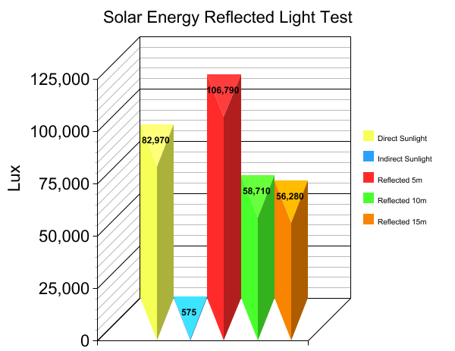
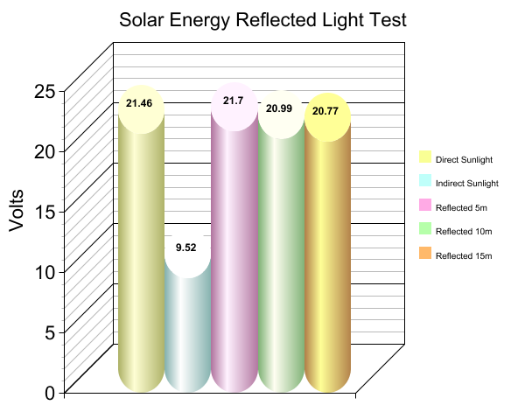

ANALYSIS AND RESULTS

The average light readings for the solar panel placed in direct sunlight was 82,970Lux, resulting in 21.46volts produced. The average light readings for the solar panel placed in indirect sunlight was 5,750Lux, resulting in 9.52volts produced. The average light readings for the solar panel with the sunlight reflected from a distance of 5m was 106,790Lux, resulting in 21.7volts produced. The average light readings for the solar panel with the sunlight reflected from a distance of 10m was 58,710Lux, resulting in 20.99volts produced. The average light readings for the solar panel with the sunlight reflected from a distance of 15m was 56,280Lux, resulting in 20.77volts produced.

CONCLUSION

The hypothesis was partially supported by the data. The voltage output from the light reflected on the solar panel from 5m was actually 1% higher than the solar panel readings recorded in direct sunlight. However according to the statistics t-Test, the difference was not high enough to be significant. The readings from the light reflected at 10 meters showed a 2% decrease in voltage and the 15m showed a 3% decrease in voltage. According to the statistics t-Test, both the 10m and the 15m distances resulted in a significant difference, but it was close. When the solar panel was placed in the indirect sunlight position, it resulted in a 56% decrease in voltage output. According to the overall results from the investigation, the researcher believes that reflecting sunlight onto a solar panel could provide enough light energy to generate a significant amount of electricity if placing the solar panel in direct sunlight is not an option.

DISCUSSION
The results were rather interesting. The sunlight reflected from 5 meters actually produced slightly more electricity than the control which was in direct sunlight. In order for the reflected sunlight process to actually work, the mirror would need to bel placed on some type of mount that would turn to keep the best angle of reflection for the sun to hit the solar panel. This process might not be practical in most situations, but in an area where there is not a good location for direct sunlight for the solar panel, and it would be too far to run electrical wires to a better location, it might just work out.

ACKNOLWEDGEMENTS

I would like to thank my science teacher Mr. Rose for showing me how to set up the volt meter and solar panel and also for helping to supervise the data collection phase of the experiment. I would also like to thank Mr. and Mrs. Rose for teaching us about GLOBE and helping us learn how to use the equipment to collect Aerosol data and other atmospheric data for GLOBE.

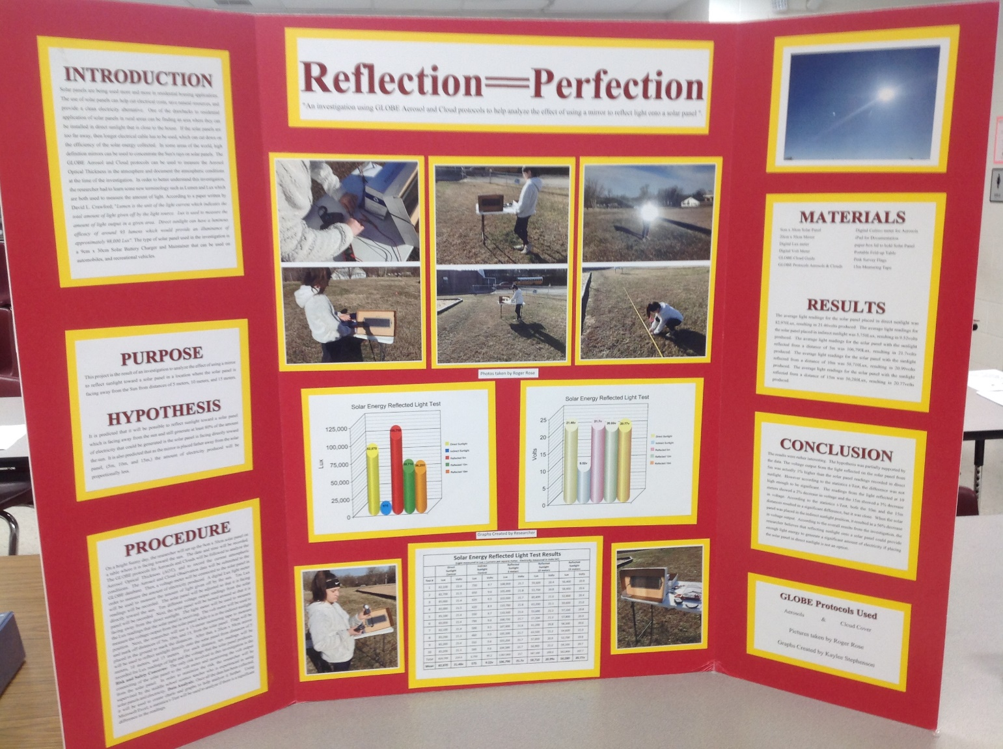

BIBLIOGRAPHY

Bakirci, Kadir. "General models for optimum tilt angles of solar panels: Turkey case study." Renewable and Sustainable Energy Reviews 16.8 (2012): 6149-6159.

Board, Ocean Studies, and National Research Council. Climate intervention: Reflecting sunlight to cool earth. National Academies Press, 2015.

Butler, Dixon M., and Ian D. MacGregor. "GLOBE: Science and education." Journal of Geoscience Education 51.1 (2003): 9-20.

Crawford, David L. "Photometry: teminology and units in the lighting and astronomical sciences." The Observatory 117 (1997): 14-18.

Currin, C. G. "Performance of 600 Lumen Solar Powered Luminaire Designed for Use in Non-Electrified Homes." Intersol Eighty Five. Pergamon, 1986. 1765-1769.

Green, Martin A., et al. "Solar cell efficiency tables (version 37)." Progress in photovoltaics: research and applications 1.19 (2010): 84-92.

BIBLIOGRAPHY (continued)

Karandikar, R. V. "Luminance of the Sun." JOSA 45.6 (1955): 483-488.

Kelly, Nelson A., and Thomas L. Gibson. "Increasing the solar photovoltaic energy capture on sunny and cloudy days." Solar Energy 85.1 (2011): 111-125.

Pode, Ramchandra, and Boucar Diouf. Solar lighting. Springer Science & Business Media, 2011.

Powell, Earl G., et al. "Apparatuses and methods to reduce safety risks associated with photovoltaic systems." U.S. Patent No. 7,807,919. 5 Oct. 2010.

Ransen, Owen. "Candelas, lumens and lux." (2017).

Ravi Tejwani ,Debanjan Sannigrahi, B.K. Chakravarthy, N.C. Narayanan, Chetan S. Solanki, “Solar Lamp for Study Purposes: Design Perspectives”, December 2013, ICAER, IIT Bombay, Mumbai,

Rizk, J. C. A. Y., and Y. Chaiko. "Solar tracking system: more efficient use of solar panels." World Academy of Science, Engineering and Technology 41 (2008): 313-315.

Rosa-Clot, Marco, et al. "Submerged photovoltaic solar panel: SP2." Renewable Energy 35.8 (2010): 1862-1865.

Schlyter, Paul. "Radiometry and photometry in astronomy." Available: stjarnhimlen. se/comp/radfaq. html 1 (2009).

Siraki, Arbi Gharakhani, and Pragasen Pillay. "Study of optimum tilt angles for solar panels in different latitudes for urban applications." Solar energy 86.6 (2012): 1920-1928.

Swart, P. L., and J. D. Van Wyk. "Source tracking and power flow control of terrestrial photovoltaic panels for concentrated sunlight." pvsp (1978): 700-705.

Tourneux, Michel. "Solar panels." U.S. Patent No. 4,336,413. 22 Jun. 1982.

Wagner, Erich, Edward N. Twesme, and Craig Hidalgo. "Solar panel." U.S. Patent No. 5,164,020. 17 Nov. 1992.

