ABSTRACT

The Grass Isn’t Always Greener...
(A study conducted using GLOBE protocols to analyze soil with different fertilizers for growing Bermuda Grass)
Ella K. Curry
6th grade Plant Science
Alpena Middle School

Is there a significant difference in type of fertilizer used to increase growth in Bermuda grass? It was predicted that chicken litter will make the best fertilizer due to the organic matter and availability. Turkey litter was predicted to be the next best for growth rate. The cow manure would be 3rd and commercial nitrogen would have the least growth rate.

Soil samples were collected and tested using a NPK soil kit to determine if deficiencies were present. The soil testing results were that the control soil was low in nitrogen and high in phosphorus and potassium. Samples were also submitted to the Cooperative Extension Service. Bermuda sprigs were weighed and planted in 5 pots and each pot was fertilized at the recommended rate for each type. Growth was observed and results were recorded.

The results were that the Chicken litter grew.08 kilograms, Turkey litter grew .06 kilograms, Manure grew .1 kilograms, Commercial grew.14 kilograms, and the Control grew .06 kilograms. The Commercial nitrogen fertilizer grew the most. When calculated into grass gained per square foot Pot A gained .043611104, Pot B gained .032708328, Pot C gained .05451388, Pot D gained .076319432, Pot E gained .032708328. Pot D gained the most grass per square foot.

The hypothesis was not supported by the data. The grass fertilized with nitrogen gained the most. The grass fertilized with cow manure came in second, with chicken litter the next highest. The grass fertilized with turkey litter and the control gained the least amount.

"The Grass Isn’t Always Greener . . ."

(A study conducted using GLOBE protocols to analyze soil with different fertilizers for growing Bermuda Grass)

Ella Curry
6th grade Alpena Middle School
Roger Rose – Science teacher
Tammy Rose – GLOBE Sponsor
March 12th 2020

TABLE OF CONTENTS

Abstract…………………………………………….…….......... 1
Title Page and Table of Contents ……………........ 2 - 3
Research Question and Hypothesis………….……….. 4
Research Methods ……………………………………………4
Materials……………………………….………………………. 5
Data Summary (Chart & Graph) ……………………………... 5 - 6
Analysis & Results…………………............................. 7
Conclusions……………………………………….…............ 7
Discussion…………………………………………...………… 8
Acknowledgements………………………………............. 8
Display Board …………………………………………… 8 – 9
References/Bibliography……………………………… 10

RESEARCH QUESTION
In our rural community, many farmers rely on hay to provide an ample supply of food for their livestock during the colder weather. My grandpa cuts about 30 acres each cutting. He first started using commercial fertilizer but it got too expensive. He then switched to chicken/turkey litter for about 5 years when he had a truck to haul it. For the last 10 years, he’s used commercial fertilizer. He switched to commercial due to a rise in cost in litter and also to eliminate weed seed/trash. Last year we got 3 cuttings of hay, the first we used 24-8-16, the second was 46% nitrogen, and the third was without any fertilizer. It made me wonder, “Is there a type of fertilizer that is better for growing grass to make hay?” Is there a significant difference in types of fertilizer (chicken litter, turkey litter, cow manure, and commercial nitrogen) used to increase growth in Bermuda grass?

HYPOTHESIS
It was predicted that chicken litter will make the best fertilizer due to the organic matter and availability. Turkey litter was predicted to be the next best for growth rate. The cow manure would be 3rd and commercial nitrogen would have the least growth rate.

RESEARCH METHODS
The researcher collected soil samples from the field where hay is baled. The researcher tested the soil using a NPK Soil Kit. The researcher’s test showed a Nitrogen deficiency. The researcher also took a sample of soil to the Cooperative Extension Service for testing. The U of A Division of Agriculture recommended 100 lbs. of nitrogen per acre. Under the direct supervision of the designated supervisor, the researcher collected turkey and chicken litter from local poultry growers and dried cow manure from the researchers own farm. The poultry litter and cow manure samples collected to use for the composting fertilizers are from sources that would normally be used to fertilize farmer's fields in the local area. Commercial fertilizer (46% Nitrogen) was purchased at MFA Co-op. Flower pots were filled with soil from the researcher’s farm. Then, Bermuda grass was pulled up from the researcher’s grandma’s flower bed. The Bermuda grass was washed and dried, then weighed and recorded before planting. The amount of fertilizer for each pot was calculated using a scale to apply amounts equal to the 100 lbs. of the commercial nitrogen fertilizer. Grass was then put in pots along with the recommend amount of fertilizer in each pot. Pot A contained chicken litter, Pot B was turkey litter, Pot C held cow manure, Pot D contained Commercial nitrogen fertilizer and Pot E was the control. Each pot was given 473 mL of water. Rainfall was recorded and grass was watered when rain was scarce. Once the grass had reached it’s full potential, it was pulled up. The grass was washed, dried, and weighed to analyze how much the grass had grown.

MATERIALS

Bermuda grass sprigs
5 flower pots
Soil (taken from site)
Soil Testing kit
Shovel
Electronic Hanging Scale
Ziploc bags
Measuring cup
Rain gauge
Manure
Chicken litter
Turkey litter
Commercial fertilizer
Digital Scale

GLOBE Protocol Used
Pedosphere – Soil Fertility - Nitrogen

DATA SUMMARY

Pot | Grass Starting Weight (g) | Grass Ending Weight (g) | Grass Weight Gained (g)
A Chicken Litter | 20 | 100 | 80
B Turkey Litter | 20 | 80 | 60
C Cow Manure | 20 | 120 | 100
D Nitrogen | 20 | 160 | 140
E Control | 40 | 100 | 60

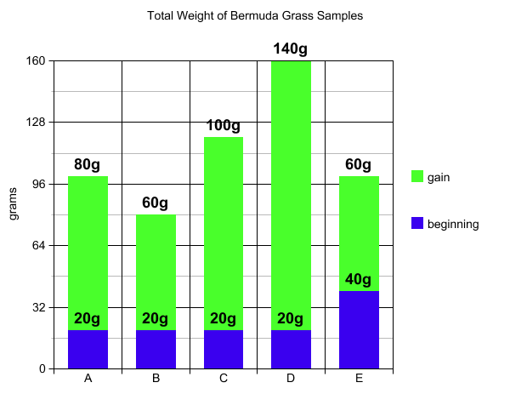

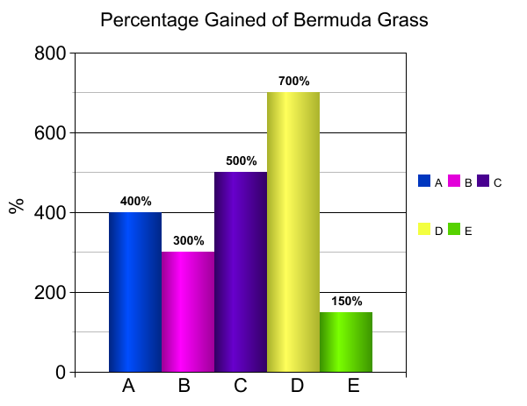
ANALYSIS AND RESULTS
The results of this project are, Pot A had grown 80 grams, Pot B had grown 60 grams, Pot C had grown 100 grams, Pot D had grown 140 grams, and Pot E had grown 60 grams. Based on the growth in the pots, Pot D grew the most. When calculated into grass gained per square foot; Pot A gained 43.611, Pot B gained 32.708, Pot C gained 54.513, Pot D gained 76.319, Pot E gained 32.708. Pot D gained the most grass per square foot. The soil testing results were that the control soil was low in nitrogen and high in phosphorus and potassium.

Cost Analysis

CONCLUSION
The hypothesis was not supported by the data. The grass fertilized with nitrogen gained the most. The grass fertilized with cow manure came in second. The grass fertilized with chicken litter showed the next highest amount of growth. The grass fertilized with turkey litter and the control gained the least amount.

DISCUSSION
The results were very interesting. The commercial nitrogen fertilizer did help the Bermuda grass grow the most. In the future, I would like to do a much larger sample area and maybe use Bermuda grass and then Orchard Grass or Fescue. It would also be good to collect and analyze soil samples at regular intervals during the growing process.

ACKNOLWEDGEMENTS
My mom and dad helped me with my project. My dad supervised me using the fertilizers and planting the Bermuda grass. My mom helped me with the testing of the soil and collecting and analyzing the data. My science teacher, Mr. Rose taught me about the GLOBE program and he let me use equipment from the school to help analyze the Bermuda grass samples.

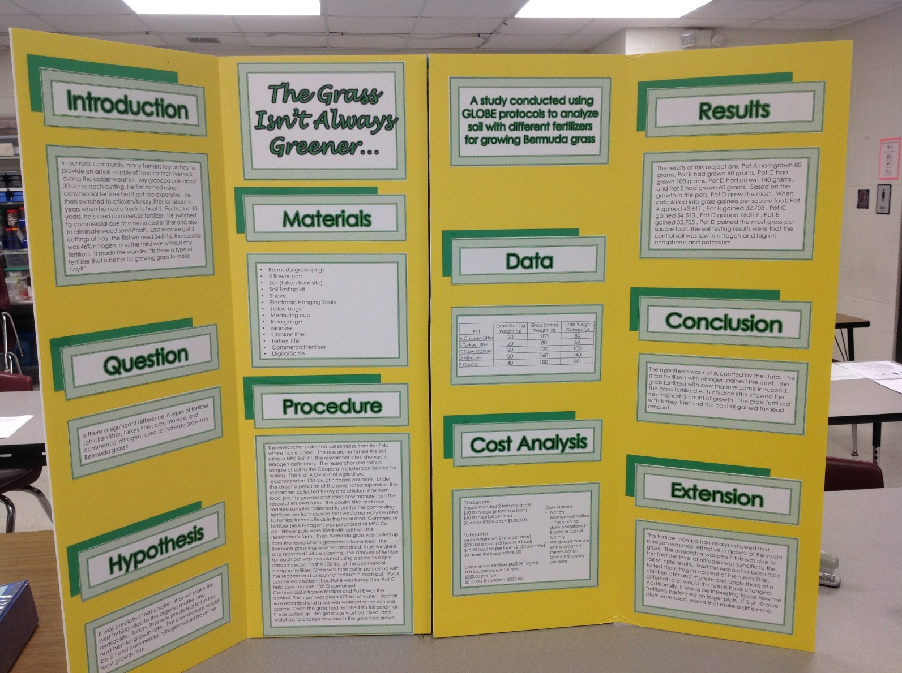

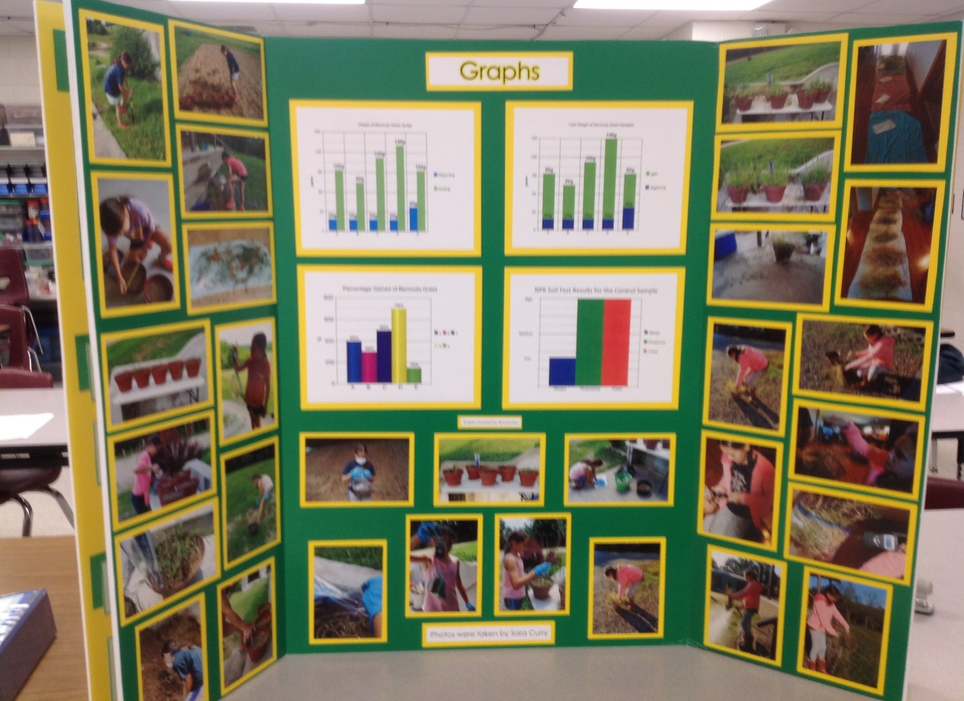
BIBLIOGRAPHY

Butler, Dixon M., and Ian D. MacGregor. "GLOBE: Science and education." Journal of Geoscience Education 51.1 (2003): 9-20.

Chen, Zhao, and Xiuping Jiang. "Microbiological safety of chicken litter or chicken litter-based organic fertilizers: a review." Agriculture 4.1 (2014): 1-29.

Eghball, Bahman, et al. "Mineralization of manure nutrients." Journal of Soil and Water Conservation 57.6 (2002): 470-473.

Evers, Gerald W. "Ryegrass–bermudagrass production and nutrient uptake when combining nitrogen fertilizer with broiler litter." Agronomy Journal 94.4 (2002): 905-910.

International Fertilizer Development Center. Fertilizer manual. No. 13. UN, 1980.

Jiang, Xiuping, and Marion Shepherd. "The role of manure and compost in produce safety." Microbial safety of fresh produce (2009): 143.

Johnson, B. J., R. N. Carrow, and R. E. Burns. "Bermudagrass Turf Response to Mowing Practices and Fertilizer 1." Agronomy journal 79.4 (1987): 677-680.

Keesstra, Saskia D., et al. "The significance of soils and soil science towards realization of the United Nations Sustainable Development Goals." Soil (2016).

Moral, R., et al. "Utilisation of manure composts by high-value crops: Safety and environmental challenges." Bioresource Technology 100.22 (2009): 5454-5460.

Safley, L. M., and J. C. Barker. "Available nitrogen in broiler and turkey litter." Transactions of the ASAE 31.4 (1988): 1070-1075.

Stewart, W. M., et al. "The contribution of commercial fertilizer nutrients to food production." Agronomy Journal 97.1 (2005): 1-6.

Tyson, S. C., and M. L. Cabrera. "Nitrogen mineralization in soils amended with composted and uncomposted poultry litter." Communications in Soil Science and Plant Analysis 24.17-18 (1993): 2361-2374.

Wood, C. W., H. A. Torbert, and D. P. Delaney. "Poultry litter as a fertilizer for bermudagrass: Effects on yield and quality." Journal of Sustainable Agriculture 3.2 (1993): 21-36.

Yuste, J. Curiel, et al. "Drought‐resistant fungi control soil organic matter decomposition and its response to temperature." Global Change Biology 17.3 (2011): 1475-1486.

