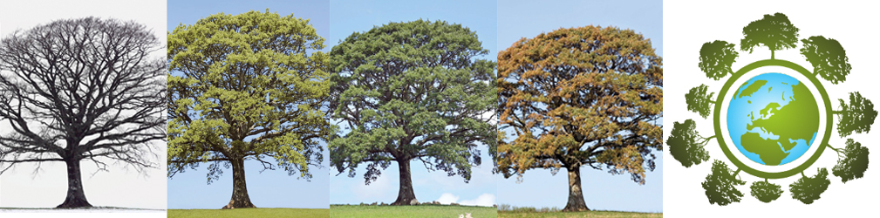

European phenology campaign
Track nature’s Green Wave
Observe how trees change during the year 2017!
Observing the Earth from space in spring, you see a green wave of vegetation moving from the southwest of Europe (Spain) to northeast (Russia) indicating that the trees grow new leaves, flowers blossom and fields turn green. But this green wave does not start every year at the same time.
Why do trees in the city already have leaves while in the rural areas they are still dormant?
What will happen to the fruit trees if it gets warmer in the future?
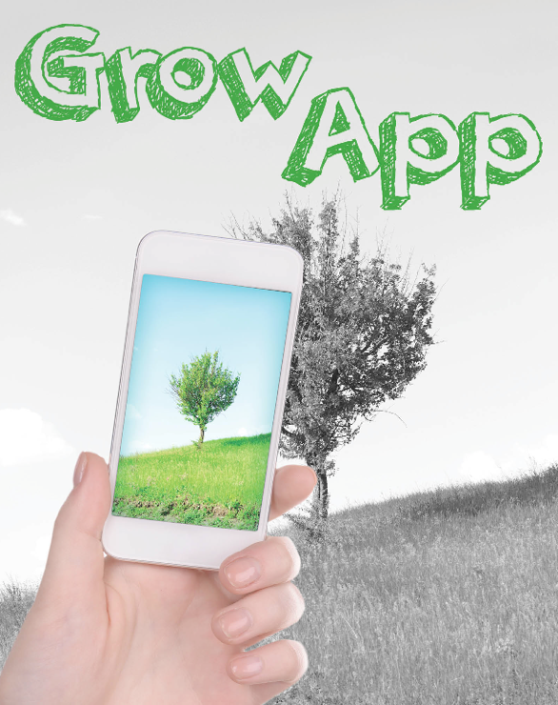
With the GrowApp smartphone app you can observe plants changing over seasons, make time lapse videos and learn how plants react to climate. This is a perfect and easy to use app for biology and geography classes alike.
- Observe trees with the GLOBE learning materials. Compare your observations with these taken by other participants.
- See how the green wave moves, how the spring starts later in Poland as compared to The Netherlands.
- Check out how elevation affects the greening up of the vegetation and compare your observations with satellite data and with meteorological measurements.
You can do all this and more by participating in the GLOBE Phenology Campaign 2017. Make learning fun and exciting with the new GrowApp and GLOBE learning activities.
How to join?
GLOBE teachers can become member of the European phenology campaign. You will get updates about the campaign and ideas on how your students can explore nature. Download the GrowApp, learning materials and a simple to use Excel tool to analyse your data and to learn how weather and climate affect phenology:
PS: Scientists call the green up and down cycle of plants “phenology”.

www.globe.gov/web/european-phenology-campaign

