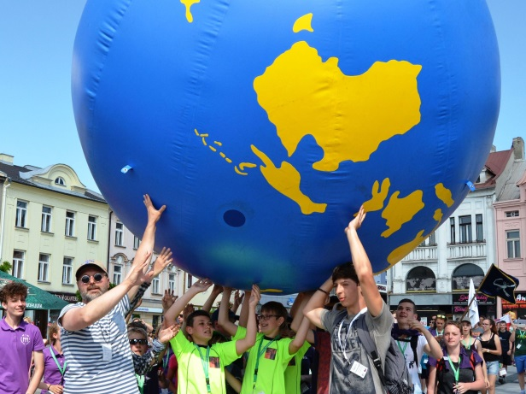
GLOBE Games 2017 are coming!
May 11-14th, 2017
Moravské Budějovice

Dear GLOBE Country Coordinators,
We would like to cordially invite you, students and teachers from your country to GLOBE Games 2017 edition, to be held between 11th and 14th May 2017 in Moravské Budějovice, in south-west Moravia, Czech Republic.
GLOBE Games are organized by TEREZA Education Center every year as a part of GLOBE Program in the Czech Republic since 1998. The games offer a unique opportunity to the GLOBE students, teachers as well as the country coordinators to meet face to face, gain new experience and knowledge and initiate school-to-school collaborations.
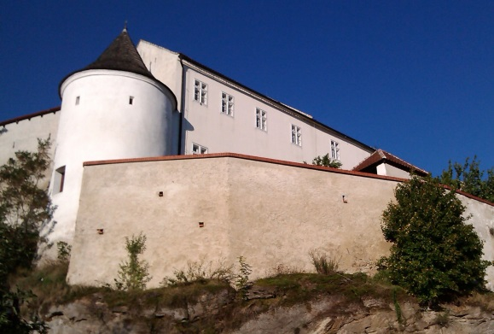
GLOBE Games 2017 will support students from the Czech Republic and other European countries to share results of their GLOBE scientific projects based on their own inquiry, to learn from experiences of researchers and other subject experts, and to experience the research field work. At the same time, the event will support GLOBE teachers by giving them an exposure to new powerful tools and projects for teaching science through the GLOBE Program.
Fortification in Moravské Budějovice
WHERE
The GLOBE Games 2017 will take place in Moravské Budějovice, a town in south-west Moravia. For the region is typical hilly landscape of the highlands, the town itself invites to visit castle, fortifications and other sites. Near the town lies the National Park Podyjí, characterized by extraordinary scenery with rocky amphitheaters, cliffs, meanders of the river Dyje, detritus fields, impervious ravines or alluvial plains around the river.
Educational Center TEREZA is organizing the GLOBE Games 2017 in close cooperation with Elementary School T. G. M. Moravské Budějovice.

CONDITIONS FOR PARTICIPANTS
The number of participants is limited to a maximum of 6 students and 2 teachers from one country. GLOBE country coordinator is also invited. Students must be at least 12 years old, with knowledge of English.
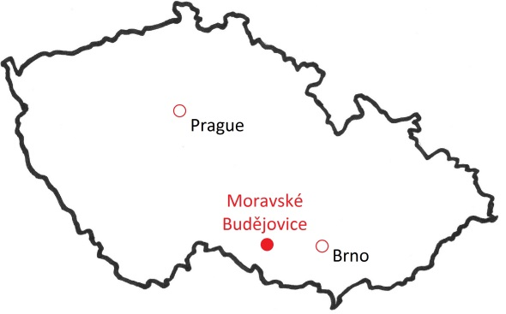
Students prepare a presentation on the topic “Our GLOBE research project” that will be presented during the student GLOBE Conference. We will send the assignment for the presentation in early April.
Are you a teacher who wants to come to the GLOBE Games without students? No problem. Contact us and we will recommend you an appropriate part of the program.
The town Moravské Budějovice is accessible by bus or by train from Prague. We can help you organize your transport from Prague to Moravské Budějovice.
ACCOMMODATION
Accommodation is possible in classrooms at the school (own sleeping bags and carry-mats necessary). You can also stay in a hostel or hotel on the outskirts of the city.
MEALS
Suitable arrangements for your meals on Thursday evening (dinner), Friday (breakfast, lunch, and dinner) and Saturday (breakfast and packed lunch) will be made. Meals will be prepared by school cafeteria (meat as well as vegetarian).
PARTICIPATION FEE
Fees will be 55 EUR per person (with accommodation in classrooms at Elementary school TGM Moravské Budějovice, náměstí Svobody 903) or 80 EUR per person (with accommodation in hostels and hotels in Moravské Budějovice).
The participation fee includes:
- Accommodation for 3 nights
- Meals (3 meals a day, meat and vegetarian version) in the school canteen
- Assistance of volunteers of the TEREZA and collaborating schools
- Materials to the GLOBE Games in English
- Participation T-shirts (100 % organic cotton)

The participation fee doesn´t include accommodation before and after GLOBE Games, sightseeing and excursions, neither travel costs from Prague to Moravské Budějovice and back.

HOW TO APPLY
If you are interested in participating in the GLOBE Games, please send us an e-mail to globe@terezanet.cz. During February we will publish on-line form for mandatory registration – stay in touch, we will inform you You can send us your questions to globe@terezanet.cz.
We look forward to see you in Moravské Budějovice!
Zora Kasiková
GLOBE Games coordinator
zora.kasikova@terezanet.cz
Educational Center TEREZA
www.terezanet.cz

PRELIMINARY PROGRAMME OF THE GLOBE GAMES 2017
Thursday 11th May
- Morning: Arrival of participants, registration, accommodation
- Afternoon: Sightseeing and Excursions
(E.g. city tour on the topic of creating our planet's surface, castle tour, demonstrations of dog training, visit a goat farm, climbing wall, a visit to a rescue station for animals etc.)
- Evening: Opening Ceremony
Friday 12th May
- Morning: Student Conference
- Afternoon: Parade and Ecofestival GLOBE
- Evening: Student’s Workshops and Teacher’s Meeting
Saturday 13th May
- Field Game for students
Sunday 14th May
- Excursions in the region (e.g. Dukovany Nuclear Power Station, National Park Podyjí)

