**General info**

***GLOBE Annual Meeting for Europe and Eurasia 2014***

*Paralimni, Cyprus*

**Accommodation**

We chose a four star hotel called ‘’Pernera Hotel’’, next to Pernera beach and close to city centre of Paralimni, Protaras and Ayia Napa.

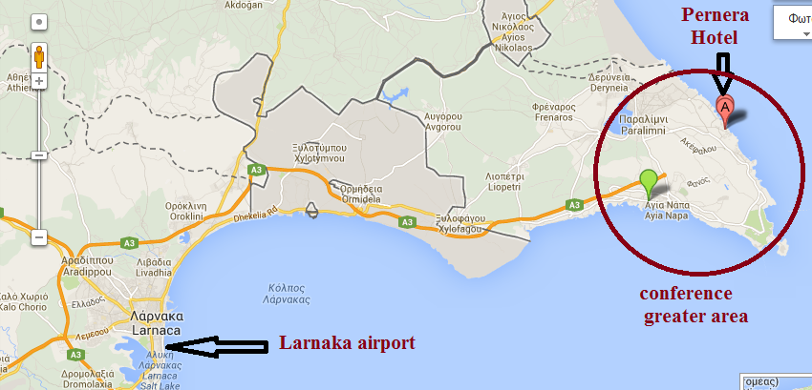

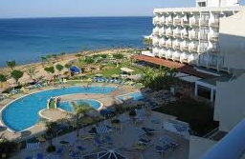

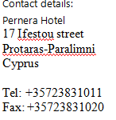

[***http://www.pernera-hotel.com***](http://www.pernera-hotel.com)

***Types of room***. If you want to have a double room you can indicate in the registration with whom you would like to share it.

If you want to have a single we will try to reserve you one. We were reassured by the manager that this is possible. Most of the rooms are also sea sight.

***Cancelling***. When you cancel your reservation you will have to pay part of the costs depending on how long before the meeting you cancel: 15% 2 months before, 35% 1 month before, 85% 7 days before, 100% less than 7 days.

**Costs**

|  |  |  |
| --- | --- | --- |
|  | Single room | Double room (per person) |
| Hotel (per night per person, including breakfast): for 29.04, 30.04, 01.05 | €60 | 50 |
| Hotel (per night per person, half board): for 25.04., 26.04., 27.04., 28.04., 02.05.,03.05., 04.05., 05.05. | 45 | 35 |
| Conference fee per day | €30 | |
| Working dinner on Thursday | €30 | |

**What is included in the conference fee?**

* Local transport during event;
* 2 Coffee breaks (coffee, tea and refreshments)
* Lunch
* Printed materials.

**What is not included in the conference fee?**

* Excursions

**Payments**

After registering you will receive an invoice (unless you are funded as a GLOBE country coordinator, see Guidelines for financial support). We kindly request to pay before the meeting.

**Travelling to Paralimni.**

The most convenient way to travel to Paralimni-Cyprus from abroad is by airplane. Larnaka international airport is just 38 km from Paralimni. You can also use Pafos international airport as an option but it is 190 km from Paralimni and there is no local transportation from Pafos to Paralimni. If you choose Larnaka airport you can use an intercity bus to arrive to Ayia Napa or Paralimni centre, and we can carry you to the hotel. Extra info from: <http://www.aboutcyprus.org.cy/en/transportation>

We will send details upon registration